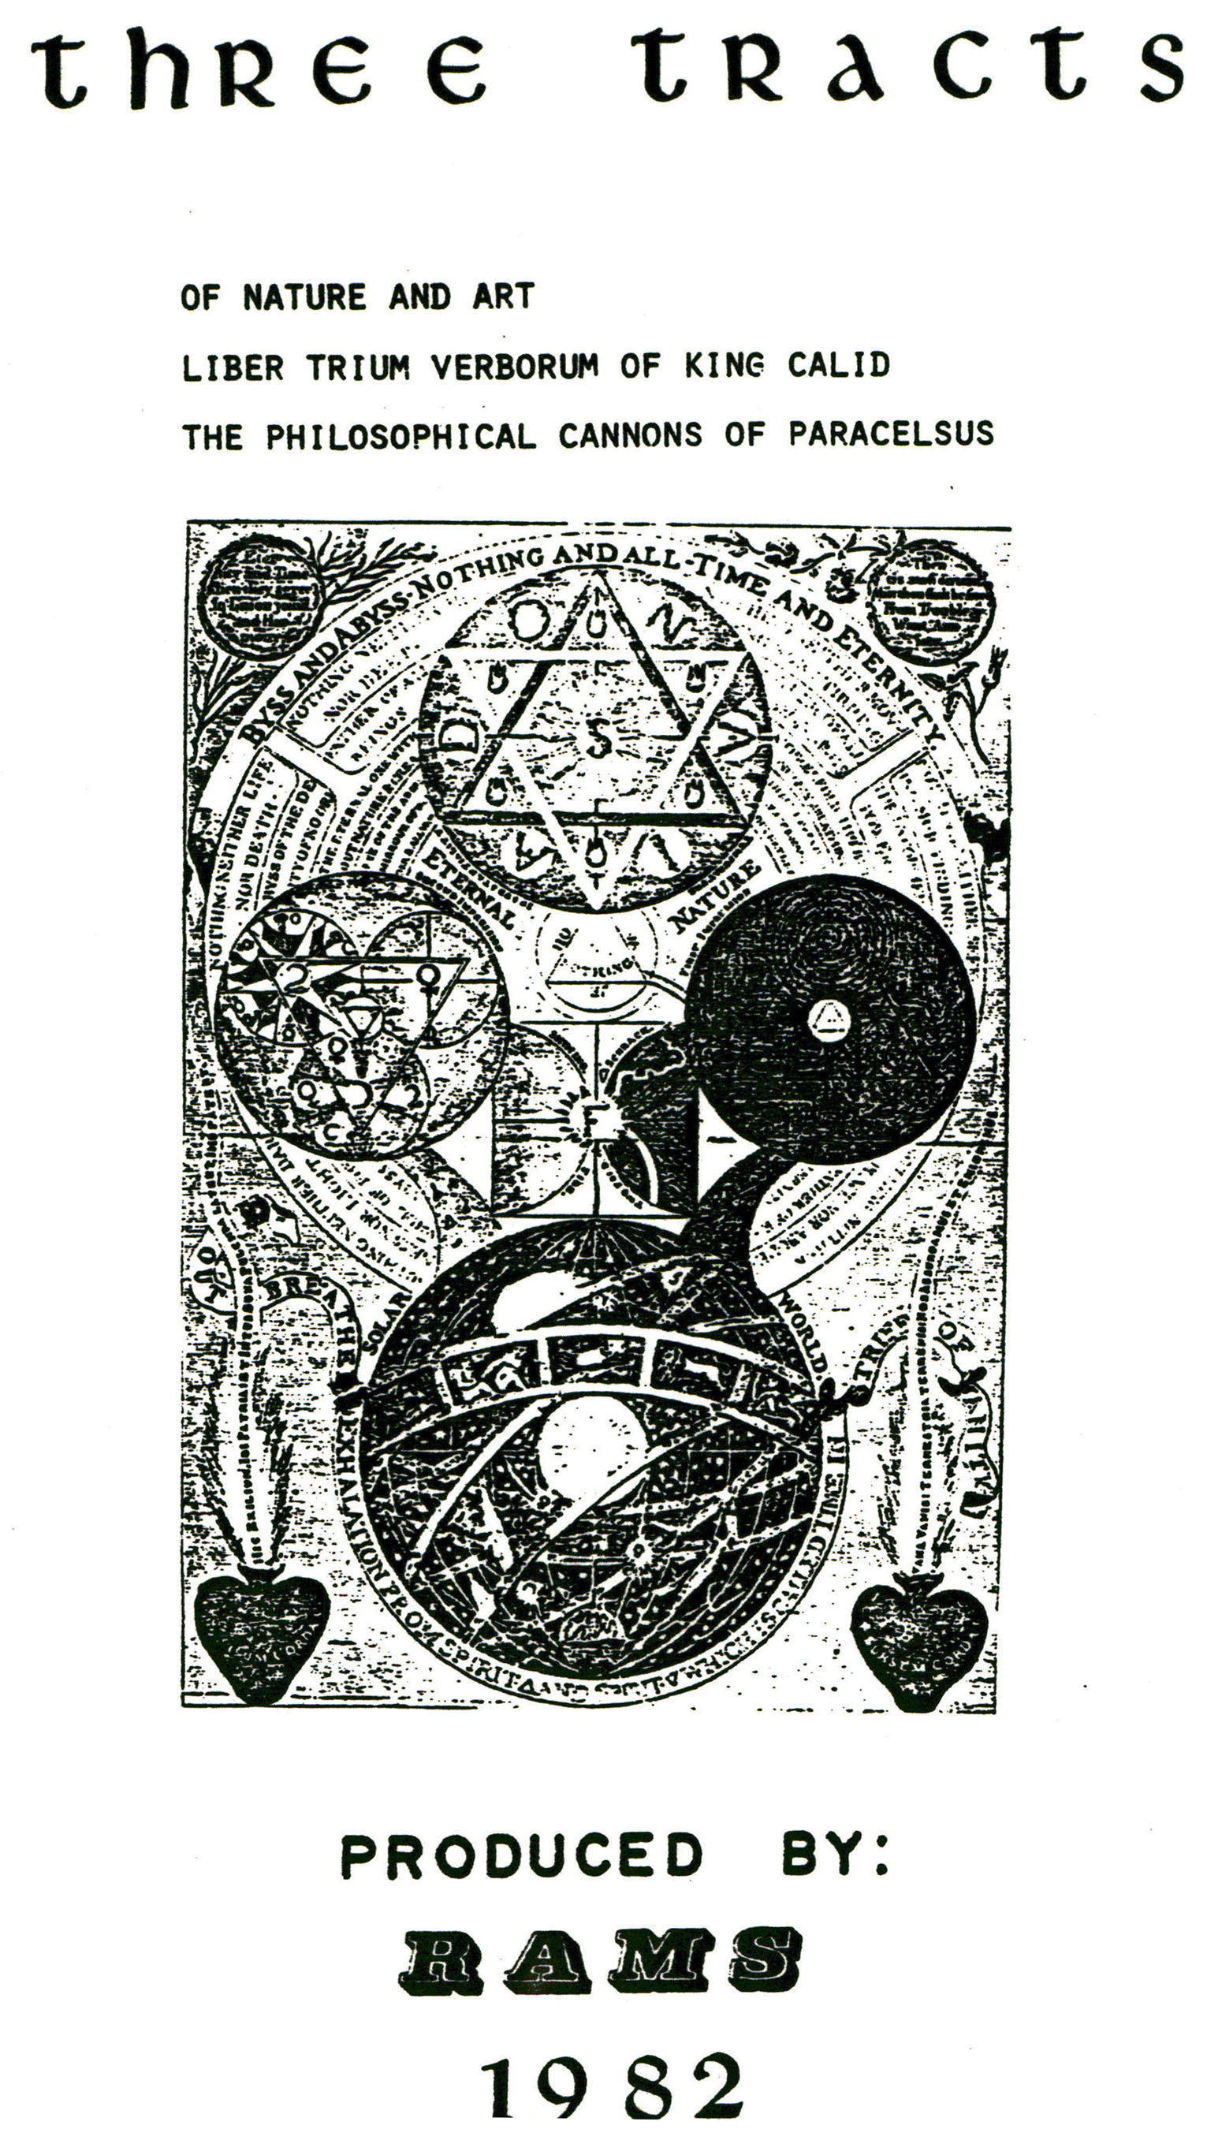

LIBER TRIUM VERBORUM 0F KING CALID
B. M. Sloane 3506

Of the Quality of ye Philosophical Stone.
The Stone out of which this work is made has in itself all the Colours, for he is White, Red and more Red, Yellow and most Yellow, of a Celestial colour Green and heavy.
In this Stone are the ~ elements for he is watery, airy and fiery and terrestrial. In this Stone the calidity and siccity is in occulto and the humidity and frigidity in manifesto, therefore we must hide the manifest; that is we must make manifest that what is occult, for that what is occult, namely calidity and siccity is oil, and this oil is dry and this siccity Tinges and nothing else, for alcali tinges and nothing else. That which is in manifesto, fridgid and humid is a corrupting aqueous fume therefore it is fit that the frigidity and humidity be equal with calidity and siccity, also that they fly not from the fire for betwixt frigidity and calidity is one particule which is hot and dry thereforethe frigidity and humidity must receive the calidity and siccity which was in occulto and be one substance for that humidity and frigidity is a corrupting substance of which it is said that the aquose and adustibe humidity corrupts the work and tinges it into blackness, and this infirmity must be destroyed by fire and by its gradus.
Of the Property of the Stone.
This is the book of the 3 Words, the book of the precious Stone who is an airy volatile frigid and humid aqueous and adustive body, and in it is calidity, siccity, frigidity and humidity another

18.

virtue is in occulto and the other in manifesto. Also that which is in occulto be made manifesto and that which is manifest may be made occult by the virtue of God and by calidity, for the Persian Philosopher says that frigidity and aqueous and adustive humidity is not amicable to calidity and siccity for calidity and siccity destroys the humid and adustive aquosity by divine virtue and then the Spirit is transmuted into a noble body not flying in the fire but like an oil which is a living multiplicative Tincture everlasting and a precious Sol.
Of the Occult Calidity and Siccity exerting in Humidity and Frigidity.
The wonderful work of the 3 Words is the work of the precious Stone in which the aquose and adustive humidity and frigidity and in the same the occult calidity and also that what is read of the three Words is by some otherwise understood that all people might not understand the cause in the 3 Words this is sought in humidity and frigidity in which is the occult calidity and siccity, and that we must know that we may make of the manifest an occult, and an occult of the manifest, and the occult is of the nature of Sol and fire, and it is the most precious oil of all occults, and a living Tincture and a permanent Water which lives always, the Vinegar of the Philosophers, and a penetrating spirit, and it is a Tinging and revivefying occult, which rectifies and illuminates all dead things, and makes them rise, and then its calidity and siccity does not fly from the fire but the aquose and adustive frigidity flys from the fire and destroys itself.

Of the Conversion of the Spirit into a Body and the Body into a Spirit.

That we may make all manifest namely the occult into a body and

19.
the body into a spirit then a friendship is made betwixt the frigidity and humidity, calidity and siccity. Therefore the Persian Philosophers say that it is a wonder how it should be but by the Power of God it can be with a soft temperament and moderate gradus of fire in the space of 2 and 7 days, for of 3 two are understood, and of 2, 5; but 3 is not understood and these are the 3 Words precious occult, and apart, given not to ungodly infedels but to the poor, from the first to the last man.
Of the Planets and their Images, and of the Operations existing in Mercury.
I say that in Mercury are the works of the Planets and their Images in their own places and the work in their own times for in the FIRST MONTH in the womb when the sperm is received by the matrix, then Saturn operates, congealing by its frigidity and siccity, the matter into one mass.
In the SECOND MONTH Jupiter operates digesting by its calidity into a fleshy mass which is called E~nbrio.
In the THIRD MONTH the mass operates and by its calidity and siccity divides, sequestrates the mass and divides the members.
The FOURTH MONTH Sol like a great Lord imznettes the spirit and gives life.
In the FIFTH MONTH Mercury operates who makes the holes and spiracles.
In the SIXTH MONTH Venus disposes and ordains the eyebrows eyes and such like.
In the SEVENTH MONTH Lunar by its frigidity and humidity operates to bring forth the Foetus and if it should be born then it is debilitated.
In the EIGHTH MONTH Saturn operates again, by its frigidity and siccity constraining or constricting the foetus and if it is born then it could not live.

20.

In the NINTH MONTH Jupiter works again and by its calidity arid humidity nourishes the foetus arid when the 9th. month is complete then the foetus is born and lives, and there are three Words, the Water preserves the foetus for three months, as also for three months who makes also the blood in the navel and condenses the same after the birth into milk, for the infant can not be born before the aireal flatus are gone.
Of the Observation of the Planets in the Work of Alchemy.
From this 3 months you must with acute ingenuity compose and extract two for two are not three understood, therefore all who intend to understand this Art, must sharpen their enginuity to open the Treasury of these 3 Words in which is hidden the whole operation and power of the Stone, in which is the Calidity and Siccity, which siccity in a living Oil and a living Tincture and is a tinged siccity, and a profundity of tinctures and this is the conjunctive calidity and humidity, and all from the Beginning seeing this Word, did not know it, and they who heard of the 3 Words did much wonder and the position is this:
From the beginning of conception till the nativity of the infant, every planet in his place shows an image by the divine power, Creating it also. And I Rackadebi say, and it is true, that in all chemical works every planet in his place shows an image till the compleatment of the operation, and then Alchemy is born artificially, but this is truly generated naturally according to the planets, like God did show to the first man, having naturally the nature of all Tinctures, and also Mercury is born having in him the 4 elements and the nature of all Tinctures, according to his gradus and in this work of Alchemy many err and few come to an end for in this work is the DANCE OF THE MOON AND THE CIRCLE OF THE SUN TO THE 3 GRADES, the first weak, the second strong, and the third perfect, and THE THREE TERMS, the first when Sol enters

21.

into Aires and is in its exaltation, secondly when Sol is in Leo, the third when Sol is in Sagitarious; but the circle of the Sun is of 28 years, in 19 years in his mines arid other tables of Alchemy Chimia is compleated; for by the number of the dances of the Moon we find the grades and from one in two grades, CLXIII till XXIV and we find in the circle of Sol 7, Understand for by this gradus the work of Alchemy is compleated.
The Exposition of the Three Words.
Let us come again to the Exposition of the 3 Words in which the whole Art of Alchemy consists, it is said that the water preserves the foetus in the matrix for 3 months, the air for 3 months, and also the fire for three months, and this is said for the Mercury by similitude, and this obscure word and term is opened to understand the truth, for there is another nature in a child bearing woman and another in Mercury, but by similitude of the heat which is found in the matrix the fire is attained (estimated) who is of 32 gradus. Therefore that third word is obscure of which is said that the fire PRESERVES, and many feel in this, for of the 3 take 2 gradus, and out of this 2 gradus, the other are extracted in 32 patiently, and in this gradus is all the Third Word explained of which is said that the first gradus compleates the Water, and Air the second gradus, compleates all that we have said and this is the gift of God.
Of the Gradus of Fire.
The Philosopher of the King of Persia and the Roman Prince says:
Also divide the 3 Words in 2 parts and this 2 parts divide again in 2 parts. And over this 2 divide 32 grades, which are the terms of fire, and are called the particles of fire, this is found in the portion of the work which is divided into 32 parts, and are

22.

called Almes (?). All this gradus are spread over the 2 first parts which are 2 terms and the 32 gradus are packed into 14. parts the first gradus is the particle of fire one albechir, and is (one) and only simple and is most none, and it is a gentle fire, and with that fire we begin to comprehend the Mercury to the Red and also 2 words are compleated in 6 maenchen, after this the 3rd. word is explained which is obscure and in which many feel and lose their senses, the Persian Philosopher says:
Let us divide this in the middle, the mediate is of 3 maenchen and this mediaty is governed by 2 gradus which are two particles of fire and also are compleated this work in 22 maenchen and this is the first term without any error, the second term 16 maenchen and is governed by 8 gradus of fire, and the third term is of 20 maenchen and is governed by 16 gradus that is particles of fire. the fourth term is of 24 niaenchen, and is governed by 32 gradus go fire, Adranus and all the Persian Philosophers say by God and his Holy Name blessed, for this is said of the temperate fire over the 3 words, of the nature of a child-bearing woman, to the comparison of the fire of Mercury. All these two terms are divided in the middle for they are both 32 maenchen and are 7 dierchen and in the end of the first term open the treasure and project what you find, which if it dances and smokes over a hot plate, then it is not enough, therefore bring it to the fire of 16, which has in it 8 gradus of fire, open again the treasure and put it over a red hot plate, and if it dances and smokes it is not enough, therefore bring it to the fire of 20 which has in it 16 gradus, open again the treasure and if it smokes still it is not yet boiled, bring it therefore to the fire of 24 maenchen and 4 dierchen which has in it 82 gradus of fire and now you will have a precious fusible Stone, golden and red. In this hour let God be blessed, and his Holy Name which is blessed above all names, because of this Holy Gift.

Finis.

