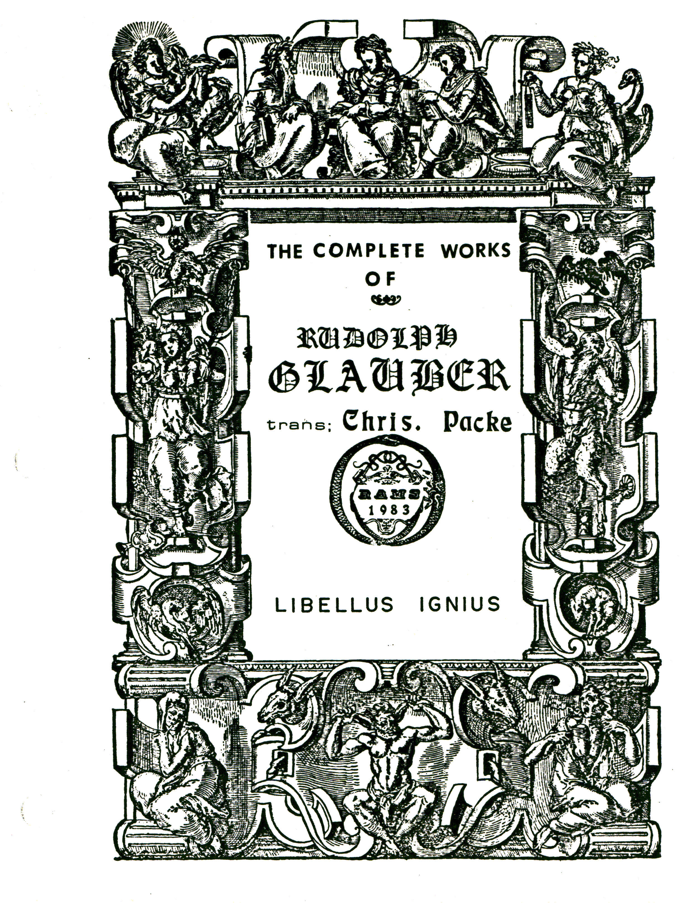

LIBELLUS IGNIUM,
OR
BOOK OF FIRES

In which is Treated of strange and hitherto unknown FIRES, to what end they serve, and what great Profit may by them accrue to Mankind.

Translated out of the HIGH-DUTCH.

[previously pp.430-442]

Beloved Reader,
That which hath moved me to write this small Treatise of SECRET FIRES, with their great Operations, hath been only this, viz. Because GOD ALMIGHTY hath commanded us not to hide our Talent in the Earth, (like the Unprofitable Servant) but to improve and augment it, as we may see in the 16 Chap. of ST. LUKE. Seeing therefore that the most merciful GOD, hath revealed those high Secrets to me, in this my great Age, makes me judge that such great gifts of GOD, have not been discovered for my sake only, who by reason of my great Age have, as it were one foot already in the Grave; but that I might make known such wonderfull Works to the World.

Of the first Fire, and its Profitable use.

How to make a Lamp, which being closed up in a Glass, may be made to burn continually by its own virtue, and give light without any other help.

Of the benefit of this Lamp.

Such a Lamp may serve all those who love to see light, as the
Image of GOD; and may also be very available to those who by reason of continual Weakness are forced to lie much upon their Beds; which they may keep continually burning in their Bed-Chamber, not only because of its clear shining light, which doth neither smoke nor scent, like all Other Combustible Lights, which scent is very prejudicial not only to the Sick, but also to the Healthy, because such smokes offend the Heart and Brain. On the contrary, this Royal Fire is pleasant, strengthening, and refreshing to the Heart and Brain, and its Cotton or Wick is made of incombustible matter, and casts a sweet flavour all over the Room. This secret Fire might also serve the Hermetick Physicans to prepare a Universal Medicine; especially if the sweet refreshing Odour, which proceeds from it in Burning, be received in a Philosophick Receiver, and administred to their Patients, as a great Cordial, renovating, and restorative Medicine.
Although this secret Fire, be of far greater advantage than what hath been mentioned, yet for certain reasons its further use must be concealed. This Fire is appropriated to the Elemental Air, seeing it hath its own Air in it self, by reason of which it burneth in a Glass well closed, and if touched by the least Air, it extinguisheth and goeth out, of which you may see more in the Fifth Part of my PHARMACOPAEA SPAGYRICA.
There is another unknown Fire, which is appropriated to the Earth, because it resembleth a black Earth, and being shut up in a close Vessel of Glass, will keep its Fire perhaps to the end of the World, provided there cometh no Air into the Vessel; but if one would have it a visible Fire, the Glass must be broken that the Air may come to it, so the matter will presently enkindle it self by the Air, and in a short time burneth to a coal, yet without flame or smoke, and at length is consumed, and leaves heavy Ashes behind.

Of the Use of this Earthy Fire.

Although it may seem to many, that this Fire is not fit for any thing, yet I affirm it to be fit for great and weighty matters, which are not fit to mention, much less to make known, by reason of the abuse which may be made of it; this Fire being ten times more forcible than Gun-powder. Moreover, it also plays its part in the Melioration of Metals, for when this black Earth-fire is fluxed in a Crucible, then poured out, and exposed to the Air, it begins to move, and grow as it were living, so that one may see how forcibly it attracteth the Air, fills it self with puffing Bladders like an incensed Toad, continuing such a motion for the space of three or four days, then the matter falleth asunder, and there floweth out of it a red fiery juice, the remainder is dead and unprofitable.
With this red juice, wonderfull things are to be done in Alchymy, not neeessary to be mentioned in this place, because it is my desire only to make known the Wonders of God. But he that will know more of it, let him read the Fifth Part of my PHARMACOPAEA SPAGYRICA, treating of the Stone of the Wise, where he will find how the blood of this Toad doth in few hours draw the Colour of Gold, so that the Body remains white, therefore it may be supposed to be the Chalybs of SENDIVOGIUS.
This Fire is also made of Steel, for when it is touched with a wet finger, sparks fly from it, as from a red-hot Iron which a Smith is forging upon an Anvil. But enough at this time of this wonderfull Earth-fire till another opportunity. RIPLEY seems to have known this Fire, and of it to have prepared his Universal Tincture; his Dream sounds thus, I have seen a red Toad drink so much and so long of the juice of the Grape, till his inwards did burst asunder,& etc.
The third Secret Fire is appropriated to the Elementary water, because it softeneth and dissolveth all hard Subjects; it also radically joineth the different nature of Metals, into wonderfull tinging Stones. Seeing that this Water-fire is of great virtue to the Metals, both particularly and universally, I am resolved (for brevity sake) to make known its virtue in a few cases, the rest will be known by the diligent. First, this wet Fire hath such great virtue, that it can dissolve radically the most fixed Gold, within the space of twelve hours, as also to unite it with LUNA, to volatilise and render it irreducible. Which volatile SOL and LUNE, is no more like unto SOL and LUNE, but in colour, easie flux, form and weight, appeareth like unto black SATURN; therefore the ancient Philosophers, because of its form and similitude, have called it the black Lead of the Wise, and because of its volatility the MERCURY of Philosophers; which MERCURY or black Lead of the Wise may be also per Se, brought into a true Tincture.
Therefore they have all erred, who have taken ANTIMONY for the true black Lead of the Wise. He that will know my sailings in this matter, let him read the Third Part of my PHARMACOPAEA SPAGYRICA, where he will find Wonders, especially how I have cleansed it to the highest degree, and concentrated it into a white Mercurial fusible Stone, which doth shew such virtues in Medicine as are to be admired. This white Stone hath such virtue, that it cureth all diseases, if it be held every morning only a while in the mouth; of which I have treated more clearly in the Fifth Part of my PHARMACOPAEA SPAGYRICA. This true black Lead, which by this humid Fire, is made of Common SOL and LUNE, hath no equality with ANTIMONY nor other common Lead.
What else is to be done in the particular Melioration of Metals, doth not belong to this place, but shall, by the help of God, be declared elsewhere.
The moist Fire hath power to extract all SOL and VENUS out of LUNE, in few hours, if the LUNE be first granulated, and then put into it, without dissolving the LUNE, so that the LUNE remaineth almost as fine as from the Test. The extracted SOL and VENUS may easily be separated from the Water, each by it self, by precipitation, insomuch that the Water retains its virtue, and there is no loss either of the SOL, LUNE, or VENUS. In like manner the allay of SOL and LUNE, by VENUS, may be extracted with ease, in great plenty, and for little charge. Which Secret would be of great use to Refiners, or such as have much Gold and Silver to be parted, as in Mines, & etc.
It is sufficiently known what great labour and charge is required by the common way of parting Gold, and Silver, and Copper, & etc. therefore needeth not to be repeated.

Here followeth a shorter and easier way.

First, if my impure Gold be in great lumps, I granulate it; but if it be Jewels, Rings, or Chains, I only neal them, and therewith fill a parting glass to the third part, then I pour thereon of my cheap and new invented MENSTRUUM, so much as may swim above it a fingers breadth, put a Limbick upon it and set it in a Sand furnace, give fire by degrees till the Liquor boil, and be all gone over the Helm, to a dry Salt. So hath the AQUA FORTIS in the time of digesting drawn to it self all the allay of LUNE, VENUS, or other Impurity, out of the Gold, in form of a green Powder, which remains with the Gold in the Glass. When it is cold, I take it out, of the Sand, and put in warm Salt water, to dissolve the extracted LUNE and VENUS, that it may be poured out of the Glass; which done, I boil it in a Copper Kettle, so the Salt-water extracts the LUNE and VENUS from the SOL, and maketh it fine. I decant the green and thick water from the SOL, and put to it in the Kettle fresh Saltwater, and boil it to extract the rest of the LUNE and VENUS from the SOL. But if this second Water should yet be green and thick, that is a sign that there yet remains more LUNE and VENUS with the SOL; therefore more fresh Salt-water is to be added to the SOL, as before. After boiling, put all the green Waters together, and at last pour upon the Gold only common sweet water, with which boil the Gold to extract the remaining saltness from it, which will leave it fine and shining in the Kettle, as fine Gold used to be, which is to be set upon a small fire to dry, this to be kept as fine Gold. The green Water is to be filtred, so the LUNE will remain behind in the filter, which is to be dried, and mixed with the common fluxing Powder of SULPHUR and NITRE, and being melted will be reduced to the finest LUNE. Boil the green filtred Water in an Iron Pot, so all the VENUS will settle to the Pot bottom, which is to be edulcorated with Water, and being mixed with the above named fluxing Powder, and reduced becometh the finest VENUS that can be seen with eyes. By this means I do not only find all my SOL, LUNE, and VENUS, but also an increase of the SOL, the reason of which increase proceeds from my AQUA FORTIS, which is a graduating Water, and of a meliorating nature and property; which encrease indeed is not over great, yet it pays for all the charge of Coals and Labour. This work may be performed in the space of twelve hours without any loss of SOL or LUNE; which differs greatly from the tedious vulgar way of separation, which is very labouious and costly, besides the great loss of the SOL and LUNE. So that ten Marks may be easier separated by my way, than one Mark by the common way.
One great Secret more, above others, which for brevity sake cannot be all inserted here, is this. It is well known to all Chymists, that all Vegetables, as also Animals, by addition of common Water, may be brought to fermentation, and according to every subject, a SPIRITUS ARDENS, of great use in Physick, may be distilled. But how to make such a subtile Spirit out of Metals, I never read in any Authour, nor heard of. But I have found out a way by which great matters may be done, which cannot be mentioned here, let others search after it as I have done, it is not good to cast Pearls before Swine. Yet that the desirous may know somewhat of an Artificial Metalliok Fermentation; I say that out of certain Salts a Water may be prepared, which when it is put upon a compact Metal, that the same by a certain property in the Water, begins to swell up and ferment, like to the fermentation of Wine, Beer, or other vegetable Drinks; and after fermentation, by distilling in Balneo yields an exceeding subtile penetrating Spirit, strong, sweet, and volatile, according to the nature and property of the Metal; which may also by rectification be concentrated and subtilized, like that which is drawn from Wine or other Vegetables, without any Corrosion; so that such a Spirit may be put into the eye without the least hurt, or sence of sharpness, (See the Sixth Part of the PHARMACOPAEA SPAGYRICA) Therefore it may easily be concluded, that such a Metallick Spirit may effectually be used in the most difficult diseases. But those Spirits are not only highly profitable in Medicine, but cannot also fail to shew their effects upon Metals; for I have already experienced thus much, that the Spirit of SOL doth in few days graduate Common MERCURY into SOL, in like manner doth the Spirit of LUNE and JUPITER graduate MERCURY into LUNE; other Spirits of Metals I have not yet tried. And although many may think to force such a Spirit out of Metals as is drawn out of Vitriol, yet they err, because every Vitriol distilled per se besides the Phlegm, acid Spirit, and heavy Oil, yields also a volatile Spirit, which may be very much subtilized by rectification, but it hath no comparison at all, nor likeness with my new invented volatile humid Spirit of Metals; because the above mentioned volatile Spirit of Vitriol, consisteth only of a subtile salt Spirit and spiritual Sulphur, which may sufficiently be demonstrated. For when such a subtile salt Spirit of Vitriol stands, a while in a Glass close stopped, the volatile Sulphur of the Vitriol sublimeth it self to the top of the Glass, and congeals it self in the form of common yellow Sulphur, and the humidity remains in the Glass like an insipid Water, without smell or taste. Therefore the volatile Spirit of Vitriol now a days prepared, is to be esteemed for nothing else but a volatile Spirit of Sulphur. In opposition to which my Metallick Spirits, especially those of SOL or LUNE have no combustible matter in them. Also the Spirit of Vitriol is yet corrosive, which the Metallick Spirits are not.
Therefore let no man think that my invented Spirits of Metals are of the same nature with the sulphureous Spirit of Vitriol, Allom, or common Salt, or the like, but let it be esteemed as a new-invented high Secret, the like of which was never yet known to the World. He to whom God shall please to reveal how these Spirits of Metals may again be brought into fixed Bodies, such a One may well esteem himself happy. Seeing that such a Spirit being yet fugitive, can mortifle running MERCURY, and transmute it into SOL. Also know, that our secret Salt water hath power to bring other Subjects into fermentation: As for example; if I was willing to bring Tartar again into fermentation, to try what Spirit it would yield, I dissolve it only in fair water, and put to it a little of our Universal ferment, so will the Tartar presently begin to ferment and work, and yields a wonderfull volatile Spirit, which is not to be had by any other way. Here I will add only one thing by way of history; namely, what happened unto me once, When I joined a little of this ferment with some Urine; that the same did presently begin to ferment, and yielded a most dreadfull scent, so that I was necessitated to carry the Urine out of the room, the smell was so offensive, that it enfeebled my Heart and Brain; and in the distilling, yielded a scent far worse than the purefying of any dead carcasses of beasts, at last I forced over all the unpleasant Phlegm, took the CAPUT MORTUUM out of the Glass, and distilled out of it a strong Corrosive Spirit, with which I did dissolve SOL and LUNE. But what is further to be expected from it, time will shew me. There came also with the strong salt Spirit, a red Oil of Urine, not strong.
To enlighten the former discourse, there remains yet something to be said, namely this: That the before mentioned Spirit of Metals may be handled in all respects like the burning Spirit of Vegetables, which is distilled from Vegetables fermented; in rectifying, the most subtile Spirit cometh over first, and the unprofitable Phlegm remains behind; and the oftener this rectification is performed, it is the more pure, subtile, strong and pleasant, so that the virtues of all other Vegetables, some of this Spirit being poured upon them and digested, may be extracted, and separated from their gross faeces, by separating the Spirit of Wine in Balneo, so the virtue of the Herb, Root, or Flower, will remain in the Glass; of which one only drop hath more virtue in Medicine, than a whole handfull of the herb from which it was extracted; yet the Spirit remains good, and is always proper for the like occasions. But if one desireth no extract, but only a Spirit of Vegetables, strong and forcible in its operation, then must the Spirit be put upon fresh well scented cordial Herbs, Roots, Flowers or Fruits, digesting them together, then abstracting the Spirit again, so will it be much stronger, subtiller, and of a more refreshing smell than before. Thus in like manner can we do with our Spirit of Metals, and make it as strong as we will, by putting the same upon fresh Metals, and letting them ferment together, then abstracting, and so fermenting and abstracting, whereby it always grows stronger and stronger, so that afterwards greater things may be done with it both in Medicine and Alchymy. If then the simple Spirit of Metals doth wonders in Medicine and Alchymy, what will not this doe, that hath three or four times its strength? Consider of it, enough to the wise. The Spirit of Metals thus made we esteem for the true AQUA VITAE or VINUM SALATIS of the Ancients, and no other made of Vegetables. Take notice also by the way, that our Ferment doth not lose its virtue in distilling, but serveth always for the like Works, to wit, the Fermentation of Metals.
Seeing that our Ferment is a volatile Salt, after Fermentation the subtile Spirit is abstracted, and the Phlegm received by it self, so at last riesth our Ferment with a stronger Fire, and leaves the mortified Metal as unprofitable faeces. So that the Ferment being once had, it may be often used, yet it is somewhat diminished every time by sticking to the glasses, yet not being costly, the loss may be easily born, so that there needs never be no want of
it. This is indeed a wonderful], subtile metallick Wine, Of which I had once a Vision about thirty years ago (with these words:
EX FECE, DE FECE, DEHES(?) CARPERE VINUM TUUM,) yet I knew not the signification to this time. I have had much thoughtfullness about it, yet all in vain, until God was lately pleased to shew me the way of Preparing such Wine.
If I should write all things which may be done with my new-invented Fermentation out of Vegetables, Animals and Metals, I should have work enough for a great Volume, and as it were bring forth a new World: But let this suffice at this time.

Next followeth the fourth Secret Fire of the Wise, to perfect an Universal Medicine both for Men and Metals.

That the ancient Philosophers did make their Universal Medicine, not out of one Subject only, is clearly to be seen out of their Writings. And as their Subject was divers, so have they also used several Fires to decoct their Subject; for some Subjects, as fixed SOL and LUNE, they have made volatile by their humid Fire, and again made the volatile fixed by means of the known fire of Wood and Coals. Therefore have they so positively affirmed, that without common Gold and Silver, no true Medicine for the Metals can be made. And this, by reason that other Subjects were yet unknown to them; and they knowing no better, thought theirs to be the only way by which the Universal Medicine could be made. But others have wholly rejected SOL and LUNE, saying they are dead, and that one should beware of them; but that their SOL and LUNE were living, and that no commonly known fire could ripen them, that a far other fire is required for that purpose; these and the like contrary Writings (although they are both true) have confounded the Searchers, so that one esteemeth one Writer and another, another, and yet are always doubtfull, after which Author they should work. PONTANUS confesseth that he erred two hundred times, although he wrought in the true matter, and should never have understood if he had not read the old Philosopher ARTEPHIUS, and of him lernt the Secret Fire. He describes also the Secret Fire in the same manner, which ARTEPHIUS doth, to wit, thus: OUR FIRE IS NO COMMON FIRE, IT IS ARTIFICIAL TO FIND OUT, IT DISSOLVES, DESTROYS AND PENETRATES ALL THINGS; IT IS EQUAL, CONTINUAL, AND CONSTANT, BURNING WITH OUR GLASS, AND NOT WITHOUT, & etc. Our Subject is also no common SOL or LUNE, but as yet an unripe Mineral, on which Nature hath but began to operate. All they who have wrought in such unripe SOL and LUNE have also of necessity known this Secret Fire, Or else they have failed, and could accomplish nothing. Some have known the volatile Gold, as also the Fire belonging to it, and yet could not come to work with it; the reason was, because they as yet wanted the instrument belonging to it, because if a volatile matter be to be ripened in an open Glass with a flaming fire, it is impossible but that the volatile MERCURY should fly away; and if a Receiver were applied to receive the volatile Spirit, then by that means the Fire would be stifled and go out. Here is good counsel at a dear rate, but the discovery of the secret Vessel maketh all cheap again; for without the knowledge of this Vessel, little is to he done. Is it to be an Universal Work, so must it also agree also with the Universal Work of this world? We see daily how that the warm Sun causing its beams to descend downwards upon the Globe of the Earth, causeth all Vegetables to grow and multiply, and not only Vegetables, but also Animals and Minerals, as PLATO witnesseth in these words: THE SUN AND MAN GENERATE MEN. So that the oftener the beams of the Sun doth draw up the moisture of the Earth, and let it fall down again in Rain, by so much the more it maketh the dry Earth fruitfull, by which means the Fruits of the Earth sprout forth faster, ripen, and multiply: because the moisture when drawn up in the day-time by the Sun beams, always leaveth behind it its fruitfull Salt, which it had attracted from the Air; in the bowels of the Earth, and is still again impregnated with the influences of the Heavens; for without the Air, nothing can live, encrease, or multiply, the which HERMES TRISMEGISTUS hath very well given to understand, when he salth all which is above, is also below, by which wonderfull things are brought forth; the Sun is its Father, the Moon its Mother, the Wind carrieth it in its belly, the Earth hath conceived it and brought it forth, and is its nurse, by continual ascending and descending it hath obtained its force, and its virtue is compleat, when it is transchanged into Earth, & etc. Here HERMES gives sufficiently to understand, that the volatile matter of the Stone is elevated from the bottom of the Vessel to the middle region of the Air, and must again descend to the Earth, that by its continual ascending and descending it may be made to live and encrease, as it is in the great World. But how to make this ascension and descention as it is and ought to be done in the Philosophick work, is not permitted to be divulged; but it is more than enough to discover and assure that in such a secret Furnace and hidden Fire, the volatile Gold of the Wise may be ripened into a living Medicine,
AMEN.

Here should come in a small Treatise, entitled,
THE EXPLICATION OF SOLOMONS WORDS: viz.

In Words, Herbs and Stones, there is great vertue. But who this SOLOMON was, is altogether uncertain; and the Treatise it self consisting of nothing but fabulous Stories of divers Events, which followed upon the speaking of certain words at divers times, and upon divers occasions, and containing nothing (as I conceive) that will be usefull either for a Christian, or an Artist, I think fit to leave it out; and more especially, because this Treatise is wholly foreign to the Authour’s knowledge and experience, but taken upon trust (as to matter of fact) at random, and from others, which is disagreeable from all the other Writings of the Author. All that I think worth the Translating is somewhat relating to the Colouring of Glass; which take as follows.
With one pound of pure Glass, mix about a dram of the Ashes of Copper, (or CROCUS VENERIS) and melt them together in a strong Fire, and you’ll find a green Glass, resembling the ONYX-STONE. In like manner also a whole pound of Glass is made like to the fairest SAPHIRE, if a dram of COBOLT or BISMUTH, melted, be added to the SCORIAE or Dross. Likewise one dram of the Rust of Iron changeth a whole pound of Glass in a yellow Stone, emulating an HYACINTH. If one shall melt a drain of the Tincture of Gold, or of the Philosophers Mercury, extracted from Gold and Silver, with a pound of Glass, that Glass becometh very red, like a RUBY in colour, as I my self have found. But if any shall be so fortunate as to make this Glass hard, as well as of a beautiful], colour, he will need to take but little pains for his living.
There is a short Discourse adjoined to this, called, THE QUINTESSENCE OF METALS; but whatsoever is mentioned in that, is contained in the Fifth Part of the PHARMACOPOEA SPAGYRICA, Book of Fires, Book of Dialogues, & etc.

The End of the Second Part.

