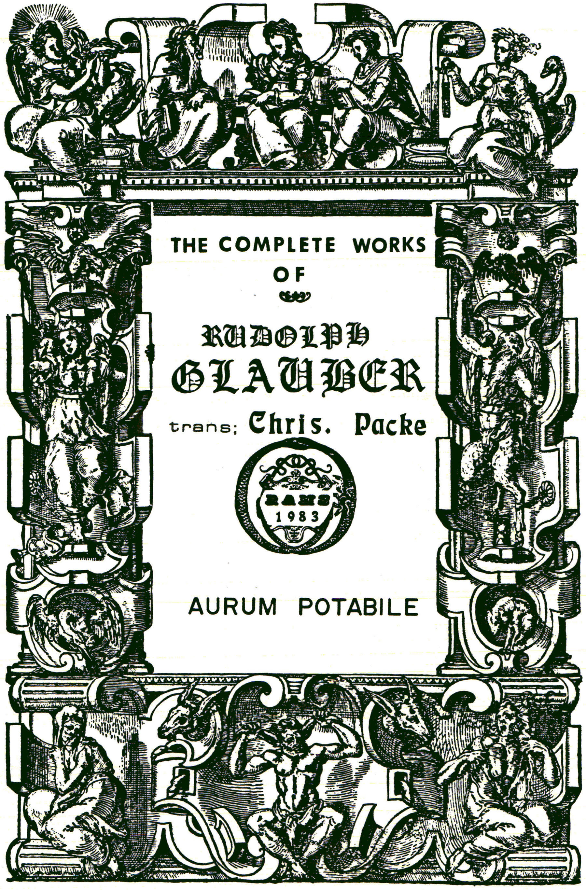
OF THE TRUE TINCTURE OF GOLD ,
Or the True
AURUM POTABILE

What is is, and how it differs from the false and sophisticated Aurum Potabile: How it tis to be Spagirically prepared; And how to be used in Medicine.

Of Aurum Potabile.

There is no man that can deny, that the true and ancient Philosophers did study long life, and the conservation of their health. Whence it came to pass that they did diligently seek out the subject of preserving health, and prolonging life; wherefore by the help of fire they did practise the separations, and proofs of all vegetables, animals, and minerals, seeking out their powers and virtues: Who found out the greatest harmony of all things as well in the heavens, as on earth, betwixt the Sun, Gold, Man and wine. For it cannot be denyed, that the life of all things proceeds from the heat of the Sun; wherefore they sought to unite gold the terrestrial sun or body fixed and perfect, caused by the rays of the sun, with man by the help of spirit of wine.
But haply there will be some, whom this my narration may offend denying that gold is the Son of the sun, or a metallick body fixed and perfect, proceeding from the rays of the sun; asking how the solary immaterial rays can be made material and corporeal? But they are very ignorant of the generation of metals, and minerals. And although I am not now resolved to write of the generation, and original of metals, yet endeavouring to demonstrate that there is a vivifying power of the sun to be found in gold (destroyed and volatilized) and to be prepared into a most wholesome medicine for man, I will not omit for the sake of the ignorant and incredulous, to demonstrate the truth by one or two examples, which although I could demonstrate by most certain and firm reasons, yet for brevities sake I am now resolved to omit them, recommending to the searcher of the Nature, and propriety of metals, my treatise DE GENERATIONE METALLORUM, which without doubt will take away all scruple from him; objecting only against him that opposeth the truth, two questions and reasons which are to be confuted: and the first is, whence comes that increase of both the quantity and quality of any viscous, mineral liquor, that hath been exposed long to the Sun in an open glass vessel? Whether from the Sun, or elsewhere? But thou sayest, that that encrease comes from the air, the vehicle of all things. I answer, if from the air, whether was not that air impregnated by the Sun? And whether there be any thing in the air, which is received not from the stars? But place this liquor in a cold Cellar, in a moist air, and thou shalt by experience know that no weight is added thereto, even as in the Sun, or (in his stead) fire: that Liquor will draw some phlegmatick moisture which will be easily separated by heat, the weight of the former liquor being left. This may be shewed by this Example:
dissolve some sulphureous metal, as Iron, Copper, or Zinck, with any acid spirit, and at length take away the spirit, make the remainder red hot; yet not too much, but as much as sufficeth to take away the spirits, which afterward (its weight being observed) put in a crucible on the fire, but take heed lest the metal run over, but at length let it darkly glow with the crucible, for the space of three or four weeks, which done, take it away again, and weigh again thenietal, and thou shalt find the evident encrease of the metal, which thou shalt perceive more evidently by this way, as follows: Put copper, or some sulphureous metal, with 16 or 18 parts of lead in a well burnt cupel; made of the ashes of wood or bones, in a tryed furnace, (the weight of the cupel, copper, and lead first exactly observed) and cause the copper to evaporate by fire with the lead, which done, take the cupel when it shall be cold, and again weigh it, and thou shalt find it far more weighty, so that its weight (though much of the lead goes into the air in the cupellating) not only exceeds its former weight, but also of the copper and lead by the said cupallation; therefore it is justly demanded whence this Encrease proceeds, whether the heat of the fire was not coagulated into a metallick body by means of that melted metal? Therefore it Is probable, that it you knew the metallick matrixes in the surface of the earth, in which the beams of the Sun and heat of fire being received, may be coagulated, metals may as well be generated in them, as in the bowels of the earth.
But thou repliest it is probable the heat of vulgar fire to have something metallick In it, which comes by attraction of the melted metal in the Cupel, but not in the Sun beams.
He that will thus try the truth, let him put a cupel very well burnt in the beams of the Sun, together with copper and lead, to which let him apply a hollow Looking—glass, so that it may be operated upon by the Sun—beams, gathered into a center, and may thence be made hot: But thou must continually hold the Looking-glass in thy hand, that thou maist turn or direct it to the Sun, according to the course thereof, lest the cupel wax cold, the beams of the Sun being turned away, but if it be rightly observed, the work shall be done no less than in a furnace of fire with glowing heat.
You must have a Looking-glass at least In diameter two feet, nor must it be too deep; but be in depth the 18 or 20 part of the globe, that so it may the further cast the beams: it must be very artifically smoothed, that it may more exactly gather the beams to the center. Now the preparation of these burning—glasses is not of this place, but in the fourth part of our Furnaces, where we have taught not only how they are to be made of metals, but also of glass, and how polished and used.
This demonstration, which might be otherwise omitted, is therefore set down, that it may be known how gold proceeds from the Sun, and is secretly endued with its proper strength and proprieties, by Chymistry, reducible into that which it was before its coagulation, namely, into a heating and living spirit, communicatIng its strength and faculties to man’s body. Therefore the Ancients used great diligence in the reduction of gold, in which nothing is found more excellent than the purest and finest spirit of wine made by distillation, and they did not use common gold melted out of stones, or washt out of sand, but purged by benefit of fire, and Philosophically quickened, and unlocked, not by help of corrosive spirits, the usual way of vulgar Chymists, but by some water which Nature freely gives without help of violent distillation; by which they manifest that which is hid in gold, and they have hid what is manifest, and therefore they have made It fit for the separation of its tincture from a gross and black superfluous body. For they knew that the compact body of gold hath no affinity with the vital Spirits, therefore they have chosen only the finest part of gold to their Elixir, viz. its tincture, which they have radically joined with the spirit of Wine, and being joined, have made them spiritual or volatile, so that neither can be separated from each other In the fire, and being in the fire, are sublimed, or fixed by a longer digestion, and coagulated into a fixt stone, which they count for the greatest treasure in the World. Therefore the ancient Philosophers affirming, that there is not a better medicine under the Sun than it, which is made from the Philosophical union of wine and gold, both by an inseparable recoag— ulation and fixation; nor without gold can spirit of wine, nor this without it be made a medicine, because gold without spirit of wine cannot be made volatile, nor this be coagulated and fixt without it. We therefore, their Posterity justly, follow the opinions of the most famous men, not for their authorities sake, but for ocular demonstration, which is the truest tryal.
Therefore the knowledge of the preparation of this medicine being bestowed on me from the highest, I have intended, because a man Is not born for himself, briefly to deliver its preparation and use: but I will not cast pearls before swine; but I will only shew the way to the studious searchers of the work of God and Nature, who doubtless will understand my writing, but not the ignorant and unskillful; let therefore the brevity of the preparation offend no man, because I mean not to prostitute this Art (divinely obtained, not with idleness, but with much watching, labours and pains) nor give to the unworthy a bit before chewed, but only to communicate it to the pious, who shall see with open eyes, that the thing is so. I desire therefore, the simplicity of my style may offend no man, being not adorned with rhetorical figures, after the wonted manner, for truth wants not many and elegant words, being contented with simplicity and brevity, with which it is easier and better demonstrated, than with those intricate and sophist— ick discourses.

Rx. of living gold one part, and three parts of quick Mercury, not of the vulgar, but the Philosophical every where to be found without charge: and labour, (thou maist also add living silver of equil weight with the gold, and indeed better than only gold, for the greater variety of colours proceeding from the mixture of male and female: but one perswaded that a better Tincture proceeds from gold alone may mix gold only, not so, one skillful of metals, who knoweth the power of the cordial union of gold and silver, dissolved in one and the same MENSTRUUM) put them mixt in a Philosophical vessel to dissolve, and in the space of one quarter of an hour, those mixt metals will be radically dissolved by the Mercury, and will give a purple colour; after encrease the fire by degrees, and it will be changed into a very fine green, to which taken out, pour the water of dew to dissolve, which may done in half an hour, filtre the solution, and abstract the water through a glass alembeck in B. which pour out again afresh, and abstract, which do three times, in the mean time that greenness will be turned into a black colour, like Ink, stinking like a carcass, and therefore odious: and it behoves sometimes to take away the water reaf fused and digested, and that blackness and stink will depart in the space of fourty hours, and will produce a pure milky whiteness, which appearing, take away all the moisture till it be dry, which will be a white mass, and in a few hours of a pleasant colour, divers colours first appearing, it is turned into a fine greenness better than the former, to which you must afuiase the spirit of wine well rectified, to the depth of two or three fingers, and that green gold dissolved will draw that spirit of wine, for the great amity, like a dry spunge drawing waters, and will communicate to it a quintessence as red as blood, by which means the greenness is deprived of its quickening tincture, the superfluous ashy body being left.

You must decant and filtrate the tinged spirit, and in a B. by a glass alembick, abstract it from the red tincture, attracting the fiery essence of the spirit of wine, so that they may be very close and inseparably conjoined, from which an unsavoury water only distills, the virtue of the spirit of wine being left with the tincture of gold like a red fiery salt, fusile and volatile; of which grain 1. can tinge one ounce of spirit of wine, or any other liquor, with a blood-red colour, for it is soluble in any moisture; and therefore may be kept in a liquid form for the Panacea of most desperate Diseases. Now I will communicate the properties of the true tincture, by which true potable gold is known. This tincture next to the stone is the beat of all medicines, between which and that, there is but this difference, the soul of gold is volatile, nor bath entrance into imperfect metals, and therefore cannot transmute into pure fine gold, which virtue is attributed to the Philosophers stone. The soul of gold, though it be the best part, yet it is not fixt in fire, but volatile; but the Philosopher’s Stone is fixt in fire, and remains, by reason of alonger digestion. But whether that soul or volatile tincture and red Lyon may be fixt by help of fire, and turned into the Universal medicine, and tinging stone, that I know not, because hitherto I have not tryed, & etc. therefore he may who extracts the soul of gold, make further tryals, whether he can find any thing better. For this work treateth of nothing but the best medicine of gold, but other things I know not.

Therefore the deceit of the Distillers of Wine, and other vegetable waters, selling potable gold, is not unknown, being not ashamed to sell any water coloured yellow or red to the ignorant for a great price. And the error of others dissolving the body of gold in AQUA REGIA, or spirit of salt, which again they abstract to a dry remainder, to which for extraction they af fuse the spirit of wine: Which is not an extraction, but some particular solution of gold, made by help of the corrosive spirits left in the gold, tinging the spirit of wine with a yellow colour, which so coloured, they call their potable gold; which notwithstanding is reduced into gold, the spirit of wine being abstracted, which can do no more than any other Caix of gold, which the ARCHEUS cannot digest, but separates, being indigested, with the Excrements. And also it is the error of others, ignorantly deceiving themselves and others, extracting the Caix of gold with peculiar MENSTRUUMS and spirits, knowing not that the MENSTRUUM af fused to gold to be red of it self by a long digestion, which decanted, they administer instead of potable gold, who if they weighed the remaining Calm, would by experience see that nothing departed from the gold, which you may try by the setting of the spirit or MENSTRUUMS in a remiss heat, or longer in cold, which of it self doth wax red, as if it had been affused to the Caix of SOL. But the cause of this redness is (unknown to them) nothing but a certain nitrous salt and volatile, as of Antimony, Urine, Tartar, Harts-horn, flair, & etc. exalting the colour of any Sulphur.
Wherefore it necessarily follows, if ARTISTS mingle with the spirit of wine in which is a sulphur, such exalting salta, that it will thence be exalted in colour, and wax red; which also happens to them, who use to extract a tincture with distilled Oils, having a volatile salt, as are oil of Lemnions, Cloves, Soot, & etc.
For such like tincture or potable gold is inefficacious, as experience witnesseth. But I would not say there is no other tincture to be prepared out of gold, beside this tincture: for being dissolved in sweet MENSTRUUMS, that it cannot be separated by precipitation, it can do wonderful things in many grievious Diseases; but always the living metal is to be chosen instead of the dead.
But true potable gold is not so only in name and shew (as are divers waters tinged with a yellow or red colour) but also endued with golden faculties and virtues, so that it may actually appear to be made of gold, but irreducible by Fire into Gold, spiritual and penetrative, strengthning the vital spirits, that they may overcome their enemies. But it must also be endued with this Virtue, that It may change imperfect metals, chiefly Mercury, Lead, and Silver into pure gold; not truly like a fixt tincture, tinging with profit the baser metals in flux; but only perfecting particularly in a moist way by digestion, where some part of the metal alone is turned into better. For this tincture of salt or gold is very volatile, so that it cannot resist the fire; but with a gentle heat it melteth like wax, and is sublimed like a red salt, soluble in spirit of Wine, that it may be fit for Physical uses.

Also true potable gold being tasted, is neither corrosive, nor astringent like other solutions of gold; neither doth it pollute the hands, the nails and hair with a black or yellow colour, but rather makes them more fine; neither doth it infect copper, tin,lead, with rust or a black colour, but rather makes them more clear; neither is it a body of gold reducible by extraction, nor into white gold, which may recover its former colour by Antimony, and AQUA REGIA, but it is like an ashy earth, and sublimable in a gentle heat like Arsenick, not enduring the tryal of the cuple, which virtues if it have, it may be called the true Tincture of Gold: but if not, not so, but rather a sophisticated potable gold, not to be medled withal.

Of the medicinal use of this golden Medicine.

We have before demonstrated the sun to be the original of gold, or endued with the incredible virtues of the terrestrial sun. For the strength and virtues of all vegetables, animals and minerals lie hid in it; which cannot be manifested but by a Philosopher, and that by separation, to wit, of the intrinsical and pure parts, from the impure.
This speech will happily seem to thee incredible or not very likely to say that gold Is reducible into a spiritual essence, agreeable to humane nature, endued with the strength of all animals, vegetables and minerals. Surely thou shalt hardly perewade him whom VULCAN hath not made a Philosopher to believe it. But who will trouble himself so much as with sure reasons to decide all Controversies, which if possible, yet for many reasons is here omitted; but for surities sake I will send back the Reader to the second part of our Furnaces, where he shall find how out of Antimony and Sulphur, by a good Chymist, with the help of fire, may be drawn not only the force and faculty of divers vegetables, but also their natural odour; which yet did not appear in them before they were radically dissolved, which if it may be done by any imperfect and fetid mineral, why not also by a perfect and mature mineral?

If we were good naturalists, and very diligent Chymists, then we need not to fill Elaboratories with so many pots and boxes, nor spend so much cost in fetching in so many foreign medicinal species, because without question the strength and properties of all vegetables, animals, and minerals, by an easier way may be found in some few subjects. And as the true tincture of SOL well fixed, is endued with all the virtues of all vegetables, animals and minerals; so also deservedly is ascribed to it the force of curing all diseases; but with a difference. For there are divers kinds of the Gout in hands, and feet, as also of the Stone and Leprosie; which sometimes are inveterate and uncureable Diseases, sometimes new and cureable. Who therefore, not mad, would promise to cure all and every disease indefferently, by any certain medicine? Certainly no man, although he had the very stone of Philosophers.
For oft times the Stone of the Bladder is expelled or cut out, most hard and insoluble by AQUA FORTIS, which not any medicine not corrosive could dissolve; which strength, although they ascribe to their medicine, yet they cannot perform it. Promises therefore do not suffice, which none can perform: for PROMISES BECOME DEBTS, which is observed by few; wherefore by the haters of the Art the truth suffers, and the hope of good success of Chymical medicines dyeth. IT IS BEST therefore TO PERFORM MORE THAN PROMISE, and the work shall praise the workman. How can a Medicine penetrate to the extream parts of the body; to wit, the hands and feet, and dissolve the coagulated matter waxing hard, which out of the Body no corrosive Medicine can dissolve? It is sufficient if a medicine finding a viscous tartareous and salt matter, not yet coagulated, do dissolve and expel it. The like is to be understood of the stone in the reins and bladder. In this manner I will ascribe the curing of the Gout in the hands and feet, the stone in the kidneys and bladder, to my tincture of SOL, as well in old as young; but so that, if need be, specifical Catharticks may be administered, and extrinsecally Bathed for promoting the cure, whereby Nature may the sooner do its office. But above all things, we must not slight Divine Providence: For oft-times God smites us with a Disease incureable by Art, unless Divine wrath be first appeased by BLUSHABLE REPENTANCE, which is the best medicine of all. As also the cure of all Diseases coming of the corruption of the Blood, as the Leprosie, the French Disease, and other impurities; which are taken away by this tincture, if withal Catharticks and Diaphoreticks are administered, cleansing and renewing the blood above all other medicines. This Tincture also takes away all the obstructions of the Liver, Spleen, Kidneys, and other parts, because it warms, attenuates, incides, and evacuates the original of divers Diseases. It also cures all violent and acute diseases, as the Epilepsie, Plague, Feavers, & etc.
It provoketh the Menstrues of old and young, chiefly, if also extransically it be rightly administered: which way many are well cured, who otherwise are like to perish miserably; it warms and cleanseth the Matrix above all other Medicines, and renders it fit to perform its office: It preserves it also from all accidents of STERILITY, and other very grievious Diseases, causing death. It expels the water of the Dropsie, by urine, it rarifieth and dryeth up the superfluous moistures of the internal and external parts, like the Sun drying and consuming waters, by which means the body recovers its pristine sanity: of other diseases to write in particular there is no need, because in all and every one, without difference, it may be used as a general Medicine, in old as well as young. This medicine doth not only restore, but also conserve health till the predestened time.
The Dose is from three grains or drops to twelve or more, but to children 1, 2, or 3, with its appropriated vehicle, or in wine or beer to be administered daily, which Dose may be taken oftener in a day, respect being had to the sick party.

And so I make an end, hoping to haved pleased my Neighbour: for without doubt, who useth this golden Medicine well, shall do well, chiefly lifting up his heart (acknowledging his sins) to God the Giver and Creator of all good, in filial humility, imploring his help and blessing; which the omnipotent God and merciful Father, that he would bestow on us his temporal blessing in this life with sound health, and hereafter life eternal, of His free grace, LET US PRAY, AMEN.

FINIS

