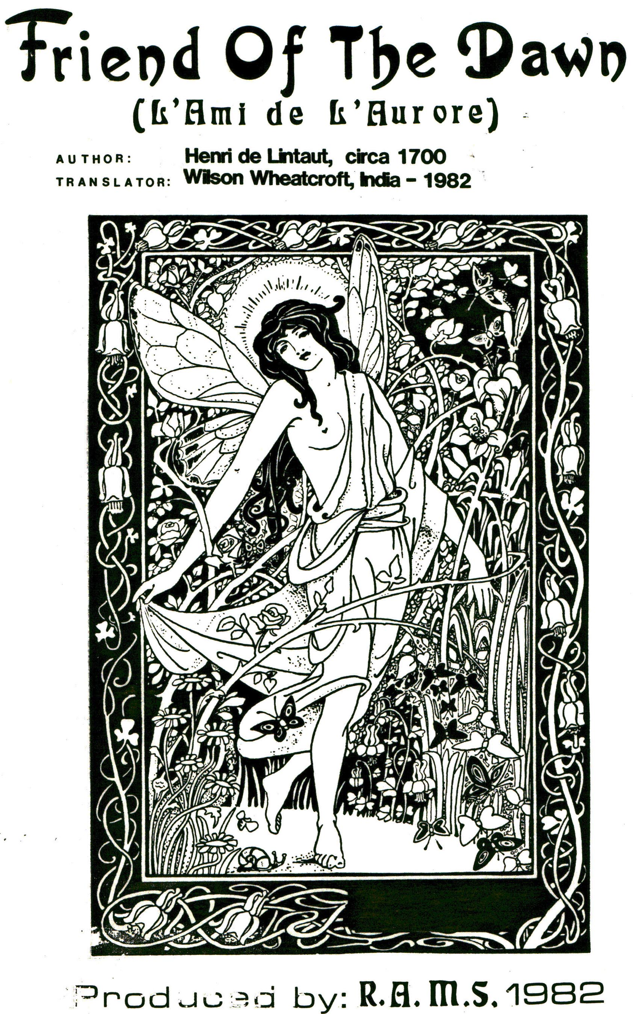

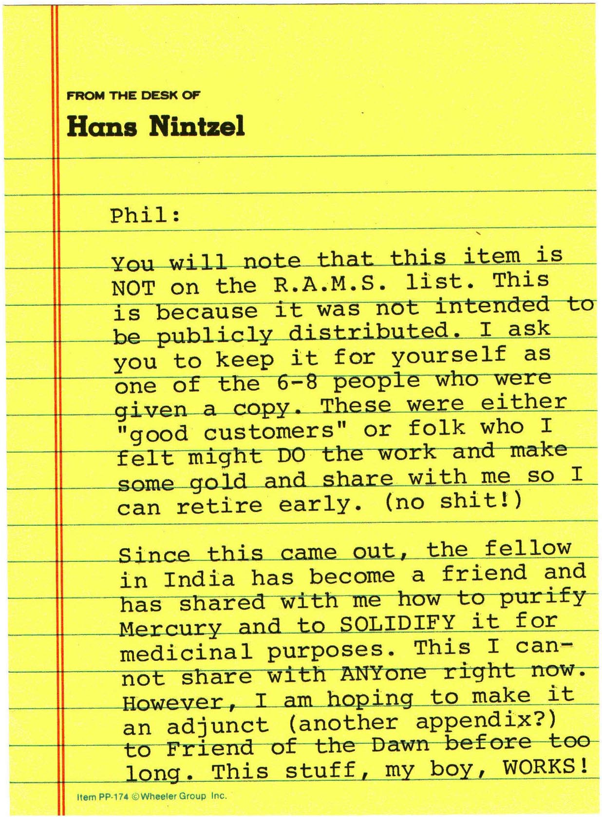

HOW TO MAKE THE PHILOSOPHER’S
STONE USING ANIMATED METALLIC
MERCURY AND
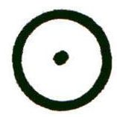OR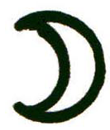
This is a translation of the essential information of “L’Ami de L’Aurore”, (The Friend of the Dawn) by Henri de LinTaut. The book is an “Editions de La Maisnie” whose address was 19 rue Val-de-Grace, 75005 Paris, France. It was published in the 17th Century from a badly damaged, hand written manuscript by Lintaut. It was later republished in 1978 in old
(or Medaeval) French. The original printing is listed in the Arsenal Library under No. 3020.

The later version was found and translated by Dr. Wilson Wheatcroft of Rochester New York while studying in Ganeshpuri, India. He completed the translation in January 1982 and forwarded the copy to RAMS for treatment. My friend Wilson then caine home.

The present document actually reflects the essence of the original and is NOT a verbatim translation. The purist may be a bit alarmed at this pronouncement, but the alchemist is assured that only lengthy (non-germane) dissertations and the non-useful “gateways” have been eliminated. Dr. Wheatcroft, a practising alchemist has distilled the spirit of the text out and left behind the caput mortuum, as it were. He adds to the text a process for treating the mercury. His comment was: “The Friend of the Dawn does not give any comment on animation of the running Mercury prior to its first combination with a very pure, very fine powder, or calx, of Sol (0) or Luna ()). It merely says to use “good” ordinary running mercury. Its method of animation follows. My suggestion is that the Mercury should be cleaned by Salt and Vinegar, as was common in those days, and distilled several times. It is possible that a “special” purification is needed. Of this I am not sure.”

An appendix will be given for laboratory processed for the purification of the vulgar 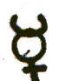 and some comments on making of 0.
Below is the theory pertinent to this text.

THEORY
Ordinary, vulgar (running) metallic Mercury is purified and then animated by being made into an amalgam (āāā) with silver or gold leaf. This is digested for 6 months. The now animated mercury is then amalgamated with more gold or silver and re-digested. A putrifaction will occur. Continued heating leads to the white stage and further heating to the red stage and, ultimately, to the STONE.
(L’AMI de L’AURORE)
When the Philosophers have said that the Moon is its Mother, it is only to suggest to the Ignorant that the feminine seed of their Stone ought to be “like” silver orits mercury or sulfur, but well a mercury of the quality of the Celestial Moon, . . . of white, silver-like color. The Moon is an inconstant, cold, patient, feminine star that receives unto herself the influence of superior bodies, and gives birth to them within this lowly world. All the celestial constitutions pass their influence by the Sphere of the Moon.
When the Philosophers name the Sun the Father of their Stone, they suggest that the Sun is the metal from which the sperm and sulfur of our Stone proceeds. The Sun is warm and dry in all its works and actions, even at the extremity of its rays. It dries up elementary vapors.
Vulgar mercury, after having been heated and animated by our art, is of the quality of the fertile Moon, and is prepared thereby to conceive by the semen of the Sun, and to carry the embryo in its belly until the time of proper birth (harvest).
The semen of the metallic Sun is hot, dry, masculine. It is the agent to engender our Stone. Therefore, in sum, the Philosophers have said the Sun is the Father, and the Moon the Mother of the Stone.
In consideration of all things made from two substances, the one hot and dry, the other cold and humid, represented by the Sun and the Moon, the Philosophers have named them 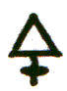 and 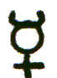 respectively, saying that it is necessary for the Sister to pull at her Brother, and the Brother pull on his Sister, until the one proceeds to dissolution.

One is an instrumental actor or agent, the other a patien receiver. They are ‘Sister’ and ‘Brother’ because they of necessity are of the same family (species), differing only in sex, or outer characteristics.

Those work in vain by using with their masculine ferment a ‘water’ strong to it. . . of another blood, not its familial ‘Sister’ . . . ‘consanquinity’ also denotes that the feminine seed of our work (the 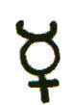) is very much like the masculine seed (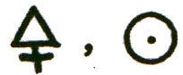), so that little is necessary for them to become one similar thing, which remaining differences depend only on the heat of one and the coldness of the other.
Simple (i. e. ’unanimated’) ordinary 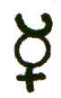vulgar (common quicksilver) is removed too much from the Sun, so, as such, it cannot serve as the feminine Matter of the Elixir. But during its preliminary mixing with a spirit of the nature of the philosophical ferment (i. e. its ‘animation’), which is its proper ‘Brother’, we do draw them so close to each other that the receives her kin, it becomes ‘like’ the Sun.

ANIMATION PROCEDURE
Take 29 parts of purified, vulgar mercury metal. With-a mortar and pestle, thoroughly mix this with L 25 parts, by weight, of 24K gold made from gold leaf that has been ground with distilled vinegar, washed, dried and pulverized into an “impalpable powder”.
This is the King, seated on the edge of the fountain of his friend, to be united with him. He will return eventually with a new body, a new youth with ten times more force and beauty, and clothes ten times more precious. All this by virtue of his bath. It is the nature of the feminine, 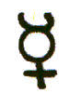 to attract the male to its love nest, not vice versa. In the love nest the two procreate their species. Being, at the beginning, on the ‘edge of the fountain’ means that the King (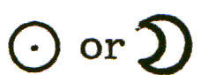 ) is very near to being amalgamated into its mercury. This is for the Red Stone. Use 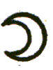 instead of  for the White Stone.
This āāā so made, is to be digested one year (which apparently = 3 months) in the First Degree (40°C), and then one year (= 3 months, months being used hereafter in this ratio), at the Second Degree (60°C). This 6 months is a gentle digestion. Use a round bottom flask, with a long neck, set in sand, 2/3 of vessel empty and tightly sealed after first degree is obtained. Before being put into flask, the weak aaa should be thoroughly washed in pure water, until water is very clean, in mortar, then thoroughly dried.
The Author says that this action stirs up the hidden power in the mercury, which, totally surrounding the Noble Metal, gradually dissolves it, releasing its power ‘into’ the dissolving metallic menstruum. This mercury starts to acquire the SUBTLE SEED of the Noble Metal, thus being ANIMATED. It is an old alchemical truth: ‘Except the Body be opened by the Spirit, it will not accept the Soul.’
MAKING THE REBIS FOR PUTRIFACTION
Once this animated mercury is available, amalgamate 4 oz. of it (this mercury) with 1 oz. of 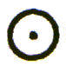(or 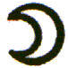) in the form of an impalpable, extremely fine powder. Make this amalgam as carefully as possible in a glass mortar and pestle. Then wash it so often in pure rain water, (or distilled water), until the water used in washing is perfectly clear and clean. Then dry the amalgam with a clean sponge, or a folded piece of hot, white linen.
Weigh it. If it weighs less than 5 oz., add enough animated to it to make it 5 oz. If over 5 oz., due to excess , squeeze the excess through clean chamois leather, keeping what is on the inside of the leather, until the āāā weighs 5 oz. only: 4.0 oz animated, + 1 oz or 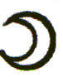
FERMENTATION
“Fermentation is the aggregation of the liquid and the body, with restoration of their natural heat.” This 5 oz. āāā, the Philosophers have called their “Ferment” because (or ) is the true leaven of the ELIXIR. “Marriage” will take place between the menstruum, the feminine, and the (or ), the masculine. The woman is said to draw the sperm, or “seed” of the . The seed of the Noble Metal will make the like itself, through DIGESTION alone.
PROCEDURE
Put the 5 oz. of washed, then thoroughly dried aaa into a proper glass vessel (one made of quartz, or PYREX, stone or porcelain) strong enough to endure various degrees of heat for 15 months, steadily. The vessel should be large enough so that about 2/3 of the flask is empty. It should have a long neck (I. e. volumetric or kjeldahl).
HEATING
Once it is warmed in its flask, seal it tightly (lute). It will be necessary to digest it 9 months for the WHITE and 12 months for the RED
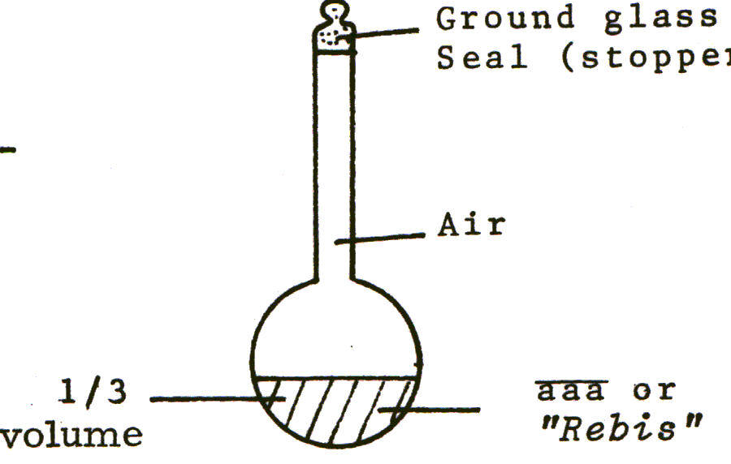

REGULATION OF EXTERNAL HEAT
Heating should be continual, and even, in the various DEGREES OF HEAT. It is a gradual process of continuous DIGESTION. In the digestion, which occurs through external heat, an occult inner FIRE (“Secret Fire“) is released in which the feminine 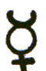 draws the semen of life from the masculine NOBLE METAL (only  OR 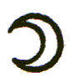)used, not a mixture).

PUTRIFACTION occurs in the first Degree of Heat. Dissolution is an extended PUTREFACTION.

Sometimes the process of heating is also called SUBLIMATION, in which there is dissolution of the into , and the incorporation into the of the sulferous principle of the ,” DISSOLUTION OF THE ONE IS THE COAGULATION OF THE OTHER”.
Through the process of solution, the CALCINATION of the Noble body occurs. The liquid dissolves the Body, freeing a Spiritual principle previously hidden in the closed body. The opens the Noble Body. The now-freed-occult principle congeals or COAGULATES the mercury.
Ground glass Seal
ON PUTRIFACTION

Some selected quotations from the text follow: Putrifaction is an action initiated by the external heat acting on the
humidity of the matter in a way that corrupts it and alters it, giving it a new form. During the first 3 months, the first Degree of moderate heat, the humidity of the menstruum corrupts or putrifies the solid mass of the Sun, and in fact, reduces the gold (or silver) to a form of mercury, like itself. This is nothing but the true ‘SOLUTION of the matter’.
In this first solution, the body is made BLACK a sign that the natural heat has begun to corrupt the body. This corruption is the necessary, first stage, without which it is not possible to do anything.
Putrifaction is only a simple breaking apart of the subtle aspects.
This purtifaction continues until the matter becomes dry, and white, thus becoming congealed and animated. The BLACKENING shall also be (the sign of) the ending of the First Degree of heat, calling for the Second Degree.
Solution cannot take place without putrifaction, yet putrifaction can occur without solution. Putrifaction lasts until the matter begins to WHITEN
Solution is the reduction of a dry, definite matter into flowing mercury - - by the mercurial menstruum, and the First Degree of temperate heat, like the heat of the Sun in Europe in February (40°C). This solution ends as soon as the (or ) is itself reduced into mercury.

This makes the spiritous, and “airy” like the mercury. And the masculine seed (from the noble metal) now released, becomes airy and fiery and also tries to volatalize, like the mercury.
The volatile must become fixed, and the fixed must be made volatile. The mercury must become coagulated and fixed, and made into the nature of the Sun. This will occur if the dissolution of the is conducted slowly, in a gentle beat. Our dissolution is, in itself, the principle of coagulation. As soon as the Ferment () is dissolved, it thereby coagulates its own dissolving menstruum (the ), achieved in the continuous heat. Our , thus subtilized and reduced into its SEED, is the TRUE SULFUR or FERMENT of our STONE. (During dissolution), the does take on - - for a certain period, the EXTERIOR FORM of its dissolving, mercurial menstruum. Yet, urged by the external heat, both male ( or) and female (animated ) join in a loving embrace. Blending their inmost subtle parts, they congeal themselves. The ferment, hot and dry in its exterior, gradually consumes the humidity of the mercurial menstruum, and dries it up. The two become all of one species. This CONJUNCTION of the Male () and Female () seeds (Sulfurous and Mercurial Principles), is followed by true CONCEPTION, the joined seeds becoming ONE LIFE which develops in the belly (digestion vessel), by a proportionate digestive heat (40°C), that putrifies the Matter, thickening it so it looks like BLACK MUD, which is the principle of COAGULATION (CONGEALATION).

PUTRIFACTION leads to COAGULATION, a drying-up of the humidity of the menstruum. It becomes a UNITARY Mass, gradually - - in the FIRST DEGREE of heat (40°C) - - coming to resemble a blackish, tar-like mud. Nature, who governs GENERATION., animates the two “dead” Species, anew, enabling them to be reborn, yet not individualized but UNITED into a NEW FORM more perfect than they bad at first.

The King () is resurrected in his Fountain. His ( ’ en) Body, cut apart and dismembered, is reconstituted into a younger, more perfect form than it originally had.

Be careful with the heat. IF Whitening preceeds the Black, you have had too much heat. This is even more the case if Red appears before either the Black or White!

But when Black occurs, gradually, one should REJOICE. Black is a sure sign of complete dissolution. Blackness is engendered from the humidity inherent in the Matter. After arriving at Blackness, you will not miss achieving the White State.
Vulgar mercury, after having been animated (by ) and heated by our Art, obtains the quality of the fertile Moon. It is then able to receive the semen from the Sun. It is feminine, patient, cool, humid. The Sun is masculine, eager, hot and drying. Philosophers have said, The Moon is its mother; the Sun is its father’. This is what they meant! The Sun is the metal from which the seed - and sulfur - of our Stone proceeds. The Sun is warm in all its parts, and rays. The Sun, expanded into the Stone, extracts and dries up the rough humors of all imperfect metals. The Mother and Father, the Moon () and Sun () are, in essence, not dissimilar.MERCURY IS UNRIPE GOLD. Because they are from one unified SPECIES.

TIMING IN THE WORK
In the First Degree of Heat, the acts on the . After complete BLACKNESS occurs, increase to the Second Degree of Heat (65°C). (Depending on the animating power of the , and the subtlety (particle size) and/or “openness” of the gold powder - - or gold calx, which is better by far, and is laboriously made by Art - - the BLACK STAGE (Nigredo) should arrive by 3 months time, maybe sooner, maybe later.) After the Second Degree, the Blackness will start to whiten within 3 months more time. Once it starts to whiten, continue the same heat. It can be increased slightly (to 75°C?) when white, keeping the heat, though, constant, until the Matter passes to a stage Whiter than the Whitest Snow in the World. This degree of PERFECT WHITENESS (Albedo) may take a total of 9 months, in these degrees of heat.

CAUTION:
Do NOT hurry with the heating. (That is, if you want the Stone, versuS a Tincture or Perpetual Minera. It must putrify, then whiten, then Redden.) In the Whitening Stage, the beat is still ‘gentle’, ‘so long as the vapors are being united and fixed into the Matter.’ If the heat is raised too much before the PERFECT WHITE Stage, the matter will grow RED, which will not profit you, UNLESS it be first composed of complete WHITE and a very PURE BLACK.

At the PERFECT WHITE STAGE, it can be heated at the Third Degree of Heat. But, if the WHITE MATTER is from a ferment. (and not a ferment), and if you want a WHITE STONE, you must take care not to heat it much into the Fourth Degree, or it will go RED. If of a ferment, the heat ends with the Third Degree. But if the original ferment, and animation was , then it should be heated even to the Fourth Degree, in order to fully fix it, until it does not at all fume when put on a burning hot spoon.
For the RED WORK, after PERFECT WHITENESS, increase the heat to the Third Degree, until it yellows, and Reddens. At the RED, it must stand in the Fourth Degree a long time (2-3 months?).

In the REDDENING, the last portions of humidity are expelled by the heat, which humidity is the cause of the WHITENESS.
THE FOUR DEGREES OF HEAT
The FIRST, ‘gentle’; the SECOND, ‘stronger by half’ (=l.5x); the THIRD, ‘doubled’; and the FOURTH, ‘built-up by half, again’ (1.5 x THIRD).
1st - 40°C 3rd — 130°C (?)
2nd - 65°C 4th - 190-200°C (?)
Translator’ s Note:

There is much disagreement as to what 2nd, 3rd and 4th Degrees are, but very much agreement on the Putrifaction Temperature, 40°C-50°C.
Ultimately, the matter must become very hot, so as to be able to be melted with or, in the WHITE STONE WORK. So, in this Scale of Degrees, there are FIVE Degrees, extending into very high temperatures.

At the Red Stage, the matter is now FIRE PROOF, but is ‘dead’ for it presently lacks the power of Ingress into inferior metals. Giving ingress will be discussed later.
FURTHER DETAILS ON THE RED AND WHITE STONES
If the Medicine has been fermented with and you want the White Medicine, you cannot heat it to the Fourth Degree, or it will loose its power for Transmutation. The higher heat makes it go towards Red.
Do not, therefore, (if you want silver), heat it (if fermented with ) to the Fourth Degree, At the end of time in the Third Degree, it will have received a high or perfect degree of WHITENESS. It can now be treated, to gain Ingress ,and will give its exuberant Perfection to imperfect metals, and transmute them into fine .
ON THE RED STONE
If fermented with , when the Matter is very WHITE at the end of the 3 months of THIRD DEGREE beat (9 months thus far), ‘quadruple your heat of digestion, and continue at 4 years (= 12 months, or until 12 months (?) or at least until the Matter looses its Whiteness and begins to Redden, then becomes very Red. Colors like a drying Iris flower appear between White and Perfect Red.
At reddness, increase the heat to Fifth Degree, until the RED COLOR is fixed, permanent, and the matter no longer fumes at all on a flowing hot spoon. Then when taken from the vessel, it will live and give life to imperfect bodies, making them , also curing all the infermities of human bodies.
Some only talk of Four Degrees, the First being moderate, and the Fourth as hot as the Matter can endure. At the Red Stage, there is no fear of scorching the matter for it rejoices in the Fire.

Once the Matter is Red, it must be taught Ingress, so it can penetrate into the most minute depths of imperfect metals. Ingress is acquired by INCERATION, so it develops penetrative virtue, yet will melt like wax.
ON MULTIPLICATION
There are two varieties of multiplication: That of VIRTUE, and that of QUANTITY. They are done differently.
Multiplication METHOD FOR VIRTUE
If you want one weight of your ‘Mercury’ to Transmute 100 weights of molten, imperfect metals, or on as much of their mercury, or on that of imperfect, average minerals, or on 100 parts of animated Mercury, or 10 parts of vulgar, crude mercury, then you must begin the cycle of the Work, all over again, to wit: -

Make an amalgam of 1 oz. of your Perfected Medicine (The White or the Red), just like the initial procedure, or method - - by amalgamating it well, rubbing it, with 10 oz. of the original, animated mercury. Guard against failure by avoiding using mercury animated by the if you intend multiplying your Red Medicine, or, taking animated Mercury for fermenting the White Medicine, for you will spoil the process. Once the amalgam is made, wash and rewash it with rain (or distilled) water until no more dirtiness, or discoloration appears in the wash water. Then thoroughly dry the amalgam, using a sponge or very hot piece of white, linen cloth. It should be dry, no moisture should remain in it.

Now put the amalgam in a strong digestion vessel luted well, and tall enough so that the Matter will never climb higher than half of the belly of the flask, leaving 2/3 empty, or so. Set the vessel in your digestion oven, and establish heat of the FIRST DEGREE, until the amalgam putrifies - - dissociates - - congeals into Blackness. At this point, increase your digestive heat to the Second Degree, then the Third Degree, continuing until the Matter becomes WHITER THAN SNOW, which is the end of this particular Multiplication, for the White Medicine.

At the WHITE Stage, the ‘Digestive’ heat is over, for you must now heat the matter at the FOURTH DEGREE. You should divide into 4 graduated increments of heat, the four DEGREES, keeping the matter in each Degree, one-fourth of the time, so that at the end, in the FOURTH STAGE, the fire will be very strongly burning.
If the Matter is fermented for the Red Medicine, then at the point when it becomes White, at the end of the THIRD DEGREE, you must increase the heat to the Fourth Degree, a quadruple of its heat, and continue as long as each of the other Degrees, or until the Matter becomes quite Red. Then it is necessary to give it heat by 4 additional Degrees (i. e. Fifth Degree, divided into 4 increments, apparently). When all the Degrees are completed - - a very hot fire - - - the Matter will be fixed and Red, like a ruby. This obtained, it is to be foUowed by the process of INCERATION, to give it Ingress, until the Matter melts like wax. Then the Stone will have lOX more VIRTUE than it had initially, and it will project, per unit weight, on 100 weights of molten imperfect metals, or animated mercury, or on a large proportion of molten median-level minerals, too.
And now, if you desire that your Medicine be able to project one weight on 1000 weights, start the Work all over again, by taking the latest, most potent Medicine (before Inceration), and amalgamating 1 oz. with 100 ozs. of the original animated , then digesting through all the colors (Black, White/Red if ), etc. If 1 oz. of this Third Medicine, completed to fullness, is further analgamated with 1000 ozs. animated mercury, and taken through the colors, when this Medicine is completed, it will project 1::l0,000 for or , respectively.
The KEY is always to increase the weight of the mercurial menstruum - - animated as taught, for 6 months - - by lOX, which will result in the Medicine being multiplied lOX in VIRTUE! Take note here of a great secret long hidden by Alchemists:
If one adds only a small increase in the amount of , per unit of Medicine being multiplied, the coldness of the mercury wit! NOT balance the intense interior heat of the Stone. Therefore, the Stone will not be opened and putrified, and dissolved. Rather, it will radiate its great heat, drying up the mercury, and congealing it, into ITSELF (or, respectively). But for the VIRTUE multiplication, it must have the opportunity, and leisure, and balance to be opened, again reduced to its elements, and into mercury, which then coagulates, through the growth colors.
We well know that unless for instance, is not reduced into mercury and subtiized into its solar sperm (sulfur), it cannot become a Stone.

In short, a small ratio of animated mercury will not work for VIRTUE Multiplications, becoming, rather congealed into before the Medicine (which is in a special state) gets dissolved. Therefore, enough animated mercury must be added so its humidity and coldness will surpass the great magnetic HEAT, which is the characteristic of the STONE of the WISE. The mercury will then dissolve, putrify, congeal, and get fixed in the fire, which the Mixture receives anew, until the Virtue be expanded as many times as the operation is repeated.
To further give illustration of the principle involved, which is one of contained heat: If an iron bar is warmed in the sun, then thrust into a bucket of cold water, it will not have in it the power to heat the water much. But if the iron bar is heated White hot, it will heat the water considerably, even a large quantity of water, for its VIRTUE, in this analogy, has increased very much by the force of the external fire, long applied.
And so, the more that the Medicine is recycled through this MULTIPLICATION, and the more strongly ‘heated up’ by the fires, it acquires the power to heat - - cook - - larger and larger quantities of imperfect metals. Its virtue may be so expanded that one weight of our MEDICINE could ‘congeal a whole Ocean, were it made of mercury’.
Multiplication METHOD FOR QUANTITY

We see that in the previous process, there was ALSO multiplication in quantity, since l0X animated mercury was being taken, each round in Virtue. But this is a bit different, since the Stone is not dissolved, each ROUND.

Philosophical alchemists call this type of multiplication, one of ‘AUGMENTATION’ of the physical mass or substance and quality. The sages have devised methods of doing it, so that the valuable powder of projection will never be exhausted, and so that the lengthy process of taking it through the colors can be avoided. This method multiplies the QUANTITY of the Stone, at its given Virtue.

Those who follow my (laboratory) techniques, will discover that ordinary mercury is, in fact, the closest matter to the Work, and that it has in it all the power that is necessary in order to achieve the Great Stone. And further, ordinary mercury requires only a little preparation in order to release this occult power.
Augmentation means increase in substance, that is, weight, with no upper limit, even unlimited weight, without redoing the complete Work, yet, without diminishing in the least the virtuous powers/qualities of the Stone’ s Stage of Perfection (VIRTUE).
But I wish to definitely caution you against multiplying the White Stone with mercury animated by , for if you do, you will spoil everything and destroy its virtue.

AUGMENTATION
In order to multiply the Red Medicine (for instance) in physical quantity:
Take 1 oz. of mercury animated by 1.5 scruples (=36 grains, or 1/16 oz.) , which has been digested 15 months, as described above, and made hot in a crucible. When it begins to boil, throw on top 1 oz. Qf your fusible Medicine, melted Red, without taking the crucible off of the fire, until it congeals the said into powder, which it will do quite quickly. Then when congealed, remove it, and put it (the Matter) into a digestion vessel, well sealed. Then develop a temperate charcoal fire underneath. Keep it going four (4) whole days and nights, as if you wished to distill it. Then increase the fire’ s heat by half (i. e. 1.5X hotter), keeping the vessel so heated 4 more days. Then increase the fire 1. SX what it is, again keeping it heated 4 days, which fire will be much hotter than the first twol After this 12 days of heat, divide the matter (cooled) between two separate crucibles, which seal. Prepare your charcoal fire to achieve the desired fixation, keeping the heat up for 29 hours, or so, building up the fire in 6-hour intervals (through the higher Degrees). As the end, you must smother the crucible with burning charcoals for 6 hours, then let the fire die, cooling your Matter. You will now find 2 ozs. of Medicine that is identical to the solution Medicine, in VIRTUE (i. e. Projection Power).

You may now multiply these two ounces in quantity, using two fresh ounces of the animated mercury described, governing the fire as just taught. At the end of your regimen of fire, you will have 4 ozs. of your Medicine, that you can further multiply with 4 ozs. of the above described, animated mercury, (heating and working it as described).

Always operate with new animated , plus the multiplied Powder. Thus, by heating, you will be able to MULTIPLY 1 oz. of your Medicine into an unlimited quantity, as you wish, all of which multiplied Medicine will be as perfect for projection on inferior bodies as what you started with. In this work, you will obtain better than that made by Nature.
ON WHITE POWDER MULTIPLICATION
If you wish to multiply your White Powder (Medicine), take 1 oz. of animated by , as taught, and project onto it 1 oz. White Medicine, as with the Red. Then take the multiplied Powder, with fresh fermented with and heated 12 months, and in this way you will be able to multiply the White Powder to any quantity, just as with the Red Stone. In order to have a great quantity of Powder, it is clearly necessary to animate with and , separately, great quantities of , and to digest them as necessary. When you have completed animation (at least using one or two furnaces), cook it further so as to multiply it in virtue. Finally, when as you want it, so as not to run out of the fixed Matter, you can multiply it in weight, as now described.
ON INCERATION
A quote from Charles Maurice d’ Houry, 1725 Editions Jobert - -Bibliotèca Esotèrica 1977 - - “Traits de Chymie Philosophique et Hermetique”.
In order to expand and multiply this Red Stone, you must dissolve it in its own ’water—of—life', its fiery, spiritous, living (animated) dissolvant. Then by digestion, Blacken, Whiten, and Redden it, observing the Degrees of fire of the First Regimen. Continue repeatingthis cycle of dissolution - heating - coagulation, 7 times, or, until the Stone becomes FUSIBLE LIKE WAX, And thus, you will be able to multiply it in quantity and quality, as you wish. Because by each new corruption of its elements, hence each Generation, it gets introduced into a New Movement, and the Stone that had its origin from our dissolving Water, re-enters the Womb of its Mother, becoming reborn, renewed, more robust and potent than before.
It is now the time to discuss INCERATION, and define it, and show how it should be done, because without Inceration, the White or Red Medicine will not be readily fusible, and will be like something ‘dead’ - - by nature of its great dryness and inability of fusion. It is its FUSIBLE Nature, that gives the Ideal Medicine proper INGRESS - -melting like wax, with penetration and transparency - - into the bodies with which the Medicine is projected.

INCERATION - - producing fusibility and ingress - - is achieved by the INHIBI1’ION of humid substance on pulverized, dry substance, repeating this operation several times, moistening and drying up again each time. That which ignorant alchemists achieve by melting with ‘waters’ and ‘oils’ to accomplish Inceration, properly ought to be done with the mercury of the same matter the Medicine was originally made:

(To wit) -

Pulverize your (dry) Medicine (in its completed state), -into an impalpable powder, then make an amalgam with 6 times its weight of mortified-animated , as taught (i. e. 1 weight or , respectively, with 29 weights of ordinary , heated 3 months at First Degree heat (40°C), and 3 months at Second Degree heat (at 6 5°C). In order to shorten all procedures, most of which require animated mercury, one should prepare enough mercury so as to be able to use the same batch of animated mercury throughout.

Take care, also, that you Incerate the White Medicine with mercury animated by , and the Red Medicine with - animated mercury. Otherwise you will do nothing that endures; and you may lose your Medicine.
Then wash your prepared amalgam several times with clean water, and dry the amalgam with a heated, clean white linen. This done, squeeze the āāā through a piece of chamois-leather, redeeming excess animated mercury (that passes through) and retaining the soft amalgam. It should be like paste, or very soft, pliable wax.
Place this soft āāā into a suitable digestion flask, sealed tightly, then place the flask into your Athanor (oven) heating it below with a gentle charcoal fire through various heats. The first should be slight (40-50°C) the second, Stronger by half (65°C). Continue each degree 3 months (NOTE: all through the text the author has used ‘1 year’ for each degree. A foot-note translated this meaning as 3 months), or, as you observe the color of the matter to demand. And if you see that your mercury volatilizes, and does not strongly become fixed, do not trouble iourself over this, for it is sufficient that its essence stays there, and softens the Medicine even without fixing itself with it. So, if it stays there it is united, and however, if by several times the matter does not become fusible enough, you should pulverize it on marble (mortar/pestle) and again amalgamate it with 6X its weight of animated , like that of which it composed - - or use the amount of such as is required - - and expell all excess through a chamois cloth (thin calf skin); then wash and dry your amalgam, and re-digest it, as described above. Continue in this maimer - - pulverizing, amalgamating, and heating, as above described, as many times as necessary until the Matter remains FUSIBLE and MELTS LIKE WAX, when it will be ready to make projection on the imperfect metals. In its fusible state, the Matter is King - - even more beautiful, stronger and more vital than he was from only having been in his Fountain ( bath). He will be enriched by a Crown -and Royal Garments more precious than he had ever worn before. Further, he will be now the sibling of Dragons (i.e. mastery over fire). He may be called a Lion - - reborn, brought back to life, younger and more beautiful than ever.

By this method of Inceration, the matter will be perfected, fixed and fusible like wax. This is the LAST STEP for the Stone, and its accomplishments, before making transmutation by projection.

This brings us, finally, to PROJECTION (which is the term used to describe the addition of the Perfected Solar or Lunar Medicine to molten metals, by ‘projecting’ it on top of the melted matter, in a crucible, resulting in the transmutation of the latter into good or , depending on the type of Medicine used, i. e., the White or Red, respectively). I will teach you how to do Projection on imperfect, molten metals and also on animated mercury, or, on mercury drawn from imperfect bodies (in which the mercury pukes up their Sulfurs, or in which a metal is reduced directly to a type of mercury resembling mercury metal), or even on regular mercury in a heated condition.
METHODS
Melt 100 weights of fine silver. When it becomes ‘boiling hot’ (i. e. well molten), make into little balls or ‘pills’ 1 weight of the prepared Red Medicine (for transmutation). Now cast one of the small balls onto the surface of the molten silver. After it is consumed, throw another little piece, on top again, and let it also be consumed. Continue one small projection after another until you have thus projected oneweight of your Medicine to the 100 weights of . (This assumes that the rate of transmutation of the Medicine used is l::lOO. It could be less, or much more, depending on its MULTIPLICATION of Virtue and/or number of cycles it had gone through. This should be very clear, as using too much /power of Red Medicine will result in incomplete transmutation; while using too little will result in waste of Medicine, and the made will have to be re-melted with additional for further transmutation. Therefore, one should know the exact strength - - by experimentation - - on a given imperfect metal or or , etc., before following this 1:100 ratio literally.) After projecting the 1:100, let the matter vigorously boil, stirring it occasionafly with a copper rod, each time, in fact, that you added a ‘pill’. Leave it 2 hours, molten, then cover your closed crucible with coals and let the fire die out slowly (covering is to unlformly cool it, slowly, so as not to crack the crucible while it has molten matter in it). When cool, break the crucible, remove the matter and remelt it, and pour it. You will have of 24 carat value, better than Nature's. All the Philosophers agree that this gold is finer than Nature’ s. (The conclusion of SOLID ONIUS as to why, was that the usual method of preparing by using strong acids is not rigorous since it does not yield truly pure of 24 carats, but reaches only 23.5 carats.) is more perfect than other imperfect metals, and therefore it is quite quickly transmuted into also, demanding proportionately less Red Medicine for the transmutation than other metals, say tin, for example, would require. And the transmutation is more total, uniform and perfect than with the more inferior metals, usually. We know this from the fact that the same unit weight of Red Medicine (of a given virtue) that completely transmutes 100 weights of fine into , will only transmute perhaps 10 weights of certain, other imperfect metals. And they might be quite crude, strongly discolored here and there - - full of ‘mean streaks of earth, black, sulfurs, and stinking’. (This might not be true with modern, pure metals, but perhaps a fine description of crude iron, lead or tin metal in 17th Century.) Therefore, one (tiny) weight unit will not suffice to ‘cook and transmute’ certain metals, or ores, of great weight, nor to purge their mineral infections - - so one must use more to achieve the transmutation. One should ideally, then, make transmutation on (this must be determined by experimentation with pure metals available today), because is so pure, clean, and is almost as digested by Nature or is ; and is red in its inward, hidden nature. So, requires only 1 weight-unit of our Medicine to digest itself, and quickly, into , and to release its own, previously hidden red tincture, (’ en color).
If you wish, though, to make from the imperfect metals, always choose the one (available) that is the most perfected.
Here is a Method for projecting on Tin: Use the Red or White Medicine, depending on whether you disire or .
TIN METHOD
Melt 10 weights of Tin. When it is well melted, and so hot that it begins to bubble and smoke, throw on top 1 unit of your Medicine, by 3 applications of little pills. Then after keeping it molten for a time, cast it into an ingot. You will have (or ), according to your choice of Medicine used. Further, this (or ) will be better than from Nature, from the mines.

Other imperfect metals can be so treated, though no other metal will be so clear and clean for projection as . You can also use some minerals (i. e., compounds or mixtures) without much preparation. But first they must be purged of their innate humidity, otherwise they will be of no value in this operation. The more perfect and pure be the imperfect metal, or average mineral, the better. (My feeling is that ores of tin, lead, copper, silver might be experimented with, the oxides being a better choice than the sulfides.) Yet, you must (extract) their mercury so often that it will be transmutable into perfect or . You can also use vulgar mercury, since it leaves the mine without preparation (he must be speaking of native mercury
metal, usually not common), and yet by the first metallic decoction, it is prepared, cleansed, and animated like I have given above as the first preparation, purged, animated, and heated, so it will receive its perfection, like the imperfect metals (upon transmutation) by this prepared Medicine. By not so much is vulgar mercury made more perfect, fermented, and
digested - - as is and - - so that (the ) may be more perfectly converted into and . Mercury fermented by or , can be digested into or . As above given, if one ferments 1. 5 weights of with 29 weights of ordinary mercury, and digests it 15 months, it is true mercury of gold’, and is so in all its qualities. It cannot be transmuted into by the White Medicine, simply because it is really too perfect, and in congealing with the White Medicine, it tends towards gold and in fact, resembles good gold made by processes of cementation. This is why it is necessary to take caution during multiplication, and/or when making with the Red Medicine. But all of the other mercuries that one endeavors to extract from imperfect bodies, or from minerals, and our ordinary mercury - animated as taught - - except the mercury of - - ALL ought to receive the perfect form of by transmutation with the White Medicine, if you govern the operation like this:

Place 5 oz. of vulgar mercury, animated as taught, or other extracted mercuries, and put the crucible on a fire of strongly burning charcoal. Leave it there until, it gets well heated, and starts to crackle just before volatilizing (boiling). At this point, throw on top of the hot mercury 1 oz. of the White Medicine, and continue heating the mixture until the Medicine melts, whereupon it animates the hot mercury, which will soon congeal into a greyish powder. It may seem to want to vaporize. When you observe this, draw charcoals around the crucible while you increase the fire. Give it a soft blast from the air source (bellows), continuing until the grey matter begins to Whiten, then Redden (from the heat? or other color change?), then cover your crucible and let the fire go out, gradually cooling it in the ashes. Break the crucible, obtain the mass, and remelt it in a new crucible, and you will have good (or , if you projected the Red).

This method of Projection has been figuritively described as the ‘King enriching his subjects’, etc.

In order to convert all of the imperfect metals into , note this:
Take 1 oz. of our Red Medicine, and throw it on top of 4 oz. of fine molten , and you will find all your matter brittle, which pulverize, then remelt, keeping it molten for 3 days. Cool. This matter, powdered, can be projected in the proportion of 1 oz. powder on 25 Mares (200 oz.) of molten , or copper, or as well, on 18 Mares (144 oz.) of lead or tin (therefore one could use tin lead solder, melted), or as well on 15 Mares (120 oz.) of ordinary mercury heated in a crucible or congealed with lead (1. e., amalgamate it). But, it is essential that all of these, if used, be well melted first. You will quickly see your matter covered by a well-thickened scum. At this, you may think your crucible has broken, or cracked. Cool. and then remelt your matter. You will discover it is now fine • But, if you have not observed the necessary proportions, depending on what metal you have chosen, your finished matter may look like something different, though changed from its first color. Then you may have to pass it through a purification stage, by cupellation, yet without putting lead into it, and in 3 hours the Cupel will have consumed all that is not perfect. This additional labor will be required if you do not take enough of the Divine Medicine for projection. You might have to also do cementation with the matter. So, observe the proper ratios during projection.

FINIS
Appendix I

PURIFICATION OF MERCURY METAL

There are several stages to this. The purpose is to remove from the mercury all metallic and nonmetallic impurities that otherwise will block or impede the Divine Amalgamation of the mercury with the Noble metal.

1) Put the mercury in a large beaker, and run cold water on it, stirring it with a rubber gloved hand, or a wooden spoon. Do this for a few minutes. If you use hot water, which is best, it will vaporize some of the mercury which will pass up into your face with the steam and kill you. So unless you have running water in a fume hood, use cold water. Then after washing, carefully pour off the water, and pour the wet mercury into a large glass or ceramic glazed cooking bowl. The water can be wiped off by drawing a folded paper towel horizontally towards you. It will usually noticeably, skim off oxides and impurities that are on the surface of the mercury, as well as drying the mercury.

2) There may be only a few such scums that gather on the surface. If there is a lot of such Impurities, so that when the mercury is stirred, a new mass of scum comes up to the surface, you will have to squeeze the mercury through a clean chamois’ skin, or, 3X folded tightly woven linen, or cotton. Make a pouch in an empty bow]. by lifting up the corners of the chamois, pour the mercury in, twist the corners tightly with rubber-gloved hands until the mercury squeezes through in little beads, into the clean bowl.

If not held firmly, some will come out of the tops of the folds. If one wants to purify a large quantity of mercury, he can make a device using air pressure to force the mercury through a plastic tube held vertically, with a chamois skin clamped to one end. A simple bicycle pump and suitable tire valve attached to a closed system will make air pressure above the mercury, forcing it gradually through the chamois.
This can be repeated several times. This removes black mercurous oxides, some metallic residues, and other dirt.
3) Put the mercury in a large glass salad bowl, and stir in purified or cleaned (recrystallized Sea Salt). This is sold (1982) in most Health Food Stores ready to use in food, which is excellent for our purposes. No need to purify sea salt any further for our purposes. Ordinary crushed Halide is most likely quite satisfactory, but Sea Salt is best. Our purpose here is to stir the mercury into the sea salt into as tiny globules as possible, which darkens the sea salt. Alchemists used a marble, or glass, mortar and pestle. This is extremely laborious. If the salt is slightly moistened with distilled water, it is a bit easier. The salt will turn grey, and then can be removed, and more mercury and fresh salt is taken and ground together, until all the mercury you wish to treat is done. One method I have found successful is to use an electric cake mixer, old fashioned powerful type, (wearing a simple face mask), turning on the blades at moderate speed and adding fresh salt,

This whips the two together into quite small mixture, almost as effective and much easier than mortar and pestle. It requires about 2 lb. of sea salt and 1 lb. of mercury in this manner. The grey salt can be removed as it accumulates, and put separately. I took a full bowl of such salt, covered with plastic wrap, taped in place, and, outside the house, (or in a fume hood), heated at 110°F for 24 hours. The sea salt chemically reacts with impurities, and, I feel, “dries” the humours from the mercury, but basically it is a physical cleansing of the minute inner parts of the mercury from metals therein amalgamated.
Then wash the salt away slowly in tap water. It dissolves the salt, and with it are washed out many dissolved impurities that do not rejoin the mercury. The water will often wash out grey, depending on how much impurity there was. This salt treatment is important even if one buys 3X distilled reageant-grade mercury, I believe. Pour off the water, when well washed and clean. One may do this self cleansing several times if desirable.
4) To the whole lot Df purified mercury in the bowl, add additional salt, but only a pound or so, and then add to it clear, distilled vinegar. Natural vinegar is best. I used 10% commercial acetic acid. This makes a dilute hydrochloric acid, acetic acid, sodium choloride ionic solution. The mixture should be vigorously rubbed with a wooden spoon for 10 minutes, then set the (pyrex) salad bowl on a low temperature hot plate to gently boil off, (or evaporate off) the acetic acid until the salt is dry. This can be washed off, when the bowl is cool (so as not to crack it), in running tap water. If you have an unlimited supply of filtered rain (or distl).water, this is better than tap water. But tap water, or even well water is 0.K. in this operation. The dilute acids dissolve any active metals (copper, for instance) and some other metals and oxides that may be in the mixture. This may be repeated if you desire.

5) Once the mercury is well washed from ail traces of acid and salt, wash it several times with distilled water to remove any residues that may be there from the tap or well water. This mercury can be dried with a paper towel, and if any scum exists on its surface, it can be removed. If the mercury used was already distilled, it is now considered cleaned, purified mercury. If you think it is still unclean, because it leaves a tail, or scum is still present on top of the mercury, then it MUST be distilled.

DISTILLATION

6) Take the dry, cleaned, purified mercury and put it into a ground glass distillation train system. It is VITAL that the joints leading to the condenser be ground glass, as high heat is required and rubber joints are unsafe due to the great poison of mercury vapor. The connections to the condenser or collection vessel may be other than ground glass, as long as they are air tight. Do np. overfill the distillation flask. I usually use 250 cc round bottom flasks, fiUed only half-full. One must use aluminum foil and/or aluminum foil filled with fiber glass, as an insulation batting on most small beating mantles to build up the heat as the mercury passes away from the heat source to the exit port going to the condenser. Some people simply wrap the whole in aluminum foil, shiny side inside. I use an aluminum foil, fiber glass filled batting, 2 layers thick, the whole then again wrapped in aluminum foil, to make an oven-like jacket above the heating mantle. This is easier than using heating tapes, and allows distillation at a lower overall temperature than would otherwise be necessary. The minimum temperature of the heating mantle that will allow distillation is best. I use an ordinary, rotary dimmer switch, 500-6 00 Watt capacity for incandescent light dimming, quite inexpensive, and readily available, in series, to control the temperature of my heating mantle, rather than a rheostat. It works perfectly, and costs less to operate the heating mantle since it is a variable transformer rather than a resistance system. Do not use too much high temperature grease, or it will contaminate the mercury you intend to distifi. But use enough so you can get the ground glass apart. (I have had to use a blow torch, and sometimes, petroleum penetrating fluid used to free rusty bolts, to penetrate the ground glass seals that are locked. It is a neat thing to know.) When you distill, have the mercury drop into distilled water, It may form a scum of mercurous and mercuric oxides. These can be easily cleansed later, so do not worry if each distillation seems to produce mercury that is not as clean as what you started with. I recommend superficial “scumming” to clean the mercury of its lighter oxides, each time between distillations. Distill 3X. I do NOT believe that 7 distillations of the mercury is ever required. Unless you remove oxides between distillations, you will positively end up with a “dimmer” end product. The purpose of distillation per se, is to remove non-volatile metals that may exist in the mercury. One must use as low a temperature as possible, simply to not volatilize the impurities, or carry them over the helm with the mercury vapor.
One trick used by chemists in late 1800’s was to put a layer of about 1/4 inch of pure iron filings (not rusty nailsl) on top of the mercury to be distilled. You will find some of this iron being carried up and over the distilling tube, and it makes the final. product dirty in the receiving flask. But iron is NONREACTIVE with mercury at these temperatures, and it traps a great deal of impurities. It floats on the more dense mercury metaL After each distillation, this dirty iron (which should be considered optional, but I have used it with great success, often accomplishing in one such distillation what 3, normal distillations required) must be discarded, and the distiUing vessel thoroughly cleaned, and dried, and all the connecting tubes and condenser and receiving vessel, as well. This dark mercury in the receiving flask can very easily be cleaned by using chamois cloth, and squeezing the mercury through a couple of times. The iron is only on the surface of the distilled mercury.
Once the mercury is so distilled, then, one final time, it should be passed through the salt cleansing, followed by the salt-vinegar cleansing. Or, merely the salt-vinegar cleansing, as you like.
Your mercury is then poured into a large clean glass cooking bowl. Drawing folded paper towels across the top to remove the last traces of scum, on the surface. I have found that adding a few drops of distilled water, then passing paper towels, folded, towards me, is the most effective way of doing this.

The moisture picks up the scum in the paper towel better. Thus it is CLEANSED from all impurities.

When a farmer is preparing his field, in which he wishes to plant his best corn, hoping for a good jgold corn harvest, does be not clean the whole of his field, removing all boulders, trees, brush, and then breaking up the earth into fine soil? He may then choose to add manure, loved by the corn, in which it grows. This makes the field alive again, not just clean. Should we not therefore follow nature and prepare our mercury, our DIVINE FOUNTAIN, a bit further so that it will be the most perfect “field” to receive our Noble King?

SIGNS OF PHYSICALLY PURIFIED MERCURY

1) It will be perfectly shiny, like a brilliant mirror, having not the least trace of spots or scum or filth. When stirred with a clean glass rod, in a large bowl, it will remain clean and brilliantly clear. This means it is clean in all aspects.
2) It will not form the least “tail”, when rolled on a flat surface of glass.
3) It takes a perfectly round shape, therefore. And it is so mobile and fluid that it delights us.
4) When a drop of pure water, is put on it, the water shines from below, and does not reveal any scum collecting in it or under it. It is physically beautiful.
5) On the etheric (prana) level of experience, if you are sensitive in this level, the mercury has a steady vibration peculiar only to mercury, that is very strong, affecting one’s etheric double in a characteristic way, hard to describe.

Note: Be very patient. This work takes several days, depending on how fast you work. Without this,your work is foolish, for you know not what you have unless you personally purify this matrix.

Taking ‘FRIEND OF THE DAWN ‘literally, this cleansed, purified mercury, which is still considered “common”, should be sufficient for the procedure of animation DIRECTLY with a noble metal, given in this manuscript. Personally, I believe it to be so, especially given the long time period for animating the mercury before sowing the field with higher density of the noble metal, silver or gold, to begin the putrifaction, etc.

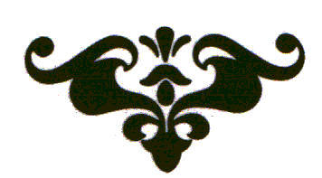

Appendix II
ANIMATION OF MERCURY METAL

For those who wish to animate the mercury a different way than given, in “Friend of the Dawn”, and to avoid 6 months of waiting, I now give ANIMATION PROCEDURES. THUS, one can pass DIRECTLY, with the animated mercury, to the step of adding the 1 oz. noble metal to the 4 oz. animated mercury, as given in “Friend of the Dawn”.

Animation is the addition to the Mercury of etheric essences, or PRINCIPLES in the etheric shell of the substance, so that the mercury when digested, WILL EAT ITS OWN TAIL. ANIMATED MERCURY, BY ITSELF, WHEN PROPERLY DIGESTED, WILL PUTRIFY AND PASS THROUGH THE COLORS. There are numerous ways of animating the mercury, which involve operations performed physically and chemically on it, in heat, that GIVE TO THE MERCURY solar and/or lunar sulfureous principles that awaken in it, its own mercurial and sulfureous principles to bring it to completeness. Some of these principles have been weakened through the purification processes, as mercury is revived from cinnebar ORE, and/or lost through its amalgamation with various metals. We are dealing with a set of etheric principles. Through certain animation procedures, these are “added back” or set again into outer manifestation in the near-physical etheric shell of the mercury, by the laws of correspondence, so the mercury acquires AWAKENED Mercurial., Sulfureous, and Salt principles once again BALANCED with each other. We know this, because it becomes alcbemically active, and when digested, it coagulates, something that non-animated, common mercury can NEVER do.

Such animation procedures were kept as a closely guarded secret, because they make the mercury extremely potent, READY TO RECEIVE THE KING OR QUEEN, which was the whole secret of the Work in this one set of methods. It must be understood that there are literally dozens of ways of preparing an alchemically active body; in which the etheric, essential principles of “mercury”, “sulfur” and “salt” are awakened, or added, in proper dynamic balance to allow further GROWTH and MATURATION in the degrees of heat that constitute the life blood of the substance. The Stone is the greatest friend of the fire. It has dominion over the fire, and all other elements, which it gains by actual EXPERIENCE, just as We grow in Godly virtues by actual experience, once we have reached the point of learning about the spiritual bread of life given by the SOURCE, and know how to imbibe it.

No one can bring this work to fruition, or harvest who is not established in proper mental and psychic balance within, which is required in order for the astral and mental GUARDIANS of this great Secret to ALLOW one to proceed with this great Work. This statement is given only as warning. One may try, but never succeed, without the proper authorization by DIVINE sources of inner and outer guidance given to the alchemist. Hundreds of obstacles must be conquered. it is essentially a lonely, private struggle since there is usually no one to turn to for counsel and advise, except the inner sources of intuition, or outer texts, often mysterious. Here, in plain language, has been set forth the entire work. YET, one should think not that this ends the matter. For, who is reading these words? Will you have the proper balance of wisdom, chemical knowledge, mind-heart balance, to achieve the goal, or compassion to know how to use wealth for the benefit of the Divine Plan? You, do you know anything of the Divine Plan on Earth? Are you a keeper of the treasure for mankind? What have you done in your life to demonstrate your willingness to serve a suffering humanity’ S need for guidance, for Truth, for Love, for health or bread? This is a most severe test. And one who conquers all of the obstacles of the “way of the Crucible”iS one who has been chosen and approved, for various Divine and Karmic reasons, to so achieve. Each one knows only in his inner heart if be or she has been given permission to achieve this great Work for the benefit of all mankind.

As I write these words, I am only in the beginning stages of this Work. So, the reader should not think that all is already achieved. What I have communicated represents my present understanding. Your own work, if followed, will reveal IF this is a complete set of teachings. There are many short cuts, if one is fully knowledgeable.

Working with purified running mercury, there are several basic ways the ancients animated it. Two of the most famous (thou secret, they were widely used by generations of great adepts in this noble Path) methods are to ADD TO THE MERCURY THE SOLAR, SULFUREOUS ETHERIC PRINCIPLES OF IRON. This is done in several ways. I will not give full details here, because these methods are available to anyone with an excellent aichemical library, and will be recognized in von Suchten, ‘Coelum Philosophorum, and othertexts, and, also in Digby’s “Choice Chemical Experiments”, edited by Hartman.

Making Cinnabar:

The basic procedure, which I will outline, is to take the purified mercury and add to it the right amount of mineral sulfur (some say flowers of sulfur, but mineral is best, since fully alive, naturally), grinding it without melting (some say melting the sulfur and spraying the mercury into it stirring with a ceramic or wooden rod. But this is dangerous - because of the fumes of mercury - without an excellent fume hood with exit fan). This makes HgS (black form). One must grind very well, usually with hand operated or mechanized mortar and pestle. Use face mask. Another method uses NH4No3, with some water added to the mercury and native sulfur, to help oxidize the mercury and make its joining with the sulfur more easily accomplished. The proportions of mercury and sulfur - are important. With the nitrate method, one must heat the HgS nitrate mixture, on low beat, until all the yellow smoke disappears. It takes 2-3 hours, and casts forth an amazing amount of smoke. One needs a secluded outdoor lab, and/or excellent fume hood. A neighbor thought my house was on fire when she saw so much smoke emerging from my attic where I had a lab. This must be washed off the nitrates, when complete& Either way, you end up with black, very well ground, CINNABAR. Some methods recommend sublimation of this BLACK form to its more tightly crystallized RED form. If you know how to do this, it is best. If you do not, some recommend merely heating, at second degree heat, the DRY cinnabar (black form) for 2-3 days in a closed system. The mercury is deadly, and MUST be a closed system. Do not do this if you do not know what you are doing, for it is deadly. Some of the cinnabar may sublime in this 2-3 day heat, but it requires much hotter temperature to sublime it completely to the red form. Some recommend subliming it from a bed of sea salt, calcined to dryness, mixed thoroughly with the black form. If so, one must wash out the salt. Cinnabar is insoluable in water.

Once you have this digested black, or sublimed red form, you must revive it in a distillation rig, USING IRON FILINGS well mixed with the cinnabar. Some recommend using only martial regulus of antimony, some a 50/50 mixture of the animony regulus with iron combines with the sulfur, and while it does so, some of its SOLAR, FIXED SULFUREOUS, ETHERIC SHELL PRINCIPLE is added to the mercury or awakens the corresponding sulfureous Principle in it. The mercury then is djs -tilled from the mixture of synthetic iron sulfide, and will come over the helm into water. Take all precautions. You may lose many distilling vessels. The dead head may harden into a mass that cannot be removed from the retort, or distilling rig. It requires a very high temperature, kept up for a considerable time, to effectively start and continue this reaction. It is not easy to do, I have found. I have also seen that when the exact reaction point is reached, the mercury literally explodes as it is freed, destroying the glassware or distilling tube. DO THIS IN A SAFE PLACE, OUTSIDE, OR IN A FUME HOOD, WELL VENTILATED. I have devised a stainless steel can, with a stainless steel tube welded in place, with the lid bolted on, to do this reaction. I have experimented a bit with glass, and do not find it an easy distillation.

After the mercury is separated by iron, from the synthetically made Cinnabar, and passed into water, it should be cleaned with chamois cloth. This constitutes ONE ROUND - making it into cinnabar, and then separating it from cinnabar with iron filings (or combination of martial regulus of antimony with iron filings, some say). One must do this 7-10 times. It is not that the mercury gets any more PURE during this procedure, but its inner, etberic shell of sulfureous and mercurial principles is activated, (or added to) alchemically. The red, solar, sulfureous principle of iron (or its counterpart in martial antimony which HAS DRAWN FORTH THE IRON SOLAR PRINCIPLE), acts on the mercury with increasing force each operation. Exactly how many such ROUNDS one must do is uncertain. Most say 7; some say 10. None say more than 10.

At the end of these rounds, you will have a running mercury metal, that looks exactly like the mercury you started with. Yet, it is differ -ent in its invisible etheric body. It is now animated. This mercury should be passed several times through chamois leather and distilled twice, from a very clean, fresh retort, or distillation train, into water. I do not recall if anyone washes it with salt at this point. All traces of iron must be removed PHYSICALLY. It must have all of the characteristics of cleansed mercury. Use distilled water when wiping off scums, if necessary.

This is now ANIMATED MERCURY. It is a great treasure. It is the fertilized matrix in which you may plant your corn.

Martial Regulus & Silver Method Of Animation

There is another classical method of making cinnabar, 3 times, reviving with antimony and/or iron each time, cleaning, THEN, continuing animation by rubbing it exhaustively with mixture of silver and martial regulus of antimony. This type of regulus has IN IT the solar principle of iron, because of the special way it is made. This regulus is like mercury of antimony. Two parts pure silver is melted with 1 part such regulus of antimony, and the mercury, 5 parts per unit weight of the silver antimony alloy (ground into the finest powder) is exhaustively rubbed with it. The antimony itself does not amalgamate well, but the silver does, TAKING WITH IT, PRINCIPLES OF THE ANTIMONY, AND IRON, imparting them to the silver-mercury amalgam. Then this amalgam must be digested at first-degree heat, and washed with distilled (or rain) water UNTIL ALL BLACKNESS IS WASHED OUT. One may digest it between washings. But all blackness must be removed, so that the mercury is shiny, bright, like the cleansed mercury but not with its mobility, since it has silver amalgamated with it. When so cleaned, this must then be distilled, leaving the clean silver in the distilling head, passing the mercury into distilled water. This silver can be recovered and remelted with fresh martial regulus. Retrieving the mercury after this operation, and cleaning it physically through chamois cloth and/or distilled water, is ONE ROUND. One should do 7-10 such rounds to further animate this mercury, which, when completed, is PERFECTED, A GREAT TREASURE. The final mercury, now animated, should be distilled by itself only twice. Cleaned a bit, after final distillation, with distilled water and mortar/pestle, and made shiny, it is a field ready now for planting.

