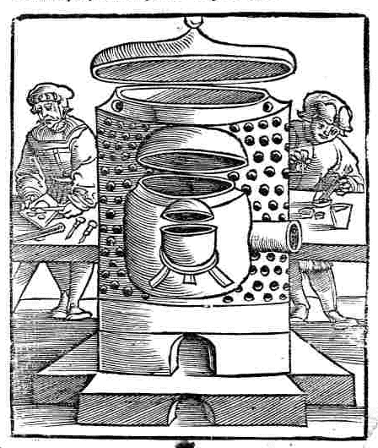
Collectanea Chymica

A
COLLECTION
Of Ten Treatises
IN
CHYMISTRY,
CONCERNING
The Liquor, Alkahest,
the Mercury of Philosophers,
and other Curiosities worthy the Perusal.

Written by
Eirenaeus Philalethes, Anonymous, Johann Baptist Van-Helmont, Dr. Francis Antony, Bernhard Earl of Trevisan,
Sir George Ripley, Roger Bacon, George Starkey, Sir Hugh Platt, and the Tomb of Semiramis.
See more in the Contents.

LONDON,
Printed for William Cooper,
at the Pelican in Little Britain,
1684.

R.A.M.S. digital
2011

Ad Lectorem.
Reader,
We seek no Mecaenas to flatter with a Dedication, nor crave we any shelter from great Personages, for we know that our Philosophy is the Worlds Contempt, and its Professors their scorn and derision, therefore we neither crave their Pardon nor fear their Frowns, but shall assert this truth only, that Arts have no Enemies but such as are Ignorant thereof, for which reason we fear no Jack-straws Insurrection though leveled against our learning, for true Wisdom is justified of her Children, and to them only we give this account of the occasion of printing this Collection of these small Chymical Treatises which was (next to the usefulness of them) for their Preservation, being by several Ingenious Chymists conceived to be well worth the perusal, and too good to be lost, for the smallest Treatises on this Subject are not always of the least worth or esteem, (for Truth needs no large Mattlings to set her forth.) And for that small Treatise of the Alkahest, it was bestowed upon and sent unto me by a Generous Stranger, who was pleased to take notice of my care in the preserving the Porta Prima at the end of Ripley Reviv'd, as likewise of that general Invitation in the aforesaid Book page 390, which i any other Gentlemen shall be pleased to Imitate, I hope in time we shall obtain all the lost pieces of the Works of that Famous Modern English Adept, so much thirsted after, which will be very acceptable Service to all Philosophers, and not the least kindness unto Your Servant W. C. B.

THE CONTENTS.
1. Eirenaeus Philalethes his Arcanum, or Secret of the immortal Liquor Alkahest, called Ignis-Aqua, in English and Latin.
2. Anonymus's Practice of Lights, or an Excellent and Ancient Treatise of the Philosophers-stone.
3. Johannis Baptist Van Helmonts Praecipiolum, or the Immature Mineral Electrum, the first Metal which is the Minera of Mercury.
These Processes was by a German given to Mr. Richard Pratt, who lived some time in Hantshire and cured the German of a Sickness, for which Kindness the German gave him these Processes, protesting that they were some of Van-Helmonts, and Mr. Pratt gave them to Mr. Yalden minister of Compton near Godlyman in Surry, who sent them to Dr. Salmon to Print, which he neglecting, some Years they were sent with Dr. Antonies's Recipe of his Aurum potabile to William Cooper to Print for the benefit of the Publick, and since I received them, I find Dr. Salmon has newly Printed them in his Doron Medicum called Liquor Aureus, Lib. 2d. Book 11. Sect. 2. page 520 to 523. As for the Electrum minerale Immaturum which he calls Idea, vide Doron lib. 1. Cap. 27. page 315. to 326. But so very much mangled and altered by putting in feigned Names, when indeed he received all of them in their proper known Names as you have them here Printed one purpose to prevent mens being deceived, for Mr. Yalden is a Man of so Christian a Temper, that he thirsts to do all the good he could in this World, the Truth hereof his poor Parishioners and Neighbours will sufficiently testify. Therefore to undeceive the World, and to save men from false Broileries and Chargeable Expenses, I have here Printed the true Copy as Mr. Yalden sent it to me, W. C. B.
4. Francis Antony M. D. his Aurum-Potabile, or his Receit, showing his Way and Method how he made and prepared that most excellent Medicine for the Body of Man.
5. Bernhard Earl of Trevisan his Treatise of the Philosophers-Stone.
6. Sir George Ripley's Bosome-book, containing his Philosophical Accurtations in the making the Philosophers Mercury and Elixirs.
7. Roger Bacon's Speculum Alchymiae, or the true Glass of Alchemy.
8. George Starkeys Admirable Efficacy, and almost incredible Virtue of true Oil which is made of Sulphur-vive per Campanam.
When this Treatise and the Post-script was Written, Mr. Starkey then lived in the Place therein specified; but he died (as I have been informed) of the Sickness, Anno. Dom. 1655. by venturing to Anatomize a Corps dead of the Plague (as Mr. Thomson the Chemist had done before him, and lived many Years after) but Mr. Starkey's adventure cost him his Life, however the Medicine truly made and prepared from Mineral Sulphur called Sulphur Vive, may now be had of very many Chemists in and about London, nay, the difficulty in making thereof is not so great, but that you may make it yourself if you please, and if you do but wait the time, and Opportunity to buy the Mineral Sulphur (not common brimstone) for the Mineral is not to be had at all times.
The Process and shape for the Glass Bell, and the manner of making and rectifying this Spirit from Mineral Sulphur or Sulphur Vive as it comes Stone-like out of the Earth, it may be seen in the Chemical Works of Hartman and Crollius called “Royal Chymistry”, Charas's Royal Pharmacopaea, Lefebure, Thibault, Lemery, Glaser, Schroder's Dispensatory, and many others, unto whom I refer you. W. C. B.
9. Sir Hugh Platts's New and Artificial Remedies against Famine, written upon the occasion of the great Dearth in the Year 1596.
10. Tumba Semiramidis, the Tomb of Semiramis Hermetically Sealed, which if a Wise Man open, he shall find inexhaustible Riches, and the Treasures of Kings, to his content. By H. V.D.

“friend of Caesar”, from William Shakespeare’s “Antony and Cleopatra”, 1607.
mettle = spirit, courage, endurance, an element of character for testing. Truly it is only a subtle spirit that ascends.
and Practical
London, 1670. Includes Basilica Cymica by Oswaldus Crolllius and Hartman’s Practice of Chemistry.

