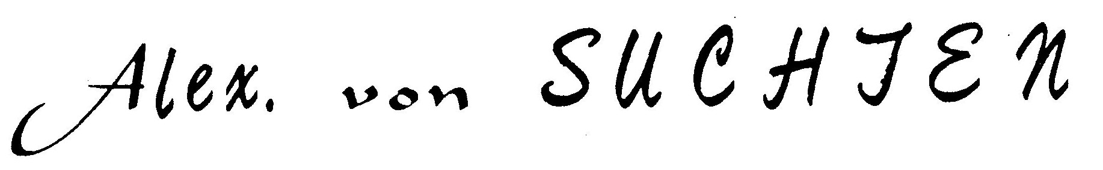

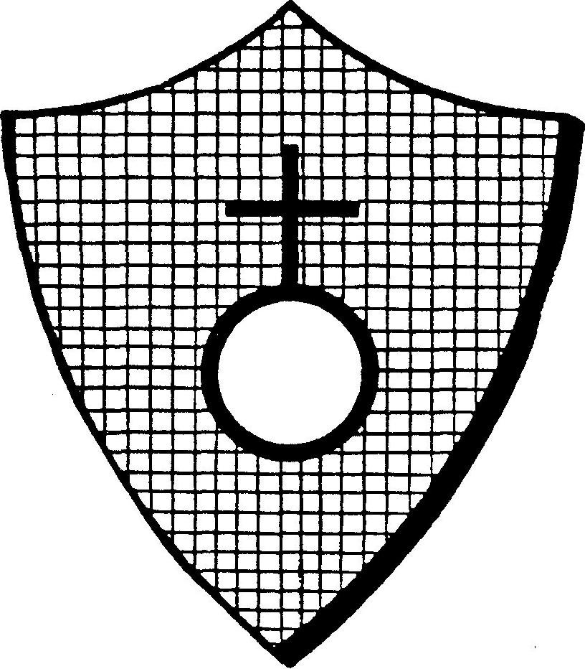
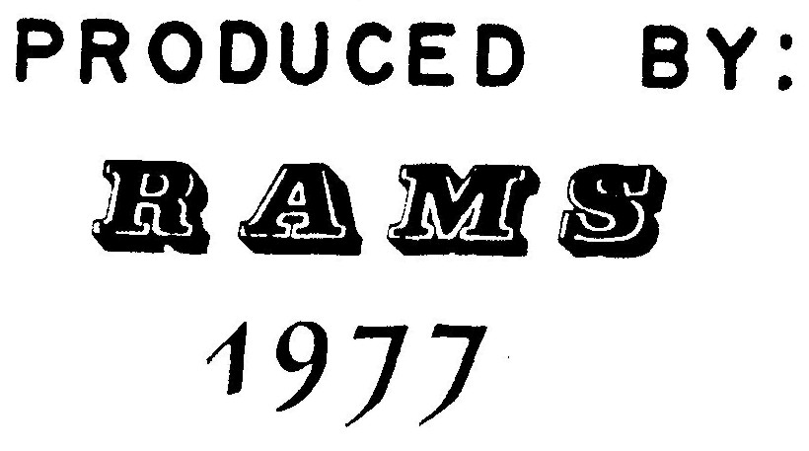
Alexander van Suchten

OF
ANTIMONY VULGAR

THE SECOND TREATISE
LONDON
Printed, and are to be sold
by Moses Pitt at the
White Hart in
Little Britain
1670
The Second Treatise
To the Honourable
JOHN BAPTISTA van SEEBACH
NOBLE SIR:
My honourable Patron and my good Friend, my humble service
in the first place presented to you: At your earnest request
I cannot but accomplish your desires, seeing you have a great
love and affection, by experience to find out the Secrets of
Nature, which at this time are known to few, and even wholly
hid in darkness. Although many of the Ancients have written
thereof, and their books dispersed, yet are they written in a
Magick stile, and profitable to none but those who from their
youth have been trained up in this Magick, or instructed by
God in such Secrets. Therefore, these Secrets for which you
humble yourself are in a deep pit, strongly locked up, so that
no man can open them unless he have received the Key from the
Spirit of Truth.Of the Magical 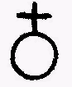 or of that of the
Ancients will I speak no thing in this treatise, seeing that
men will know nothing of it; but what they read of it they
apply only to common  ; of the which you only desire a
treatise which I will freely communicate to you and will write,
1
1. What it is. 2. Of what parts it is composed. 3. Into what
it may be resolved again.
And you shall in this treatise understand me no otherwise
than according to the Letter; for I will use here no Metaphors,
Allegories, or Similitudes; only I will describe  with a
plain stile, that you may not be deceived, though you prepare
it according to the Letter, and ye shall obtain that of which
I write; by these, you may also judge whether in common 
that secret, or Chymical & Physical Mystery be or not, of the
which Paracelsus and the Magicians have written.
Now 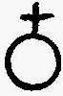 as it cometh out of the Mountains, is not pure as
it should be; for it is mingled with stones of the mine. I
never saw any that came forth pure from the Mountains; there-
fore ere one use it, it must be purified, which purification
is done by digestion;but this digestion is a Sulphureous Fire.
The best 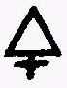 is a 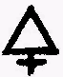 Metalline, and though Artists do
purifie it with vegetable fire, that is with Tartar, yet is
this digestion not natural, But that the Tartar divides the
Regulus from its Faeces this is the cause that the 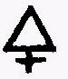 of 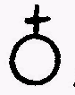,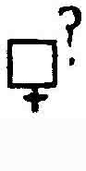
is more Vegetable than Metalline, but you shall purify it with
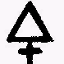 that is sprung from Mercury, and not from Salts; for this
metalline 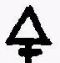 will ve reduced in the Arg. vive. of  into
Arg. vive, and lastly out of this Arg. vive will pure gold be
made. How this Metalline 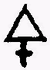 that purifieth 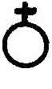 is only in 
and no where else, and this purification is done thus: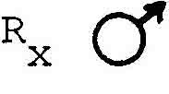
or Iron 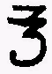 4 (I am wont to take pieces of nails which are
neither gross nor thick) put them into a strong crucible, and
set them in a wind Furnace. Let it stand so long till you see
2
the Nails or Iron are soft, then put into the Crucible 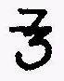 8
of  , make a strong fire that the may flow well in
the , then cast into the crucible with an Iron Ladle, a
good handful of Saltpetre; then let them boil up together
in the Crucible (let the Crucible therefore be considerably
great, that it boil not out) and let it stand still till all
be quiet and flowing, then cast it forth into a casting pot
so the REGULUS setleth itself so soon as the matter is coagu-
lated in the Puckle-pot. Put it out and let it cool, and strike
the Faeces from the REGULUS, which appeareth and shineth like
a marchasite. The Faeces you may lay up till you know what to
do with it for in it is a mystery of which I will not speak at
this time. Put the REGULUS into a crucible again and let it
flow; when it floweth, then cast therein one 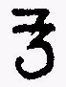 and 1/2
of & let them flow well together, then put in as much
Nitre as you did before, and let it flow as ye did at the first
time, cast it into the Puckle, strike the Regulus off from the
Faeces. This Regulus is purer and finer than the first. Cast a-
way the Faeces for they are worth nothing. Let the Regulus melt
the third time in a Crucible, and when it flows, poure thereon
a ladle of NITRE, and when you see that the NITRE floweth on the
Metal as on Oyl (which must be done with a strong fire otherwise
the Nitre coagulateth itself and be hard) then cast it into a
puckle, strike the Regulus from the Faeces. This Regulus is
yet finer, purer and more Metalline than the former; the Faeces
are nothing worth. Fourthly, let this Regulus melt in a clean
Crucible, and when it is melted as pure 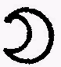 , cast some NITRE
thereon, let it penetrate through each other & then cast it into
a Puckle, beat the Faeces off from the Regulus, which Faeces will
3
be of a golden color and then it is prepared. The Regulus will
be as white as 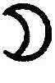 , and have above a fine Star; this Regulus,
if it be rightly wrought, will weigh four ounces and the work
may well be finished in two hours. Some copies say twelve
hours and in this manner is common prepared, wherein you
shall mark this piece, VIZ, what it is that thus divideth the
Faeces from . You shall not think that Nitre doth it, but
know that Antimony draweth out the soul from  , that is,
his best 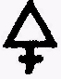 , and reduceth the same into 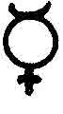 ; this
is nothing else but fire, and hath the operation of fire which
digesteth the crude into and divideth the Mine from
the Metal; you shall also know that this of is hid in
this purged , under the whiteness of the Antimonial Mer-
cury; for this Lunary whiteness which you see in the Regulus
is not from his 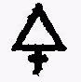 but from Arg. vive, under which lurketh
MERCURY OF MARS which is nothing else than SOL: this of
MARS is also nothing else in the aforesaid of  than as
a Spirit or an air, and remaineth so long living in the Arg.
vive of  till out of it be made a body again, this is 
and then divideth itself from the of .
So now you understand what fire is which thus purifieth common
ANTIMONY; you must also understand what that fire is which
purifieth and digesteth magical ANTIMONY, that is, what that
SOL PHILOSOPHOR is which we call  POTABILE which even so
well divideth itself in the end from PHILOSOPHOR
as the  divideth itself from the Arg. vive of ANTIMONY.
Therefore, it is very necessary that you seriously consider
how it worketh, so shall you find what nature is; not only in
4
common Metals, but even in all things, and in the Metals of
PHILOSOPHERS, which are known to the Wise men. The chymists do
assay ANTIMONY by iron; when they have done this, they know not
what they have made, nor the working of Nature, nor do they know
what Nature is here: therefore teach they nothing, but remain
Fools and Asses. Seeing that they have now divided ANTIMONY
from his Mineral Faeces, they should also know that in this
ANTIMONY there is as yet a Faeces, which is nothing else than a
burning ; when this is divided, so cometh ANTIMONY
again into his first matter or being, which is nothing else but
Arg. vive, and this Arg. vive is created out of the greatest
Mystery of Nature but Plato commandeth me to rest here.
(VIDE: NICHOLAS the ALLOBROGIAN.)
To divide the from the purged ANTIMONY is the clearest op-
eration but therein is a great knowledge hidden: So much thereof
as is necessary for the knowledge of this Work will I manifest;
but the other for divers reasons will I pass by.
A thing, if it be destroyed and mortified, it shall be raised
again and made living; and the same thing which is the cause of
death by separating the life must have two powers in it, of sep-
arating and vivifying; and these two must be one in power, but
two in numbers for all Mysteries spring from this Fountain and
are one essence, wonderfully distributed according to the will
of God. This Will of God is the specifick of every creature and
a being incomprehensible by sense not less than God. Now is
ARGENT VIVE dead in  . Shall it be made living, so must it
be raised up by that which it hath been ere it was dead
for that life is in it very abundant and incorruptible; nothing
5
which is dead can be made living but by his own and proper life
and not by the life of other things; who writeth and teacheth
otherwise is no philosopher, and the destroyed life, when it is
again made living, is the Ferment of living things by which it
was made living; and that thing is by Augmentation and Multi-
plication, Magical. Hence it followeth that in living things
there must be a disposition which is transmutable into the dis-
position of other things, if it would be raised again: for the
Will of God that all things must die, is that Specifick of all
Creatures which after death augmenteth it self infinitely.
Now it followeth farther that those living things which are
serviceable to our work and manual operations, by which the
Metals are also transmuted into Sol, must also have such a
Specifick in that they can be brought thus by no art without
Regeneration as the senseless Alchmysts give forth; for were
there no Specifick therein, how could they be transmuted, be-
cause Species is not transmuted into Species; for if transmu-
tation be not done, so can also no seed grow and augment itself;
for that is against Nature. Therefore must that living have the
nature of water, as you can see that a grain of Corn cast into
the Earth is made living by water, that is, in the Grain is a
dead water, which is by water made living again, and the Fer-
ment of water is that which giveth the water his Specifick
Nature, so do infinite grains grow from one. So understand in
this operation that the ARGENT VIVE of ANTIMONY 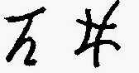 is dead,
and can never be made living but by ARGENT VIVE. In this manner
is corruption regenerated, and multiplication in the form of
Metal made.
6
You may here demand, Seeing the water multiplieth the grains
in the earth, and is transmuted into very grains, if also the
ARGENT VIVE of Metals multiplied with common , may be made
again into a Metal? To this I answer that this is not possible
in common Metals, but in Philosophical Metals it may be done
very easily for our MERCURY layeth his Specifick from him, and
taketh it again by Art; that is, from him may be made SOL and
LUNA, which it was before, but why this cannot be done in common
Metals, there are many Reasons, which I will pass by at this time.
Now the MERCURY of ANTIMONY shall be living; that is Arg. vive
shall be made per Arg. vive; but this cannot be done without
mixture, and farther, we see that Regulus will not mingle in it
with common Arg. vive because of the which is in the Regu-
lus; for seeing the same is not Metalline, it hath no communion
with the Arg. vive that is common, and it hindereth the mixture.
Therefore must there be a medium betwixt common ARGENT VIVE and
the MERCURY OF ANTIMONY; this medium must be a separative power,
which is not in common Arg. vive, for in it is no Specifick;
and the separative power is a Specifick which coagulateth Mer-
cury. God hath made this ARGENT VIVE in the will of man, which
notwithstanding is nothing else than common MERCURY and that of
the Philosophers. These two remain two in the will of man, that
he can bring a Specifick to them, which is necessary for there
is none there: according to these things, viz, the separative
is a Specifick MERCURIAL, but one must know in what MERCURY it
is to be found, and by experience it is found that it is in no
other MERCURY than in the MERCURY OF LUNA.
Therefore, take of LUNA PURISSIMAE one ounce, REGULI PRAEDICI
half an ounce, let the 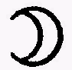 glow well in a crucible, afterwards
7
cast the Regulus on it, so will they melt presently and stand
in the Crucible as fine Arg. vive, cast them into an ingot,
and you shall find a Mass metalline of the colour of Lead; beat
this metalline mass to a powder, which will easily be done.
Afterward, take fine Arg. vive, four or five ounces, pour it
in a small Phyal-Glass and then pour the powder on it, let it
stand a night and day in B.M., so goeth the powder into Arg.
vive; stir it well together and when the powder is well ming-
led with the common Arg. vive, then pour it out and amalgam
it well on a stone, so will the Amalagam thereof be red. Put
thus Amalagam into a wooden dish, and rub it well with a
Pestel, so will the water be black; cast this water off in
part and put more water on, and rub it till this water be
black also. Do this so long till the Amalgam be made white,
the blackness which is washed from the Amalgam settleth it-
self in the bottom of the water, which keep, and cast the
water away again, put this Amalgam again into a Phyal, let
it stand in a B. a night, pour it out and wash it again. So
giveth it a blackness again, which pour to the other, wash
it so long till it give no more blackness; you may also grind
this Amalgam with pure, clean salt, so cometh the blackness
the sooner from it. Now when the Amalgam is made clean again,
set it again in a Phial in a B. a night and wash it again.
Reiterate this work so often till no more blackness goeth from
the Amalgam, then will it be pure, clean, bright and white; and
mark the more blackness the Amalgam giveth, the more MERCURY
is resolved from the ANTIMONY. So soon as no more blackness
showeth itself (ABSTRACT AND COHOBATE IT 7 OR 9 TIMES, THEN
'TIS PHILOSOPHICAL ) in washing presently, then distill in
a glass retort the Arg. vive from Luna. If the washing is right-
8
ly done, so shall you find your LUNA bright and clear and
white in the retort; but if your LUNA be of a leaden colour,
it is a sign that it hath as yet ANTIMONY amongst it; there-
fore must this washing be done for so long and oft till no more
blackness come forth; the Recipient must be full of cold water
ere you distill the MERCURY into it, then shall you find a
bright Arg. vive which now is three-fold, viz: Arg. vive
Common: Arg. vive Antimony, and Mercury of Mars. This you must
know that MERCURY OF MARS transmuteth the other two into his
Nature, as other Metals do, because MERCURIUS MARTIS is not
universally and radically mixed with the other two, but di-
videth itself from them, as you shall hear. Therefore, this
Arg. vive is not called Arg. vive of Mars, but Mercury of
Antimony for Antimony is fuller of Mercury. That Arg. vive of
Mars which is hid in this Mercury of Antimony, is SOL volatile;
and this you may not only believe, but also see it with your
Eyes. If you take a little of the Amalgam washed clean, and
gently evaporate the Ar. vive from Luna, so remaineth the Aurum
Volatil, that is, the Mercury of Mars with the Luna, and tingeth
the Luna into the highest coloured Sol. But, seeing that this
Sol is not fixt, the Fire driveth this Tincture from Luna. Here
also is a point to be marked, that this SOL VOLATIL, which tinges
Luna into Gold, but not fixed. Who understandeth the cause of
this is not ignorant of the Sophistications of the Alchymist
who would tinge Luna into Sol for they understand that Mercury
alone is the Tincture; but when it is changed into Metals, then
it loseth the power of Tinging, and if it were fixt, so is a
fine Metal, for Metals are nothing else than Mercury coagulated
and fixed. But in this Work are only coagulated or fixed.
How Mercury of Antimony of Antimony tingeth is a more subtill
9
manual operation. He that will make it, must well know the fire;
therefore look well thereto; I myself have oftimes made it and
I have also oft failed.
Now how the of  shall be fixt into true  and
the of  shall be transmuted from other Metals into
this Nature will I not hold from you. For in this operation
every one seeth what the Metals are, who have not his five
senses bewitched (I speak of true coagulation, not sophistical)
and can mark that it is not possible to make from  , or
out of 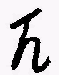 and 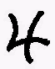 Silver; so sees he also very well that
common will not be coagulated artificially; but the Arg.
vive of Metals easily, which before hath been coagulated; yet
not every coagulated, but the alone of  ; for in
this of  is found the nature of the last fixation; but
in 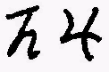 not. Therefore cannot any man give them that
which they have not from God and Nature. It troubleth me not
that many Chymical Books are written against the Truth, what
the Searcher of Alchymy imagineth and understandeth in his Trans-
mutations is altogether another thing; therefore can I write of
this Sophistry and speak with Paracelsus: They which understand
Alchymy according to the letter, reap nothing but tare straw.
Now concerning the before mentioned, which is distilled
from 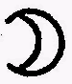 you shall know that it penetrateth the Metals and
divideth the Elements of the Metals; that is, the and 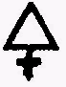
from one another; common doth it not; it must then be ac-
uated by the of Antimony and be changed in his nature and
essence, as now is declared to you in this operation. You shall
also know that every Metal hath his peculiar operation, and is
10
not resolved as another. I will in an hour bring out of
out of can I hardly do it in two months. Therefore, much
lieth in the manual operation.
The practice how it is performed with the of Venus must I
here shew, for this cause that you may find the Gold which
coming from  , lieth hid in the of Venus. That is it
of which I have made mention; this  is nothing else than the
Mercurial Spirit which is in  , as the soul in man; but
seeing this SOL is no more corporeal, as it was before in
but through the Mercurial Spirit of Antimony is made a Spirit;
it can no more be more corporal but only by the Spirit of Salt
in Venus. This Spirit is not the of Venus, also not 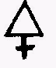 ,
but a middle betwixt both; when this middle cometh forth of
Venus, then do his parts fall in pieces, that is, his and
the of Venus abideth in the Antimony; the 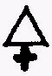 must be
washed from it, and is a Sulphureous gray Earth like Ashes.
Take 1.2 of the best Hungarian Vitriol, dissolve it in common
water, set it in a strong Pot over the fire, and cast a handfull
of small pieces of iron therein. Let them seeth half a quarter
of an hour; then put away the water, and put to the Iron the
which is have distilled from 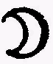 , so the Venus which the Iron
reduceth from Vitriol amalgameth itself with the Arg. vive:Wash
the Amalgam clean, that all the pieces of Iron come from it; now
when this Amalgam is wholly pure and clean, let it dry and then
put it in a Glass-Phial, set it in B.M. and let it stand there
in eight dayes, so will this Amalgam be of a dark gray; then
pour it out and wash it clean as men are wont to do with an
Amalgam, in a Dish. The powder which is washed from the Amalgam
11
put apart; put this Amalgam eight dayes in B.M. and then wash
it as before; this work must be reiterated thrice. If you would
resolve all the into and , then must you do this so
oft till that the Amalgam be made into pure ARG. VIVE; for it
will not be done so quickly. When you have had this Amalgam
thrice in B.M. and thrice washed, then distill the ARG. VIVE
from the ; as you drew it before from the 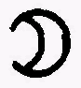 . This is
called of : for it is no more vulgar , nor yet is it
of  but through the of it is fermented and transmuted
into the of . This of is a wonderfull ,
as every one can try who shall use it in Chymical Operations.
The precipitate also made of this is exceeding bright and
wonderfull in the eyes of Alchymists; but as bright as it is,
it is a gross poyson in physick. Keep yourself from it, let
not his fine appearance deceive you. In this of
is  out of  , which I have oft mentioned, yet hidden.
It wanteth the frigidity of the Moon, by which it shall be
coagulated in the perpetual and first coagulation of Sol; and
the process of coagulation is thus:
Take of fine part I wherein is no Gold, of this Mercury of
Venus, parts IV, make an Amalgam thereof, and that the Amalgam
may the easier be accomplished, dissolve the Luna in common
Aqua Fortis and precipitate it with , as it is commonly
done. So falleth the to the bottom and is a fine, bright
powder, which may easily, by grinding, be Amalgamated with
the Mercury of Venus. Wash this Amalgam that is be clean and
bright, put it into a Phial, and let it stand for 24 hours in
B.M. boiling, then will it be black as a Coal; take it out,
grind it on a stone, and wash it clean; this blackness is the
12
Soul of which is drawn from the Spirit of Antimony and in
this last work is coagulated into Sol. With this Sol there are
as yet Feces of , which separate themselves from the Mer-
cury of Venus through this coagulation; for the Mercury of
Venus is always green in the superficies. This Green shall be
coagulated with Sol (note: other copies say 'Luna') and being
separated from Arg. vive shall be reduced into a body, and so
is the Spirit of  found; and so you see what it was and
again what is from him. Now who hath a desire to take pains, he
may try how much is in one pound of 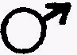 , so much Sol
shall he find therein and not more. He shall also see that more
cost goeth to this work than the Sol is worth. The Arg. vive
which is in other Metals cannot be so coagulated into Sol; but
it continually remaineth living; the Reasons having been shown
before. Thus is the Arg. vive vulgar acuated with the Mercury
of Antimony, that it draweth all the Mercury from imperfect
Metals and is transmuted by them into their Nature. As it cometh
to pass in , have I here declared by the way of Sol out
of  , which must be in this work for the purifying of  ;
so have you also heard how this Sol is again extracted out and
appeareth before the eyes; otherwise you would not believe that
the purification of Antimony is done by the Sol in .
Now will I farther write to you what Medicine there is in
common  ; afterward for a conclusion will I impart to you
as a brother, what farther out of this Regulus of  can be
made; for I dare not in truth boast and say, that it is not
unknown to me, and I will write to you for a warning (If God
give you his Grace that you can understand) what it is that
13
seduceth so many people, yea, even the Learned; and captivated
them and brought them even to their Grave.
De Sulphure Antimonii
Now concerning the other part of  , that is, his 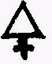 , you
shall know that it is a fatness and assimulateth itself to the
Fire which is in a black Coal. Therefore, take the blackness
which you have washed from the Amalgam of and 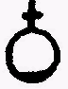 , dry
it in the Sun or otherwise in some gentle warmth. So shall you
have a powder of a leaden colour to which, as yet, some Arg.
vive vulgar doth cleave, abiding with it in the washing so now
if you can stifle this powder in a close warmth as Colliers make
wood Coals, then will it be black, and altogether like beaten
or powdered Coals: but if you cannot so stifle it, its no great
matter.
Take this powder of a lead colour, put it into a Crucible, put
it on the fire, but make it not to glow, either inwardly or out-
wardly; so will the Mercury fume away. This powder is inflamed
by the warmth, and burneth not as 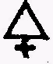 with a flame, but as a
glimmering dry coal which giveth no flame. When it is so burnt
out, there remaineth in the Crucible a powder which may be re-
duced into Regulus. Weigh this powder, so shall you see how much
of the Antimony is resolved into his parts, and if you could dry
up this powder that it be black, and the Common Mercury cometh
from it, so may you reckon how much of the Common Mercury is
come into this Mercury of  and how much combustible 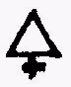 was
in this Arg. vive. So then you have the knowledge of  fully;
that is, his Elements of Arg. vive and 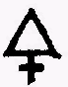 . This is enough to
14
shew what  is, and how the common Arg. vive is fermented
and actuated through and with it; that it can thereby resolve
the other Metals, every one according to his Nature and dis-
position. How it is done in the process is sufficiently
declared for examples sake: But how it is to be done in other
Metals, viz., how by the of  , a may be brought
forth, that commend I to the experienced and skilled with the
Fire: For is was not my purpose to manifest all things.
The Medicinal Sweet
It's known to you before to prepare many ways of Antimony for
Physick, but I have not as yet seen any who have observed the
Arcanum in it. The good people imagine that whatsover is
written of Antimony is written of COMMON Antimony, which not-
withstanding they find not by the proof; therefore we may
justly think that MEDICINAL Antimony is much another thing, as
indeed it is. For the ANTIMONY OF THE PHILOSOPHERS is their
Mercury, and in it are all Medicines in potentia, therefore
it is called, Quintessence. In the Vulgar Antimony, is not
the Quintessence of Physick, but only the Essence of the Ele-
ment of Water, which Essence is a Medicine against the Sick-
nesses which spring out of the MICROCOSMICAL FIRE. Now the
Physick of this Antimony is not in his Mercury, but in his Fire,
of the which I have spoken briefly, which you shall in this
manner understand: In Wood there is a fire which we must have in
our Kitchens to prepare our meats; so is Antimony a fire by
which we digest our Medicines which thereby receiveth the ess-
ence of his Elements. Through this Essence, the elemental heat
15
in our sickness is also digested. For though the Galenists
think to drive forth the heat through Purslane, Endive, Night-
Shade and other cold Simples, but cannot do it, for the heat
looseth itself naturally; so is this Medicine in Antimony Vul-
gar and not only in it, but in all other things of the which
the Element of Water is the Mother. Therefore, is a Physician
even so little bound to this Antimony as a Cook to Beech-wood;
for when he hath it not, then he useth Birch or Willow, by the
which he cannot so well dress his meat. Besides this essential
Medicine as well as well in other things as in Antimony, and
is called in Magick AURUM. But of that Medicine which is pre-
pared by the Fire of Antimony, I have nothing to say. It is
known of to God and to those He hath manifested it. The wise
men call it their MERCURIUS PHILOSOPHOR and it is an Essence
which may be changed in all the Elements of Nature and Art;
for we know that this Antimony purgeth strongly upward and
downward, which is done not by the Essence but by the body to
which the Essence changeth. Now who can divide the Essence from
the Body, he hath found a Medicine that worketh neither upward
nor downward, but without purgation finisheth the work and
through a strong Calcination with Salt Spirit, which is the
cause of a Metalline Fusion, it be driven from it, that it
causeth neither Vomit nor Stool, but forceth sweat. Yet it not
the Medicine, but  calcined which is a poyson as the other
Metals are, which are strongly calcined which taken in the body
manifests it as calcined  . It may also be well di-
gested by 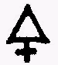 Metalline, that it may be red and fixed in the
fire, yet is there not in it what the Artist seeketh. Therefore,
all is lost which is begun with this Medicine. There is then a
16
thing which divideth his Essence from his Body, and is to
Of The Secrets In Regulus
Farther, of divers Arcana's which are in the above mentioned
Regulus, I have wonders to tell you; he which hath not thorough-
ly searched it will not believe me; for God lets not such things
be common, and come forth publickly, especially in these base
times, in the which Honor and Shame, Virtue and Vice, Lying and
Truth are equally prized, Now we seek not the Truth, but Vain-
Glory; and therefore doth God infatuate our sences, and we hate
and envy one another, and destroy our wealth, and we ourselves
are the cause thereof. Farther, I warn you, that I have discov-
ered much, and from my writing you may understand more than I
say, but all things shall not be written by reason of Praters
and Sophisters, which flatter themselves that they have been
of the Council of JOVE. I will also by this show forth my mind
to you and I wish you well from my heart, that you may try in
these things as much as myself, and I hope that time will give
that which I cannot, and in time know what I mean. Now that I
may keep my promise, you shall know that this Regulus hath de-
ceived the best Philosophers and Chymists of greatest account
and reading amongst us. For its such a rare mineral that there
is scarce the like in the world, and can make even the most
Learned and understanding men Fools. What is given me from it,
what I have seen from my good Companions mark. In my little
Book concerning the Mysteries of Antimony, which no man under-
standeth, even to this hour, have I said that Metal might be
made out of it. So much belongeth to this point, I did not then
17
cumber or trouble myself with it, but only explained myself
and manifested the Medicine which are in it and go under its
name. Now know that out of this Regulus all Metals may be made
such as Lead, Tin, Copper, Iron, Silver and Sol, and so made
that to the appearance and in hammering, melting, casting
proof of the Test, and in the driving by Antimony, they are
as good as the natural Metals. Lead which is made thereof, is
in all proofs, good Lead, only it is a little harder than the
Natural; but the Lead which is made of Antimony crude, not
washed, hath not that hardness; the Tin is exceeeding fine and
before coagulation, on the Touchstone, for certain as the
finest ; the Nature of Tin easily taketh it to its self
and is easily made Tin.
With the Copper it is thus also; for so soon as the Odour of
Venus is vegetant, it penetrateth the Regulus, and giveth it
the Nature of Copper; this operation is done very easily and
quickly. You can make an ounce of Regulus into Copper in the
time you can eat a soft egg.
Iron and Antimony are easily changed one into another, there-
fore is Antimony presently  ,and out of  is Antimony
easily made, and also 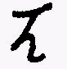 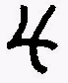 & may easily be reduced
into  , yet  easiest of all. These four Metals I myself
have out of Regulus; the other two, viz,  & 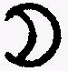 have I
seen my friend make, The is bright and may be cast, ham-
mered and beaten as other natural , and may be driven off
in 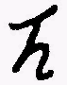 , and goeth not away from the Test. I thought a long
time that it was nothing else but the best ; but my Com-
18
panion said, that in weight, it was heavier than other
I therefore, being jealous what it was, did endeavour to
dissolve it in Aquafort made of Vitriol and Nitre, but it
would not touch it. Then I was much troubled in my thoughts
and laid it in an Aqua Regia, and it dissolved totally. Then
I thought that in the reduction it would be Sol, but I found
a white powder very like to Tin which is calcined in Aqua
Fortis. When I reduced this powder, there was thereout a glass
of a Milkie colour, so found I what I had for good 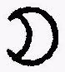 ;
nevertheless, I was not content with these proofs, hoping for
better things; and therefore I took four ounces of this 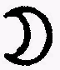
and amalgamated it with common , and set it in a gentle
heat four weeks. It was in the Superficies black and indiff-
erent hard; I took it out and beat it to pieces with a ham-
mer and then did grind it to powder, and afterward by oft rub-
bing, I made it into an Amalgam again as it was before, then
drew I the away in a retort and found my again.
This I amalgamated again not with common , but with
of 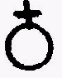 , of the which I have spoken before. This amalgam did I set, as before, three days and nights and found that the Amalgam, the longer it stood, the moister it was. In eight days it was as melted 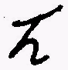 , and so it stood in the fire a month. Afterwards I took it out and distilled it by Retort, and the MERCURY of ANTIMONY, and the came all from the Retort and were a MERCURY. So know that the made of Regulus was nothing else than Mercury coagulated, and not constant in a metalline form, but goeth away again and will be Mercury which thing might well make a Chymist a fool. Now come I to , and to tell you what happened to me is a wonder.
19
When I had showed to my good companion, who thought nothing
else than he had got a great prize, he would not believe it
but took it into his own hands, and at length found the truth.
He began to question his  , and he spake, although I have
oftentimes tried it, yet will not I trust myself, but take this
half ounce of Gold and try it as you please. Mr. Hans, the
Goldsmith saith it is true Gold. So took I the  and brought
it to the Goldsmith, and asked him if it were Gold. He said it
was and he could work it for  , for to the Sight, Touchstone
and Hammer, it was very good  . Nevertheless, took I the 
and did put to it 2 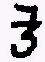 of to granulate it and divide it in
Aqua Fort. The dissolved itself and the  fell to the
bottom; this proof was true; this Sol powder I mixed with a
crude  , and cast it through Regulus; let it flow in a
crucible and cast Nitre upon it and drew the 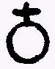 from the Sol,
and drew it off with 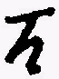 . This trial I found also true. This
Sol, driven off, did I cast again through with  and 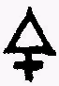 ;
then took I the Regulus and let them go away before the Goldsmiths
Bellows, for I had none. This trial was good also (the Sol stood),
on which every Chymist may justly rejoice. Nevertheless, seeing
the Luna deceived me, therefore could I not trust the Sol, but
causeth it to be beaten very thin, and amalgamated it with my
of 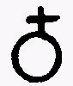 , and did set it four weeks in a gentle warmth
and took notice that the Amalgam was not hard, but soft, which
was grievous to me. Nevertheless, I did let it stand four weeks
and found my Amalgam much moister after then when I put it in.
Then did I put it into a Crucible over a small fire, that the
Crucible did not fully glow, and my flew away incredibly
swiftly from the  that I did not mark it but thought that
my was coagulated into , but when I weighed my 
20
I found no more than half an ounce and 2 quintileins (2 drams)
and thought certainly that the two Quintileins were pure Gold.
These two Quintileins I proved further with of 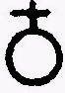 in the
same manner as the first time. Then at length I evaporated the
Mercury from it, and found my two Quintileins again. Then was
I merry and hoped that my companion would communicate his Pre-
paration to me and had Golden Mountains in my head and I
brought a good Message to my Companion. But he himself was not
merry, but spake evil of it. Well, said he, I had great labor
and pains with this , and more than I do say: what cannot
be, that cannot I desire. But let it be a fine sophistication
that which hath been made, for the Gold-seeking Alchymists
which run hither and thither, today devouring one tomorrow an-
other. The Gold which remaineth over and above thee is not come
from the Regulus, but is a composition of the natural  ; for
I could not coagulate the Regulus into if there be not good
Gold with it. This Sol hath remained in the test, but the other
not. I know not how to bring it further and now understand the
cause well, that that cannot be that I hoped. This fell into the
mind of my companion and I feared the manual operations and I
thought of my Metals. He spake that the 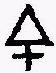 of which co-
agulateth the Mercury is not united to it in radice, therefore
it remaineth not with it. And if thou searchest thoroughly, thy
Regulus will not be again and remain so, but
will be Mercury again which neither you nor any other can co-
agulate to a good metal as some imagine, when they have the
of  , that the Art will not fail then; but it
is a Lunatick Melancholick Phantasie, from the which they that
are not experienced in Alchymy, but only book-learned, and have
21
gone on hear-say, can make arguements and conclude by themselves
but when they come to the fire they see their Folly. Tell me
when a dead thing is made living? When is his bound of Nature,
in Death or in Life? What hath it been before death or life?
Shall any come to this fixt immutable principle? What seekest
thou then in metals vivified? But these things speak I not to
thee, nor of thee, but of the Alchymists for whom pray God that
he deliver them from such unreasonable men.
Of this sort discoursed we much together and seeing then I was
intangled, as to hold the printed Books of Alchymy for Gospels,
but being led with I know not what Spirit, I doubted more than I
believed. Therefore I always did think of the cause wherefore
Alchymy was written by the first Philosophers, and did very
often treat with this my good friend and Companion, well skilled
in the Fire, concerning our   & 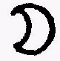,
in all which I found that true which the chymists put together
for the Alchymical Art, and am in good hope that he will put
from him this phantasie and think after the Philosophical Met-
als, Now so much as belongeth to you, Noble Patron and friend,
there is as yet one thing to be handled pertaining to this oper-
ation, which I neither can nor will withold from you the Chym-
ists such as RASIS, PETER BONUS, FERRAR, TREVISAN and the other
of the Dialogue, and many others who have well examined the im-
perfect metals, and had good experience. They at length remain
in this opinion, that it is impossible to make Sol by the Art
but out of Argent Vive. Seeing that they see that Sol is nothing
else than Argent Vive coagulated with its proper 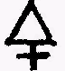and fixed,
now have they also well understood by their operation, that Mercury cannot be fixed into perfect Sol, unless Sol be dissolved
22
and brought into Mercury; this opinion have they taken from the
ground that they see that Nature could not fix that ARGENT VIVE
of with the external which cleaveth unto them;
much less shall Art do it; whereupon, they that thought to take
an ARGENT VIVE which hath been perfectly fixed before and to mix
this ARGENT VIVE with common mercury or other Metals, that both
may be one Individuum; but seeing this mixture cannot be done
with common Sol, they have taken the Sol in Mars and have thought
to mix it so with the common Mercury that they should never be
separated, but that the Sol should alwayes remain with the Mercury,
and the Mercury with Sol. That is, where the Sol is coagulated
again and also the Mercury is coagulated and fixed: in this prac-
tice everyone hath had his way or working, according to his under-
standing, and have spent long time herein; but this much is certain
to me, that they alwayes did, ere they obtained the end of their
speculation. Therefore, saith the worthy TRITHEMIUS, that Alchymy
is a perpetual Virgin and writeth of it thus: Chymia is beloved by
many and yet, She is chaste. She hath many domestick servants
which keep their mistress with watchful Eyes and oft take upon
themselves her name that they may preserve her from the embrace-
ments of so many importunate Lovers, and always unpolluted: Vanity,
fraud, deceipt, sophistication, covetousness, falseness, boldness,
lying, foolishness, poverty, desperation, proscription, cheating
are the Lacqueys of Chymistry: who feigning themselves to be the
Mistress, that they may keep her unravished, do freely prostitute
themselves to rich, covetous, worldly and proud Lovers. Thus much.
He that will not believe the true man, may search and try accord-
ing to his Phantasie, as I and others have sufficiently done. What
I have told you here, cometh from experience that it is so. Who
23
hath a desire to spend his money and time thereon, he shall find
it so.
Thus have I finished what I promised to write of the of  ,
and also what the Ancients have sought and found in this of
All which have I truly declared; on which you may conclude whether
this Mineral is known to me or not. They which boast that they can
make the of Metals without ARGENT VIVE, they give us to under-
stand that they are not Philosophers, and that they know not what
Corruption, Regeneration and the Multiplication of things is, and
if they did rightly behold their work, they would see that they
are deceived. Let Boasters be Boasters; believe in these things
nothing but what your eyes see, and consider alwayes the possi-
bility of Nature, so shall you come easily out of this Labyrinth.
Lastly, I desire that you would not be offended that I have held
you so long with this Treatise; the condition at present which I
suffer, permits little rest to write of this Operation, therefore
have I cast it on the paper so miserably; when I have more
leisure, I will finish other writings, which, as yet, for want of
opportunity, I cannot.
The Alchymists everlasting God dominate the Lovers of Truth with
His Spirit and bring them out of the Bonds of thick darkness and
unprofitable talk of supposed Learned men. AMEN.
FINIS
24
ADDITION

OUT OF
THE

HALIGRAPHIA

Of
BASIL VALENTINE
25
HOW TO MAKE THE SALT OF ANTIMONY
Powder good HUNGARIAN Antimony, small as meal, and calcine it
over a gentle cole-fire as men usually do. Always stirring it with
an Iron till all be whitish and it smoke no more, but endureth an
indifferent strong Fire. Then put it into a crucible and melt it
into a transparent yellow Glass; beat this Glass small, put it
into a retort Glass, and pour on it strong distilled Wine Vinegar.
Let it stand in gentle warmth, and the Vinegar will extract the
tincture of 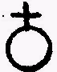 , and will be coloured very high, which Tincture,
or extract of may be further prepared and be used for an ex-
cellent medicine.
(V. BAS. VAL. TRIUM. MAG.)
Now when the Tincture is all extracted, and coloureth no more
the Vinegar, then dry the powder at the bottom wholly, which
will be black. Grind it with so much yellow , put it into a
melting pot, well luted, and place in an indifferent Fire till
the be wholly burnt away. Then grind the matter remaining
very small and pour on it new distilled Vinegar and draw the
Salt thereby, and afterwards through reiterated distillations,
draw off the eagerness of the Vinegar from it, and clarifie the
Salt with the Spirit of Wine, till it be bright, clear and white.
If thou hath wrought rightly, thou shalt have the Salt of 
wholly fixt and active, although there is another way to make
the Salt of , which is written elsewhere.
DOSE: 4 gr. and it is equal to the Salt of and cureth diseases.
(AND MAY EASILY BE MADE SOL)
26
THE USE OF THE SALT OF ANTIMONY
This SALT of ANTIMONY is of a wonderful operation; for it per-
forms almost all that the Salt of Gold doth, given in like quan-
tity; it cleanseth the whole body of man, purifieth the Bloud,
expels all Evils, consumes all obnoxious Humours, whence all open
sores have their beginning and recourse to; it cures the French
disease, taken four gr. at the most with a dram of the distilled
water of LIGNUM VITAE, sweating upon it, and this used daily
until amendment.
The water of Lignum Vitae is thus made: First, Grind it small,
then moisten it with good Spirit of Wine in a Vessell close stopt.
Let it stand certain days in a gentle heat; this done, pour a
good quantity of FUMITORY water or Scabious water, upon it.
Digest then, 14 days in a Bath, then distill it; Preserve the
Liquor apart, and the Oyl apart, in Glasses close stopt. Use the
water with the SALT of ANTIMONY. It is likewise used with good
success in other diseases whereof we treated in another place;
but an understanding Physician knows very well what virtues are
in GUAIACUM, and what benefit it doth in the cure of diseases.
There are other ways to distil a Water and Oyl of the said Wood,
which is needless to be mentioned here.
The SALT of ANTIMONY checks the Leprosie and other deep-rooted
27
Diseases; it is good against the Gout, and weakness of the joints,
purifies and makes good bloud, corroborates the Heart and the
Balsam of Man's Body drunk with a spoonful of AQUA VITAE; it re-
storeth lost strength, opens all internal Imposthumes, cleanses
all external corroding sores, being strewed into them, or duly
applied with good Plaisters or Ointments, Being dissolved in good
distilled Wine Vinegar, it doth in a short time bring great ease
to evil and incurable Sores to all Admiration. Being drunk with
waters of WORMWOOD or Carduus Benedictus, it cures all Agues of
long standing, which are deeply rooted, and admit no cure, esp-
ecially the Quartane. Being drunk with Mint or Wormwood-water,
it causeth a good digestion; drunk with waters of SPEEDWEL, Red
CORN-ROSE-water causeth a good memory.
This Salt is used in ALCHYMY or Transmutation of Metals into
Gold. If you add to it the fatness that drips out of the wheels
of the Chariot of the Sun, when as the Alchymists Phaeton under-
took to drive it, as the Poets describe it in their Alchymical
Fiction. For the excellent Fictions of the Poets which they
produce and write concerning the Celestial Gods, are nothing
else but Covers to conceal the Secret Arts and Mysteries of Al-
chymy. As of APOLLO when he slew the Serpent PYTHON; as also the
adultery of MARS and VENUS, and it shall be proved as I am of
the opinion, that Chymical Operations are revealed in Poetical
Fictions, when they write of the Loves and Venereal Actions of the
Gods and Goddesses; as also when they itroduce various and won-
derful Metamorphoses and Transmutations; for if we should under-
stand their Fables literally, we should prejudice wise Antiquity,
to think that such understanding and wise persons should believe
and write such and so many wicked things of the Gods.
FINIS

