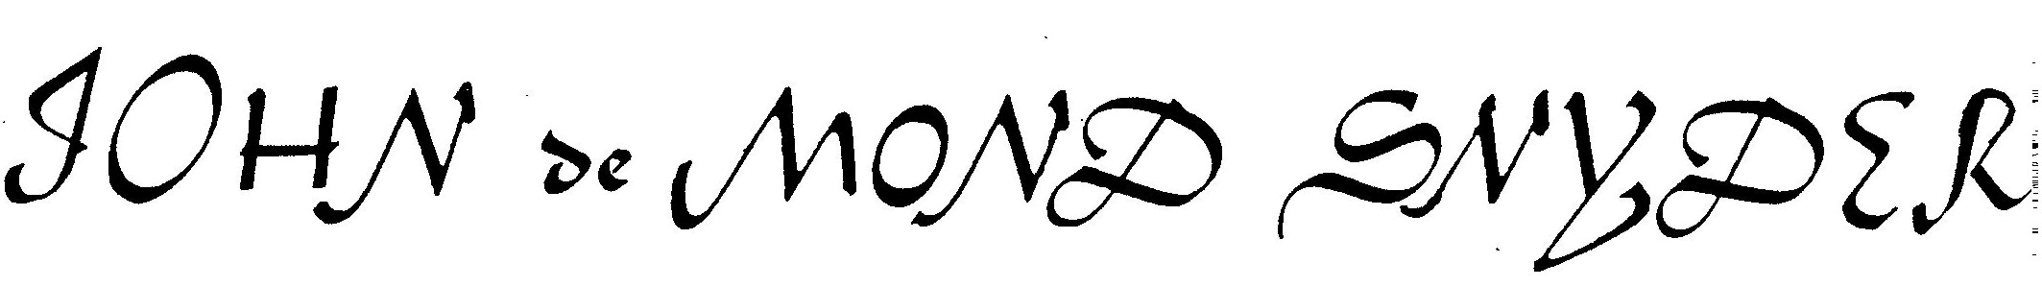

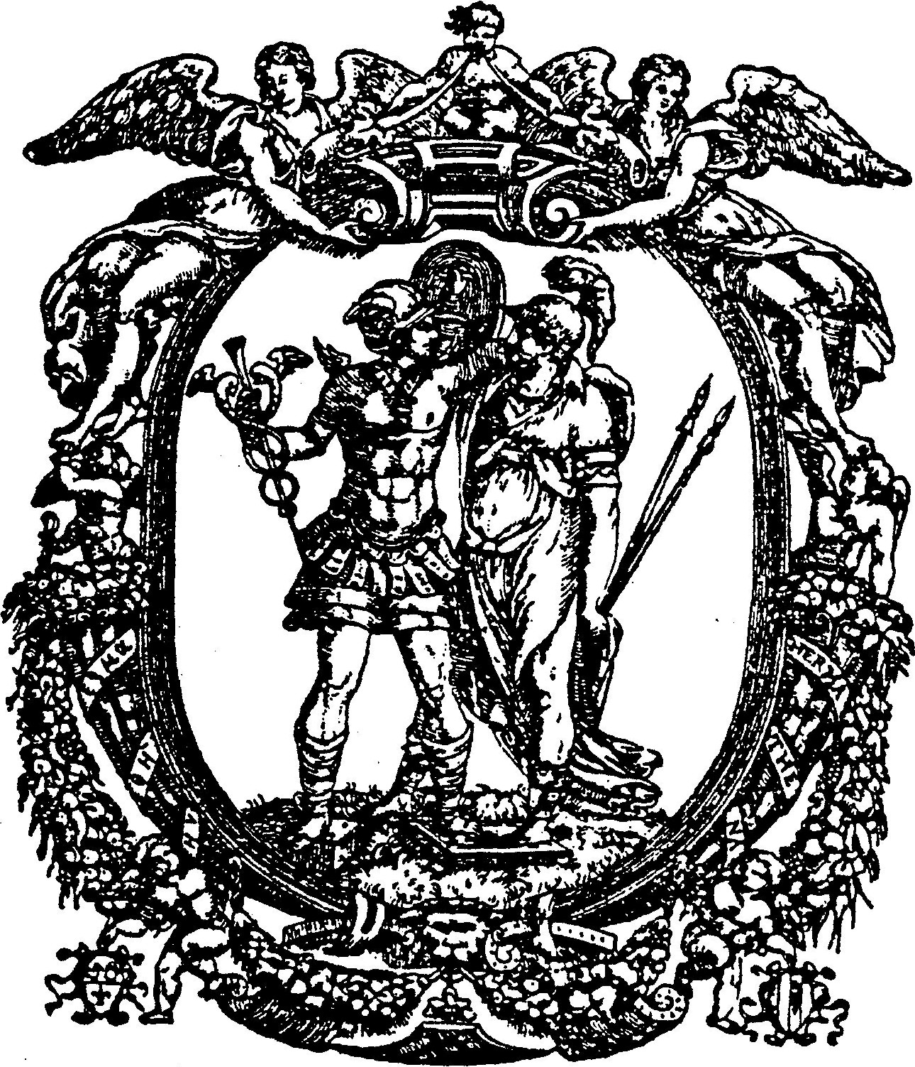

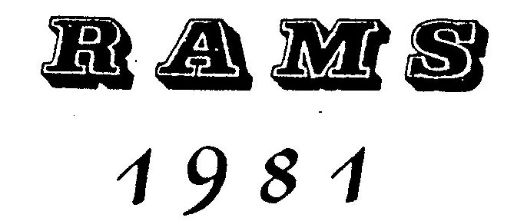
John de Monde Snyder's Universal and Particular Processes.

Translated from the Ehrenthal Manuscript.

The principal obstacle and most prominent corner stone whereon most persons have stumbled in the Universal Work is: Primo la materia, secundo the menstrum thereof and tertio the true destruction of the metals, namely, into their three principles viz. 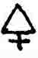 & .
Now how these things all follow each other, and must be taken for the high work of the Universal Tincture, will con ajuto dell 'Omnipotente be clearly described and noted in due order in the following, as is done in the actual and accomplished work & wrought by hand.
Firstly according to the description of the true Philosophers, among whom John de Monte Snyder, should be most readily and on account of his clear exposition most eminently considered, our true and genuine Master is the old dragon, and white Eagle, Man and Woman, two Mercurial Waters, Dua argenta viva, efconpin diversi nomi, but indeed it is with its own name Antimony and the highly clarified Sublimate. Of these two can the high work be made, to shorten the time however these two are animated & fermented with metallic & .
Now the preparation of the Antimony is in this wise.
First take finely powdered Hungarian (which I consider the best) or in case such cannot be had other fused 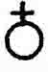 , in weight 1 lb., drop it gradually into a red hot crucible, and let it fuse clear.
When this happens have ready a thin iron rod well red hot and stir it into the fused and it will cause an ebullition and eat into the red hot iron as much as is needful in the space of half of a quarter of an hour, that generally 1 lb. of takes as much as 14 to 18 & even 20 Loth or half ounces. When that is done throw a handful of well dried Sal Niter upon it, and as soon as the Niter is fused it must be poured into a casting cone, and you will find a solid Regulus, of about 18 to 20 or 24 Loth or half ounces in weight. This Regulus must be purified twice with Niter and Tartar and it will show a fine star, especially the hungarian. Of Niter must be taken 1 lb. and of Tartar 8 Loth or half ounces and mixed together, therewith the martial regulus is purified, and reserved for the following use.
The other Reguli that are also needful for the high Work, that Mars add ed be brought, are to be made in this wise.
Take 1 lb. finely ground or pounded and mix thereto 1 lb. finely powdered niter and ¾ lb. pounded Tartar, mix it together, and put it into a large mortar of cast iron in spoonfuls and with the first spoonful throw in a red hot cinder well alight, and let the mixture decrepidate. When it has decrepitated, throw in some more, et cosi successive che si calcina Sulfo, when it has cooled pound the matter and let it fuse well in a red hot crucible well covered that it may fuse quite clear, when you will find a Regulus, weighing about 8 to 10 half ounces, which must once again be rectified with 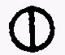 & . The scoriae remaining upon the Regulus must be reduced to powder and placed on blotting paper to filter, pour thereon common well-water, and this so long, until some of the can be traced in the common water, which can soon be discerned by pouring in of wine vinegar. The filter & wash it with common water. Accioche si levano totalmente le salie sal , quale in gustare, si puo cognoscere, and in this wise you get a fine deep-red of , which you must Dry and keep for further use.
Those feces that remained on the paper, let them again dry, powder them, and mix thereto equal weight of finely powdered Tartar and let it fuse in a strong heat, and you will get a very fine Regulus of high lustre, which up to now has become revealed to but few, & is considered an arcanum; now this Regulus is the first that wholly unites itself with Mars, although the first which was precipitated with & , and is got by the first fusion does also perform its own part, yet nevertheless this one is far higher esteemed, on account of its being almost wholly fixed and its delicate mercurial quality. The scoria remaining on this second Regulus must again be pounded and put to filter, and you get again a high in colour.
When no more can be got, take the faeces, mix with some Tartar, and you will see whether it will still give a Regulus, and should it give no Regulus, then take the feces and put them in a wide crucible to calcinate, until they become quite ashen or whitish, then put them to filter with common boiling water, that the 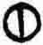 antimoni may be extracted. Let the water evaporate in a glass bowl, and you will find the ii, and if you would have it better and more clear, it is purified by frequent solution and coagulation, also with rectified S. V. or S. V. Tartarisati, but I for my part consider common well water best. This now is de how the id est the of the Regulus can begot.
But the Mercury for the high work of the universal particular Tincture is prepared in this wise, whereof also very clear description is given in the writings of John de Monte Snyder namely in his treatise de Metamorphosis Planetarum in Ch. 6, 22, 28, and other chapters can be seen and read the same kind viz.
Take 1 lb. washed clean with&common; grind it with 1 lb. good ,,and 1 lb. common Salt, grind it all to powder, fiat pulvis, fiat ignis, fiat exaltatio as John de Monte Snyder mentions in Ch. 28 when all has been reduced to powder put in in a convenient subliming glass and sublimate the at first with gentle fire until the steam & vapour is past, but afterwards with strong heat, that it may rise to the top quite white, and in this wise must the be clarified three times, for thus also avers Monte Snyder in Ch. 27 when he says: Volatile sursum, bis vel fer.
Now when the has been on this wise prepared, then take thereof 1 lb. finely powdered good and pour the same into a convenient retort, place it in a sand bath, and give it at first a gently fire, and a few drops of phlegm will pass over, but afterwards the lac virginis, and when there is no more milk, some drops of blood will come over, then the fire must be increased, and you will get more blood and afterwards a few drops of mercury vive will come, then give it strong fire, from above as well as from below for 4 or 5 hours then goes the cinabaris in collo della retorta, then let it cool, keep the lac virginis separate, the mercury vive also separate and lastly also the cinnabar separate in a vessel. But in case the lac virginis should not be clear and pure, then take Regulus Martialem 12 half ounces let it fuse, and put thereto Ur fine  plate, let fuse well together, and when it is well fused pour it out and pound it small, put it into a retort and pour thereon equal weight of lac virginis, distil it at first with gently fire, and at last with strong heat, and the milk become somewhat yellow, which must be animated in such a manner:
Recipe de Cinabrio 3 or 4 half ounces, put thereto 1 half ounce , pour or place thereon 16 half ounces de Menstrui; let it dissolve at a gentle heat and the milk will become blood equestoe' Mercurio noster sedgsiato (?) el fons vitae, verus ios noster essentificatus in which fountain the metallick  & , are apt to be purified and joined together, which manner now however by means of the magical elements, that are the Keys to health and wealth, all metals are to be reduced into & or how the metallick soul is to be got, and also the fixed Sal metallica to be conquered, the process depends more on the manual work, but as the Science without the work and reciproce the work without the Science brings no fruits, such Science and Manipulation, as far as is possible, is herewith clearly described.
The magical elements or the threefold magical fire is 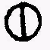 , & Regulus  which John de Monte Snyder calls us Saturni, il 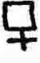 ,
si deve prendere accioche la anima, id est metalica conserved before the fire.
John de Monte Snyder in tractatis de Metamorphosis planetarum Ch. 15 thus describes the Magical Fire.
With these words Vulcan prepared an artistic firework, which was made of an unkindled fire, a fiery air and a vegetable salt.
N. B. The unkindled fire is , the fiery air is  , and the vegetable  is , and is thus observed in weight.
9 half ounces, - 3 thirds
6 half ounces, - 2 thirds
2 to 3 half ounces, - 1 third
Grind all together fine, let fulminate & keep.
The Conjunction and Amalgamation with the Metals and our id est regulo is done in this wise.
Regulus Martiale, ben purigato si prende 5 lotti et del  1 loth si fonde bene in sieme, poi si getta al cannlle e si tritura solilmense, e si serva per foliminare,
Regulo Martiale 4 lottoni & of the  1 loth sit amalgamo in igne.
Reg. 3 loth & de  1 loth,  et  .... 3 lotoni to
9 loth of the martiale Regulo. Regulo fatto per se, can et
 et primario il regulo ex scorijs, uti dictum est, take 4 loth powder such in mortano di fero, when this is done take thereto 2 loth thin lamels of iron, the thinner the better, lay them into a crucible with cover & let it get well red hot, then put in such powdered Regulus in spoonfuls & let it fuse well with great heat, but this sign must be observed that as soon as the Regulus with the  is in clear fusion then he has taken sufficient to himself, and it must then be cast, which will take place in about half an hour. Break the ingot and it must be white in colour, that is one sign. The other sign is this, I have taken 4 loth Regulus and 2 loth , and the fused mass will weigh at least 5 ½ loth, then
I am assured that the & Reg. are become one, which mass must be reduced to powder and kept for Destruction. In this wise are reduced all metals in materiam primam id est into our and is called the conjunction of the philosophical heaven with the terrestial planets.
Now how these conjoined metals are destroyed with the previous Described fulmine radicaliter in aperto Igne, the weight that must be observed, which is of great importance, the following is a clear report and actual experience as namely to the conjoined mass of gold and martial regulus of half ounce of these clear powdered mass are required of the aforedescribed fulmen.... 8 loth (or half ounces).
To one half ounce of the Lunar is required of the fulmen...6 loth.
To one loth of the Venereal .... 5 loth of the fulmen is required. Of the reg. el to one loth...6 loth fulmen; of the 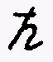 al 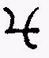, to one loth of such conjoined mass is required of the fulmen 4 loth the same also if you would fulminate the Martial Regulus.
Now when the fulmen & the conjoined metal have been mixed together then it is needful to have at hand a crucible as red-hot as is possible surrounded with red-hot charcoals. In such red-hot crucible the aforesaid fulmen with the conjoined metals is thrown in by spoonfuls, but that at all times that which has been thrown in before must be in fusion. Now when the whole matter has been thrown in, then take great care that the fire does not diminish, the better the fire and the stronger it is, the more throughly will the metal be destroyed, but on the contrary if the fire is too small the matter remains & hardens to a black mass, which can hardly be any more brought into fusion except with the most violent heat and projection of Sal Niter, but which cannot be done without Danger.
Therefore observe as a principal rule to keep a good heat in the destruction of metals.
Further let it be known that a certain sign must be observed that the metal does not burn away or be reduced to a black slag,
for when the metal in strong heat becomes a vitrum then all is lost, for you get then neither nor but only a totally burnt matter, that can not be used to universal or particular work and must be thrown away: To prevent this is of consequence to know the correct manipulation and observe this sign namely when the thoroughly mixed matter has been thrown into the Crucible and is continually standing in fusion, you will continually see for a certain time a flashing smoke above the crucible and not be able well to see the fusion of the matter, then is the time to cast and you will find a blackish mass and lowest at the bottom a little of the conjoined Regulus, the less there is the better, then you are assured that neither the nor the  have been endangered in the fire, as there was still some matter left for the fulmen to lay hold of.
The fulminated matter must now be reduced to powder, and placed to filter with cold common well water, the water filtered through is put together and some vinegar is mixed with it then the water becomes and appears as blood, in this wise the metallic can be easily got by filtering the common water and acetum. But the following must thereby be observed, namely that all saline admixtures of the must diligently and well be washed away with common water, which can not only be known by smell and taste, but also the following sign will be observed, namely, when the common water has been poured on the filtered , and the water is filtered through, pour a little  into it, if the colour of the water is green or yellowish then there is still some saline admixed to the , but if the water gains no other colour than ordinale mente, then the has been well cleansed from all Salines.
Now when there is no more in the fulminated matter, then let the yellow feces dry, when they are dry, rub to powder and fulminate it adwith following manner:

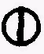 16 loth (half ounces)
10 loth (half ounces)
 2 loth (half ounces)
This is altogether pulverized and put thereto 6 loth well desiccated id est well dried feces mentioned above and mix, then throw into a red hot crucible, and let it fuse in strong heat for ¼ of an hour or more, then pour it out, pulverize, and put it to filter and with common water the little with addition of aceti is washed away. Then dry the feces, pulverize them and in a wide crucible put them to calcinate, the crucible being covered, and let it thus calcinate well for 12 to 16 hours, namely until it becomes whitish or ashy colour, then put it again to filter.
Filter the Salt well with hot water until there is no more Salt therein, qual nel gustare delle feco si puo conoscere, the water filtered through put into glass basons on hot sand and let it gradually evaporate until the  appears quite dry and white, then it is ready.
N. B. The Martial Salt will commonly fall somewhat reddish, except the first which give a quite white .
But if you would have these salts higher and more spiritualised they should be rectified with well rectified Spirit of Wine or else with rectified aceto or with common well-water, and their colour will be encreased, but I hold it advisable if they appear clear and white at the first time keep those for although one may dissolve and coagulate such salts they will be found in same weight almost.
The feces remaining from the filtration of the Salts, are kept and when there is sufficient it should again be tried with the fulmine, whether it still gives off a  , if not, it can be cast away.
In this described manner, all metallic and mineral salts are conquered and gained.
Now follows the Composition of the Composition of the Universale Generalissimo.
In this wise: Take of the fixed and clear  metalico, grind
it on a clean porphyry, thereof one half ounce, or as much as you
will, upon one half ounce of put 5 or more or 6 halfounces
lacle Virgineo place it in a gentle heat for some 40 hours, or at
the longest for 3 days and nights, and the therein will dis-
solve, as much as is agreeable to the milk, then pour it off and
keep it in warmth until the following conjunction.
Similarly take two half ounces and pour thereon 10 to 12 half
ounces of Milk, and let it stand as long as the  , and the
will become opened in the milk, when this has happened, pour the
two solutions together into a long necked phial close the mouth
of the phile well with a cork and white wax, and place it at first
ad digestionem into a very gentle heat for 30 or 36 days and nights,
and the matter will "become quite black and thick like pitch, then
give it a stronger heat, that it begins to come whitish or ashen
grey, then augment again the fire, that the matter gets quite white.
Now when it is become quite white (but before that many and wonder-
ful colours will appear) then give it strong heat, till it becomes
quite red. When it has been brought to quite a red mass, and the
matter on the bottom of the phial remains quite fixed, then it
must be fermented and imbibed.
For example: I have taken of the solution of the& circiter 20 half ounces, and put thereto 1 upon 10, as namely 1 loth (half ounce) de is. and 1 loth de , together with 2 loth lac virgineo essentificato, and letit thus stand until it again become quite red and fixed.
N. B. One to 10 is thus to be understood that nemely to 10 loth of tincture ½ loth de is., et aa. , with one loth essentificati must be taken.
To this massa of 24 loth when it has to be fermented for the
secind time is done as follows:
I take fine Pr. , three times passed dissolve the same in
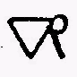 , precipitate it with Sp. is., or Tartari, lixivate the
gold calx well and throughly, that no acid remains therewith,
powder it subtilly on porphyry, to this tincture of 24 loth you
must have 2 loth gold calx, the 1 to 12 is the ferment. These
2 loth are mixed with 4 loth decocle Virgineo animiato, and
put to the above described 24 loth Tincture and fixed together,
now when it has again been fixed, then imbibe it again cum lacte
animato with the fifth part of the weight of the tincture, namely,
to 30 loth of the before described universal Medicine I take the
5th. part pro imbibitione de menstruu, namely 6 loth that is the
first imbibition.
To the second 7 ¼ loth
To the third 8 ½ loth
To the fourth 10 loth
Eat sic consequently each time with the fifth part of the already fixed tincture, that in this wise the Tincture in quantitate et qualitate in infinitum sau be augmented, and this Tincture on complete imbibitions tinges 1 part to 1000 parts of all imperfect Metals into . And the oftener such Tincture is dissolved and coagulated the higher it tinges. But the imbibitions must always be done with menstruo essentificato, which although it has been mentioned before, but there is a better and higher animation of the Menstruu made, if the red Tincture that already been got and is made in that wise.
Take 2 loth, of the Tincture ½ loth grind it well together and add 12 loth of the white milk, so that it may remain in gentle heat for two days and nights, then decant and use per imbibitiones ad infinitum.
In conclusion there is a still higher multiplication, which philosophers and adepts keep very concealed, namely they say by dissolving and congealating is the strength increased. I personally gained it by extra favour of our Adept.
Take of the fermented red tincture post of mam Imbibitionem 1 half ounce add thereto 10 half ounces menstruo animalo, let it dissolve in gentle heat, that it may go perfectly black and into putrefaction, then encrease the fire until the perfect red, the longer with stronger fire which happens within two months, and one part tinges 10,000 parts, and this is the true Multiplication that always encreases ten fold in mantitate et qualitate for ever, almost beyond computation.
But as concerns human health this must be observed, that such
de primo ordine before it has been fermented, id est, when it comes
to the perfect red, of the same 2 to 3 and at most 4 grains de
2 ordine, when it has been 7 times imbibed one to two grains,
de 3rd. ordine so such tenfold in quantitale of qualitate encreased
that a mustard seed therefore is sufficient. Take it in any con-
venient liquor or cordial. Come il adepto misustru isse.
Now follows the other Universal Work.
Which is not generalissimo, but only such a universal work that
changes all imperfect metals into constant gold and silver, but not
in such form and fineness as the before described, but it can be
augmented in qualitate et quantitate per imbibitiones, that one
part of such tincture can transmute several hundred parts of im-
perfect metals, and the conjunction and fixation is done in the
following manner:
Take lunar  1 loth, Sulphur 3 drachmas, Sulphur 3 drachm. Grind it together to finest powder, put it in a phiel con il collo longo, and pour in 6 loth of the milk animated with Antimonial Cinnabar.
Close the glass well with a cork and with white wax, place it
at first for some 20 days into gentle heat, and it will quite at
the beginning enter into putrefaction, and thus in gentle heat dissolve and coagulate, when you observe that the black is about
to pass away, then you must give another grade of fire, until it
begins to have divers colours, then give stronger heat, namely
the third grade, and you will get the perfect white, when the
white has taken place then give the fourth grade of the fire that
you may see the red. This red has no real stability, for it will
now turn whitish now reddish then is time that it must be fermented,
in such a manner when there is of the Tincture 8 ½ loth, 1 take
to it ½ loth and ½ loth  with 2 loth of the animated
milk, put it in digestion for some days and nights, at first in
gentle afterwards in stronger heat, namely in the fourth grade,
and get the perfect fixed red.
This is fermented to become Tincture in the following way:
Take reduced to calx by 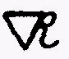 and lixivated of all acidity, if
the Tincture is in weight 11 ½ loth, I take of the calx 1 loth,
and 3 loth of the menstruo essentificato, put it together and when
it has come to coagulation, then I have 15 ½ loth, then I take again
the other imbibition as with the 5th. part, that is, 3 loth of
animated milk, let it again together coagulate and fix.
In the third imbibition take 3 ½ loth
In the fourth imbibition take 4 ½ loth
In the fifth imbibition take 5 loth
In the sixth & seventh 6 loth.
After termination of all imbibitions take out the tincture,
divide the same into other and larger glasses, and augment the
same again with the fifth part of the fixed tincture in quantitate
et qualitate ad libitum. This Tincture after seven imbibitions
tinges 1 part to 100 parts of all imperfect metals into constant
gold, and the oftener it is imbibed and coagulated, the higher
it gets in its operation, that one part transmutes several hundred
parts of impure metals into fine gold.
Then it is increased in quantitite in the following manner:
If you put of such tincture 3 parts to one part of pure gold in a crucible that well endureth the fire, lute the same well and
set it in a good wind and melting furnace and keep it in fusion
for three days and nights, when all will become a vitrum, of which
1 part thrown on 100 parts of heated Mercury ex destillatione of
the white milk will still become tincture, and tinges 1 part also
some hundred parts of other Metals into , and this is an increase
in short time in quantitate, but the Mercury must be made rather
hot before you project the tincture upon it.
But per corpo humano this universal medicine is used against all diseases, unfermented, from 4, 5 or 6 grains. Post eni Imbibitiones 1, 2, or at most 3 grains, but if it has been frequently augmented you give only one grain.
Particulare ex universali.
Take  or Sal 1 loth, 2 loth mix well together, with ½ loth well elixivated silver calx, grind it well together, and add thereto 3 ½ loth of milk animated with et Cinnabrio  i in this wise you put first the milk at the bottom of the phial, which is best if it have a flat bottom, and thereon put the mixture de  et fermento; Close the phial with a cork and white wax, and put it at first 2 or 3 weeks in gentle digestion that
through putrefaction it may get to perfect coagulation and ash
colour then increase the fire until the matter gets quite white,
when it is quite white then give it another imbibition with tacle
animato, that it may become more easily fusible than with 2 loth of
the milk, or also a little more, when it has come through putre-
factio ad albedinem, it is a medicine per comune ad augmentum
perpetuum in this wise that you take of this Medicine 3 parts and
put one part of com. that has been washed with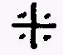 and common
 , grind it together and put it ad digestionem for 14 days or
21 days at most, and the will become perfectly fixed and able
to pass cupellation, in such wise that you can set such augmentum ad libitum and the augmentum perpetuum is always continued with a
third part of com.
But there is still a better augmentation that tinges all metals
into to be done with this particular process namely; when it has
arrived at the perfect white you can at once imbibe and ferment
it with both de or or also with both together and 2 loth
animated Menstruo that has melted with the fourth grade of the
fire to perfect red, and it is also very good and very serviceable
when it has got to the red, that it should again be imbibed with
1 loth and 2 loth de Menstruo and again be brought per omnes
colores ad rubedinem, then it tinges one part to 10 parts of im-
perfect metals except into constant gold, and such imbibition
only with addition of the 5th or 4th. part of de Solo Menstruo
essentificito; can such tincture be augmented so high in quantitate
et qualitate, that 1 part will tinge several 100 parts.
The other Particular.
Take well elixivated calx of Luna 4 loth et ana ½ loth. De Menstruo essentificito 2 ¼ loth put it together let it digest for a time of 4 weeks at first gently, then with strong heat, and all the a will become good .
The third Particular.
Take calx 2 loth, &  de Marte ½ loth, 1 ½ loth,
Menstruo essentificato con Cinnabrio 1 ½ loth, put it together
for a month, at first gentle and then strong heat till it gets
red, then imbibe it well with 1 ¼ loth id est 5 Drachmas of milk
and by strong fire let it get red at once. Of this medicine 2
loth projected upon 2 mark of standing un fusion gives 10 to
12 loth and when this medicine has been frequently imbibed with
Menstruo animato, it tinges also &  into constant.

Now follows how the true Aurum Potabile also potabile can be made.

Firstly make a pure de , or , dissolve the same in
Menstruo nostro animiato con Cinnabaro, leave it for four days
and nights in quite gentle heat, and the Menstruum will dissolve
the most noble lar or or and the menstruum will become
cloudly, upon the same pour rectified Spirit Vini Tartarisati,
leave it to putrify in Balneo for a month, till the S. V. becomes
highly coloured, distil the S. V. off with gentle fire, and you
will get the true Aurum Potabile, which can not again be reduced
to a corpus; Of this use 1, 2, or at the most 3 Drops. And in this
wise all Metallick as well de as of can be brought to
potability and used as high Medicine.
Further follows how all gems, as diamonds, rubies, and emeralds and sapphires can be augmented, tinged and brought into a true Tincture.
Take of the second or third Regulo made of the feces, when
the is fused with & and the has been washed off, as is
clearly described on page 6, take the same regulo, powder it, then
take thereof 3 or 4 loth and of the gem, be it Diamond, ruby or
what you will, mix it well together and put it in a covered crucible
should have a hole in the centre, place it in a fire of calcination
for 24 hours, then open the Crucible and feel with an iron rod
if there is any regulus left therein, and in case the regulus therein
is in fusion then let it go off with a good fire and stirring con-
tinually, till all is reduced to powder, then take it out, let it
get cold, and put it on an iron patola, let it get red hot in the
fire, and cast it while red hot into the hereafter described water,
and the gems will become perfectly calcined and can be reduced
to fine powder by grinding, and the more frequently this is done of getting it red hot and then quenching it the better it will be.
Common distilled well-water by weight 4 lbs. therein dissolve
 8 loth, Sal Commune 8 loth, and Sal Nitro 8 loth. In this water is done the quenching of all kinds of gems. Although there are also other calcinations of gems according to the ways of some adepts as with pure and clear with addition of a fixed Sal Commune, but these are long and difficult processes and the before described way is the best because given by experience and proved to be real by adepts.
Now when the gems have been reduced to subtile powder, take of the same one part as for instance:
Gem powder 1 loth
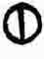 5 loth
3 loth
1 loth

this all well mixed together and ½ loth Cinnabrio ground into it that the gems may be more throughly attacked, and such composition is thrown in spoonfuls in a very red hot crucible and with best heat as possible kept in continual fusion for a quarter of an hour, then pour it out on a grinding stone reduce it to powder, and put it to filter with common well-water that all acidity may go away, but the sulphur you must conquer by pouringinto the first water running through the filter, of which by weight very little will be gained.
The feces are thus calcined ad salom but they must at first be well desiccated, else they are not good for fulmination:
Take the feces 4 loth
8 loth
4 loth
½ loth

mix it well together let it well fuse together for a time that one could say several times the Lords Prayer, then pour it out and with diligence reduce it to fine powder, then per filtrum deprive it of the saline which can be discerned by tasting.
When this has been done, take the faces let them again be well dried and put them to a good calcining fire in a wide crucible, and calcine for 24 hours, that the crucible may stand at all times in a good heat, then take it out let it cool, pulverise, and put it to filter with boiling water. Put the water into evaporating basons till the  is well dried, in this wise you get the  & of all gems.
The lac virginis is animated therewith in this way: Take of the white milk which is quite pure which must not be animated with ought else than the of gems, as follows: 1 loth of the of gems is taken to 8 loth of the milk, place it into gentle heat, that it may dissolve then let it stand in a closed vessel for three days and nights, and the menstruum will absorb the most noble and essencified therewith.
But the Conjunction of the Tincture is done in the following way:
Of the white unfermented earth, generated by the conjunction of  et cum menstruo nostro and called abbificatio;
take abbificatio 4 loth
of the gem ½ loth
the gem ½ loth
Of the rightly animated Medicine 2 loth.
This all well mixed, namely, la terra alba et together put into a phial and then the menstruum poured thereon, set it at first in gentle heat for 8 days and nights, then continue with stronger fire to the highest white and it will tinge Crystal, made soft or red hot, to the highest Diamond, in the red colour should it have been fermented with Diamond, to true Carbuncle, in the green colour if it is so fermented with emerald, to the highest green Emerald.
In the blue colour to Sapphires and lastly should it be fermented with the et delli rubini and brought into these, it will also tinge Crystal to such high Rubies as in lustre will not be inferiour to diamond.
This tincture is always animated with its like animated menstruo continually multiplied and imbibed. Always if there is 6 loth of Tincture in weight like 1 ½ loth of the animated milk.
One more Particular pro Corpo homano to be used in all Diseases, its dose is from 1, 2, to 3 grains.
Namely Sal 2 loth
½ loth
1 loth
 1 loth
This all well mixed together put it in a phial, and pour thereon 1 ½ loth de menstruo animato, and digest it within two months time at first in gentle and afterwards in strong heat to redness, it is an excellent medicine as before mentioned.
It is augmented con et in this wise:
Of the Tincture there is 7 loth, take thereto 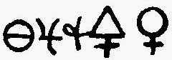-- ½ loth, menstruo animato 1 loth and in this way it is always augmented.
Merton 24 IV. 1901 J. K.

