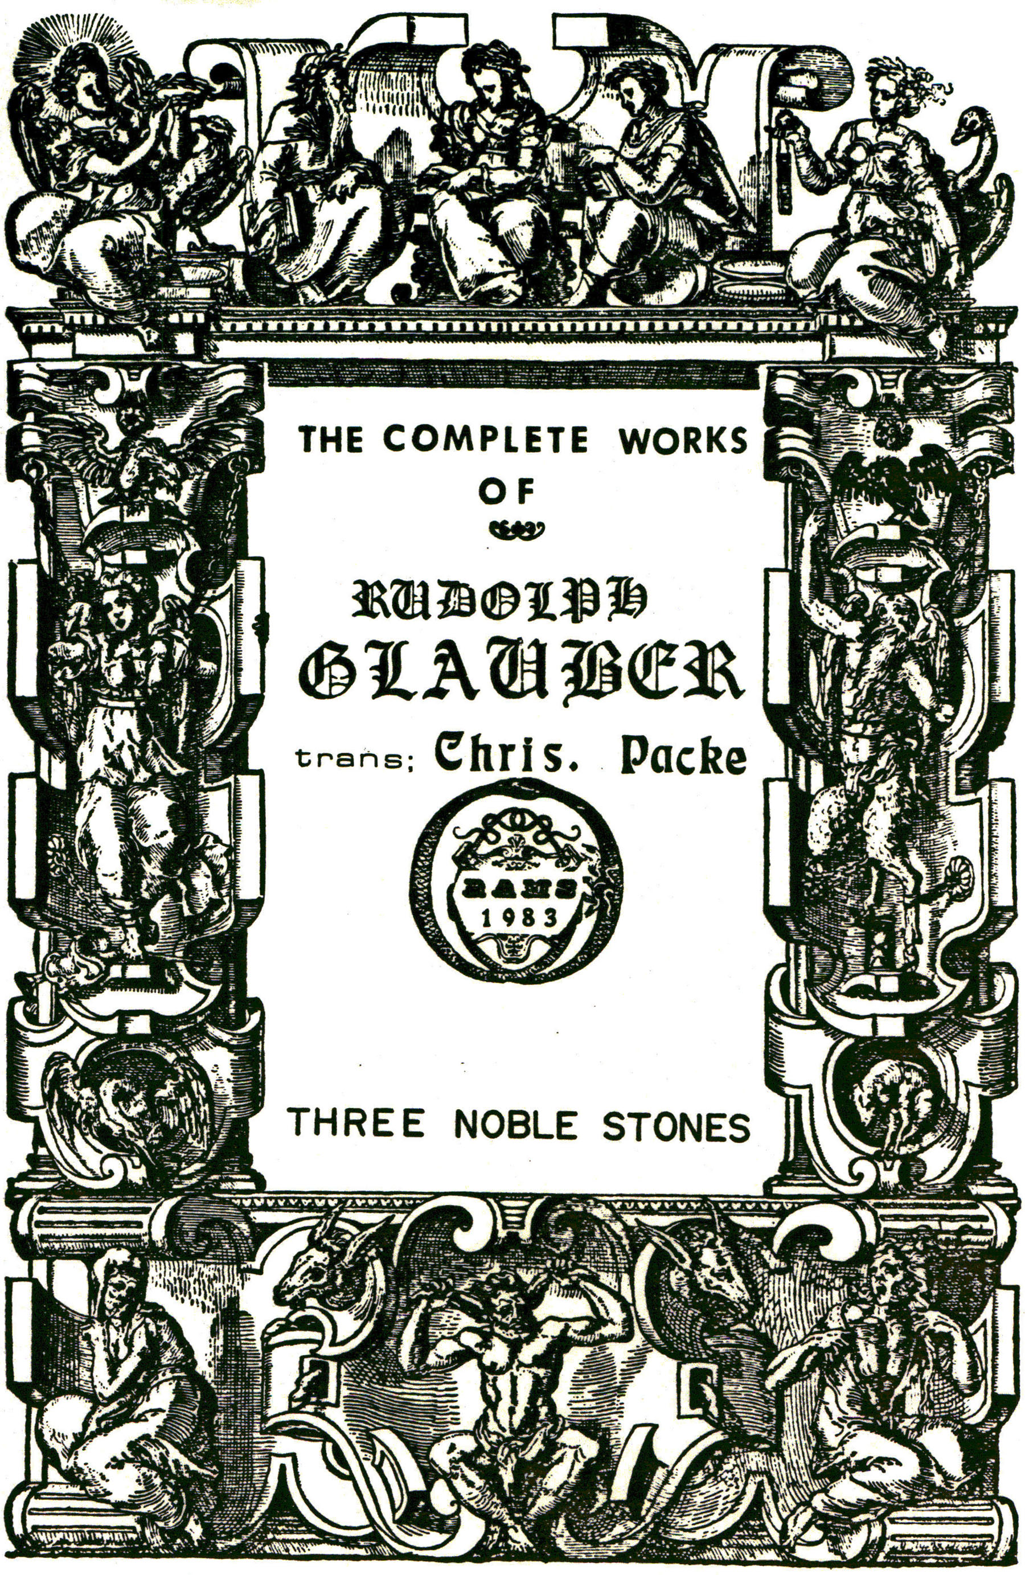
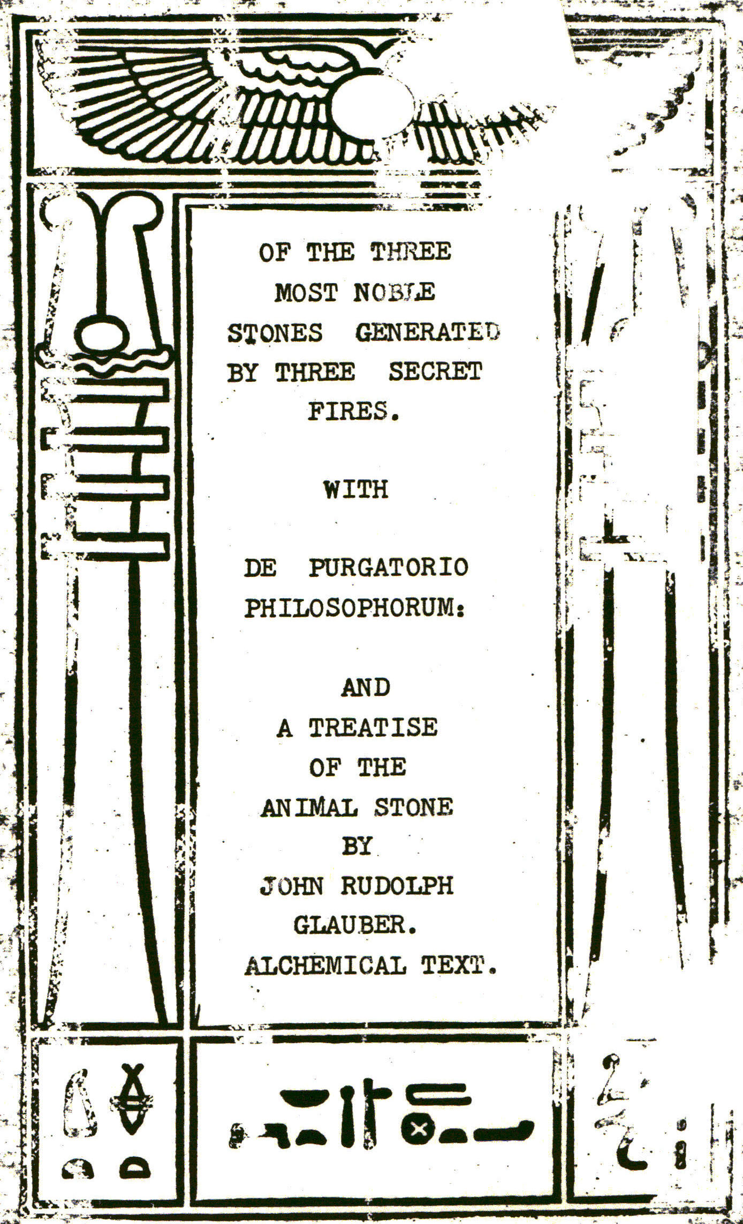

OF THE THREE MOST NOBLE STONES GENERATED BY THREE SECRET FIRES
AND
First, Of the Stone of Philosophers, which is prepared by the Secret Fire of the Wise.
Secondly, of the upper and lower Thunder-stone, how they are generated above, by the Meteorological Fire; and below, by the Secret Artificial Fire.
Thirdly, How the LAPIS IGNIS, or Fire-stone of BASILIUS, is to be prepared out of ANTIMONY by Art.
And how those Three most noble Stones of the World, are to be used in Physick and Alchemy.
Translated out of the High-Dutch.

Reader,
In the end of the Appendix to the Seventh Part of my PHARMACOPAEA SPAGYRICA, I have made mention of Three Fires, which are not Common, but unknown to the World. By which are generated three wonderful Stones, which I did intend to publish. First, of the secret Fire of Philosophers, commonly called the Fire of ARTEPHIUS; because ARTEPHIUS a very ancient Philosopher did first write of it, who was also envious like others, and would write nothing of it, till he came to be nine hundred Years old, which way the Philosophers Stone was to be made by this Fire. These Writings have been long tossed up and down the World, before any could be certain, whether or no this miraculous Fire could be found in Nature. At length some Philosophers attained its knowledge, and published it for the good of the World. But because, those Philosophers were very obscure in their Writings, the Art could not be made common, but remaineth secret to this hour: So that one of a Thousand among the now reputed Philosophers, (who have filled the whole World with their unexperienced Writings) scarcely one is to be found, who know anything of it. And because this secret Fire was called by the true Philosophers IGNIS PHILOSOPHORUM, it would have becomed them, to know somewhat of it. HELMONT the most experienced and learned Philosopher of his time, although he had studied long in the Universities, yet he doth not Glory in any Arts he there learned:
But on the contrary, he saith, that Physick, as it is taught in the Schools, Is of no value. And, that not the Universities, but the Fire, made him a Philosopher. And therefore, he calls himself a Philosopher by the Fire. And without doubt, our secret Fire was known to him, as appears by his excellent Writings. For his ELEMENTUM IGNIS VENERIS, to which he attributes so many Virtues, could not well be made, without this secret Fire. A Quintessence may be drawn out of VENUS, but that will not effect, what the Red Element of the incombustible SULPHUR can. PARACELSUS, in his Book of SULPHUR, writes, that an excellent ELEMENTUM IGNIS may be made out of common SULPHUR, which he so highly commends, that he dares to say, that except a Physican hath this Element of Fire, (that is the fixed Quintessence of SULPHUR, among his ARCANUMS, he cannot rightly be reputed a Physican, but a Money Catcher, and Robber of the Sick. In my lately published Treatise of SULPHUR, I have also described an ELEMENTUM IGNIS, which is certainly a very excellent Medicine against all Cold Distempers, but this is not yet fixed, but combustible, but the Element of Fire ought to be Incombustible. For as long as a Medicine made out of SULPHUR is still combustible, and subject to blacken Silver when touched with it, it cannot he reputed the true ELEMENTUM IGNIS SULPHURIS. For the true Element of Fire of SULPHUR doth not make Silver black, but tingeth it with a constant Golden Colour, which cannot be washed off. As also, the Element of Fire ought to be of this Nature, to enter a Red hot Plate of Silver without fume, as Oil sinks into dry Leather; and to tinge it Yellow. Also, it ought to tinge common MERCURY into Gold, when added to it in a due heat. This Quintessence of SULPHUR, also must not be burnt by the Fire as other Oil, but remain incombustible. Therefore, the Philosophers have called it an Incombustible Oil, a permanent Water, AURUM POTABILE, & etc. When it hath those Virtues, then it can perform what PARACELSUS attributes to it, viz. Wonders both in Physick and Alchemy; and by this, ARISTOTLE and his followers (who assert, that the Species of Metals cannot be transmuted) are quite out of Doors.
It is true, ARISTOTLE also saith, that the Metals cannot be transmuted, if they be not first reduced to their first matter, of which I have sufficiently treated. This our fixed Oil of SULPHUR transmutes the Metals without any precedent reduction of them to their first matter. For our secret Fire hath taken away what soever was pernicious or combustible; so that only the purest and incombustible part remains, by which such great things in Medicine and Alchemy are performed, that it refuteth all those who speak against it; although many Imposters by their cheats, from place to place, have given occasion to speak evil of the Noblest of Arts; which hath had an ill effect heretofore upon my self.

An History of the Poisonous Tail of Common Alchemy.

Here follows a large Historical Digression of some great Abuses which the Author some time underwent, but pertaining nothing to the Scope of this Treatise, I will not trouble the Reader with it.

Now concerning our secret Fire, It is not made of Coals or Wood; or other combustible Matter, but compounded of certain Fiery Waters, which burn, but not like other Fires without the Glass, but always within the Glass; wherefore ARTEPHIUS, as the first Author of the secret Fire, useth these words. “Our Fire is Mineral, Equil, Continual, it Vapours not unless it be too much stirred up, it partakes of SULPHUR, and is taken elsewhere than from the matter; it pulleth down all things, dissolveth, concealeth, and calcineth, it is artifical to find; it is a short way without cost; it is moist, vapourous, digestive, altering, piercing, subtile. Airy, not violent, not burning, compassing, or environing, containing but one, and it is the Fountain of Living Water which goeth about and containeth the place, where the King and Queen Bathe themselves.”
This is ARTEPHIUS’S Description of the Fire of Philosophers. PONTANUS hath also wrote of this Fire, to whose Epistle I refer the Reader for the more easie introduction to it.
ARTEPHIUS hath here plainly enough described the Matter, and the MERCURIAL Water, and PONTANUS hath confirmed it. He to whom God will give it, will easily comprehend It; but ARTEPHIUS and PONTANUS teach nothing, but how to ripen the Stone of Philosophers compounded of Gold, Silver, and ANTIMONY, by this secret Fire. But because several others as well universal as particular are to be easily prepared by this our Fire; I think fit to say somewhat of it. Our Fire maturates whatsoever is put to it, whether Vegetables, Animals or Minerals, and therefore our Fire, as also the Matter of the Philosophers Stone it self, is called Vegetable, Animal, and Mineral; as also a natural, non-natural, and supernatural Fire. He who is not satisified with this may read ARTEPHIUS himself, where he will find more of this our secret Fire.
Now understanding what ARTEPHIUS and PONTANUS have written of our secret Fire, I could not but describe it somewhat more openly, to shew the Artist a nearer and easier way to obtain it. I GLAUBER can truly affirm this, That in my young days I have travelled many Countries, and diligently searched for an Experienced Philosopher, that might teach me some good. But I no where found my desire, but I often found some diligent Physican, who following CROLLIUS, HARTMAN, BEGUINUS, and other Experienced Physicans, prepared their own Medicines, by which they gained Honour and Wealth, and were therewith content. Some of them had indeed read ARTEPHIUS and PONTANUS, but had not light enough to understand them. I have also endeavoured to frequent the elaboratories of Princes, to learn something there. Indeed I found Processes enough there, which were sent from great Men. By following of which, and working in ARSENICK, ORPIMENT, COBALT, CINNABAR, MERCURY and the like Minerals, I drew a great deal of Poison into my Body, till at length I grew weary of it, and therefore set my mind upon SPAGYRICK Medicines, by which I have found many curious Secrets, and gained a sufficient Livelyhood. But yet at the same time, I attentively read the Writings of the Philosophers, and out of them learned many good things, chiefly BASILIUS, BRACESEUS, NEUSEMENTIUS, and the like good Authors; but the secret Fire of ARTEPHIUS, or the proper Agent, I could not Learn, I have often Discoursed of it with Learned men, but always found, that they understood less of it than my self. For they had not read the Ancient Philosophers, but had spent their time in getting of Money, and sending their Receipts to the Apothecaries Shops. But after a light was enkindled in me from above, and I began to know this secret Fire, I began to have an aversion to the tedious, and troublesome work with Glasses, therefore I set it all aside, and now find my self more at ease, by this Capital work, for I make no further use of Furnaces, Glasses, or Coals, but can now do more and greater things in half a Nutshell or Egg-shell, than I could before, with all my Furnaces, Glasses and Coals, for which I give incessant thanks to God, who is the giver of all Good. This I was willing to add, viz. that our Fire is hard to be found, but easie to be made, when known. Concerning the Matter, it is not always the same, but may be taken after several ways, yet according to the true proportion of the Fire, for this is all in all, the proper Agent must be only excited by our Fire, and carried on to the promoting of the Maturation of our Matter; for the proper Agent is here as much concerned, as the fire it self, for that alone could not work sufficiently to prepare an unripe Mineral by it self, without the help of the proper Agent, in so short a time, into a Tincture constant in the Fire, or universal Medicine. Now whoever hath a mind to do any thing with our secret Fire, must have constancy of mind, tarry at home, and beg assistance of God, whose Blessing he must wait for with Patience. Now concerning the farther use of our secret Fire, it is thus, that all Vegetables, as Herbs, Roots, Seeds, Woods, & etc. and all Animals, none excepted, together with all Minerals and Metals, may without Cost, be easily brought into excellent Medicaments, particularly. For our Fire MATURATES the purest ANIMA, or Quintessence of all things. Poisionous Subjects are converted into Medicine, sour and bitter into pleasant and sweet. The immature is ripened; and our Fire can be better compared with nothing, than with the Sun, which gives Life to all Vegetables, Animals, and Minerals, and makes the imperfect, perfect, nothing excepted. In fine, Our Fire is the greatest and most noble in the World, the Sun excepted: But God is above all, the Lord of the Creation. But what need I say much of the Melioration of Vegetables, Animals, and Minerals, by our secret Fire, I have said enough, if I should say more, it would render it too Common.
But thus much it will be necessary to add, viz. what the Subjects are, which are the most easily wrought upon by our Fire. Among Vegetables, Wine, and what pertains to it is the best; Among Minerals, ANTIMONY and MERCURY, which is our living Gold; Among Animals, Man, and what appertains to him. You have your own choice to chuse, which you will, you have sufficient Advice, and want nothing more, but the Blessing of God, without which all is in vain.

Here followeth the Composition, or Preparation of our Secret Fire.

Three Heathenish Deities command this our secret Fire, viz. APOLLO, DIANA and PLUTO. APOLLO affords the warm Sun-shine. DIANA gives the cooling and refreshing Night. And PLUTO gives his Fiery Hellish Rain. That you may better understand it, APOLLO gives Wine three times, DIANA Milk twice, and PLUTO his Hellish Fire once. Out of these-three Gifts, our Fire is prepared. This is the true Preparation of our wonderful Fire. To speak of this more amply, is not convenient; we must not cast Pearls before Swine, which way this Fire is to be used to any Subject, is sufficiently discovered to a Man thereunto elected by God. But there are many, who having no dependency upon God’s Blessing, proceed after an evil and cheating manner, so that those ALCHEMISTS, or Gold-makers, are become a scorn to the Country, and no Man cares to dwell by them, lest their greats and continual Fires should bring damage to his Neighbours, and this not without reason. For in making Oil of VITRIOL after the common way, a Fire is kept ordinarily for fourty or fifty hours, which is a very tedious Work; but the Adepts can force over a Pound of Oil of VITRIOL in an hours time, with very few Coals, which thing I have already touched in my Writings, and shall say more of it in my Second Appendix. I have recommended this compendious way of making Oil of VITRIOL and SULPHUR, to some Men; but they adhered so close to their old lingering way, that they were regardless of a better, notwithstanding that the Oil of VITRIOL, and the ACIDUM of SULPHUR, are the Basis or Foundation of all common HERMETICK Medicine, for all other Mineral Spirits are by them acquired easily and plentifully. That Mineral ACID which is plentifully found in VITRIOL and SULPHUR, is the only Agent whereby Nature MATURATES the yet volatile and unripe Minerals in the Earth. And also all Tinctures, which are fixed and constant in the Fire, are by the hand of the ARTIST prepared by this, yet with the Addition of its Compeer, the external Fire. This universal ACIDUM is our Horse-dung, and the STYGIAN water, in which JASON drowned his Dragon and made him fixed: But when I here mentioned JASON’S Dragon, it comes Into my mind what happened to me, when I once attempted to make such a Dragon, which vomited out Fire, and a black poisionous Smoke, out of SULPHUR and SALT-PETER; And because this History, may serve as a warning to many, who may incur much danger oftentimes by the common ALCHEMY, I will here insert it. A little before I became Bed-ridden, I had undertaken to steal from the ever watchful Dragon, that Golden FLEECE which he hath in his keeping, and because this fierce Dragon will part with nothing before he be half slain, or at least, laid to sleep, therefore I was busied in this work, and had made a mixture of SULPHUR, NITER and TARTAR, and also another of SALT-PETER, ANTIMONY and TARTAR, each apart in an Earthen Pot, in order to Fire them for Detonation. And although I had ordered, that one Pot should first be detonated, and then the other, that the Smoke might not be too great, yet this was not done, but they were fired both together, which caused such a great, black and stinking Smoke to ascend the Chimney, that when the Neighbours saw it, they thought the House had been on fire, and cried out, Fire, knocked at my Door, to come in to quench it, when there was none, notwithstanding this was not done in my dwelling House, but in a House remote from all others, so that it could have done no hurt to any else, if it had been burnt down, but they not being satisifled got Ladders and looked down the Chimney, and seeing no Fire there, they then said, it was Witchcraft. Out of this History, one may see what a dangerous Toil the common ALCHEMY hath. This work to kill the Dragon, and to spoil him of his Golden FLEECE, is one of the pleasantest that ever I did in ALCHEMY, except the secret Fire. For when the SULPHUR, SALTPETER, ANTIMONY and TARTAR, are detonated together, and sublimed with SAL ARMONIACK, the Golden FLEECE riseth in a curious Golden Colour, and tingeth the Head, and Receiver with all sorts of Colours, like unto the Rainbow, or a Peacocks Tail, and also one sees the Foot—steps of the scaly Dragon most gloriously in the Head; which NEUSEMENTIUS hath excellently described, in a few FRENCH Verses, and hath omitted almost nothing which belongs to this Work; and because I here write of this sort of Work, it will not be amiss to add those Verses. Concerning this, NEDEA thus exhorts JASON in OVID.

Pervigil ecce Draco, Squamis crepitantibus horrens,
Sibilat & torso pectore verrit humam.

Which NEUSEMENTIUS hath rendered into French.
[Note: this is given in French and then in Latin; which is corrupt, Therefore I am giving the English translation only of the French rendering of the above original Latin Quote. D. H.]

Behold this scaly Dragon swelled with Ire,
His Crest doth brandish, with a dreadful Brow;
Nere closeth Eyes, nor Ears, nor yet retires
From dismal noise, and horrid Teeth to shew:
From his broad Throat flames issue out
Black fumes infect the Air about.
Behold the Rings, which his encircled Tail
Casts on the Earth, whilst he doth form his Coil;
With his broad Breast he crept upon its Face
Sweeping the ground, always in the same Trace.

Here in few words the Philosopher describes the whole Work, how to spoil the Dragon of his Golden FLEECE. But only to those who easily understand these Verses, whose eyes God hath opened, and are already pretty well skilled in this Art. But to the unexpert all remains dark. Reading only will not do it, but you must put your hand to the Work, if you will attain to any thing. I have, for several years together, read, sought, and laboured in vain, before I found the right way of obtaining this Golden FLEECE. And when at length I became Master of this Art, I could not but admire that it was so easie a thing, and yet so difficult to be learned out of Books. PARACELSUS and NEUSEMENTIUS write the plainest of this, of which two expert Men, I first learned this Art, but afterwards I found a more Compendious way, so that I can now perform the whole Work, with the Charge of one Ducat (or ten Shillings) in a very short time. But I must leave it to others to do, being yet detained in my Bed by my sickness: So that I can do no more, than to shew to others by my Writings and Instructions, the ready way to the Land of Promise.

Of the Second Fire, and its marvellous Fire—stone, which is generated by it.

We know, that Fire generates Stones, every one according to its Nature. The secret Fire of the Philosophers, engenders the Philosophers Stone, which is a universal Medicine for Men and Metals, as we have already heard. That the Meteorical fire, from whence proceeds Lightning and Thunder, generates also Stones, is known to all, for the Air procreates the same things, which are found upon the Earth. Therefore HERMES in his SMARAGDINE Table hath very well said, That whatsoever is beneath is also above, and what is above, is also beneath, by which, marvellous things are done. We know; that Frogs and Grasshoppers and the like, which are procreated in the Air, have fallen down with the Rain. I have read in a certain Historian, that once a Calf fell down with the Rain.
ANAXAGORAS, a famous Philosopher, pronosticated in his Life time, that after he was dead, a great Stone should fall down from the Air, to the Earth, which also came to pass. We also know, that sometimes great pieces of Iron have fallen down, not compact, but sticking one part to another like drops. And also, every Body knows, that Stones are cast down by Thunder and lightning, which Stones are formed and concentrated by the Lightning, and so have assumed the Nature of a Stone; for in the Lightning is hid a very miraculous Property; seeing that Lightning is a Fire of quite another Nature, than our common Fire, which breaks in pieces all hard things which resist, but toucheth not what maketh no resistance, it hath very often happened, that the Lightning hath broken a Mans Bones, without hurting his flesh. We have also known, that it hath melted the Sword in the Scabbard, and left the Scabbard whole. This Stone generated by Lightning, hath quite another Nature than the common Stones, for it is not transparent like a Pebble or Sand-stone, which melt in the Fire. Neither hath it the Nature of transparent and hard Gems, which do not melt in the fire, and yet keep their Lustre, neither can the fire reduce it into Lime, as it doth to Chalk-stone. In a word, it can be compared with no Stone in the World. Its shape is also wonderful, for it is generally sharp at both ends, but yet they are not all of one Figure or shape, they are generally smooth on the outside, and of a milky Colour, and reddish within. I have one which is Triangular like a Star, and if you turn it, tis’ like a Heart, of which I never saw the like. I have also one which is Coal-black, which is rough both within and without, it is a wonder to me, that this Stone will not strike fire with Steel, notwithstanding it is generated by fire. We may also by Art make Lightning out of Iron or Steel, in which also is generated a strange Stone. The Thunderbolts love all things which are combustible, especially Gun-powder, for the Lightening it self proceeds from SALT-PETER and SULPHUR, and that is the reason, why it so often strikes into Towers, where Gun-powder is kept, and also it useth to strike Old Oak Trees, which contain SULPHUR and SALTPETER, also upon Church Steeples, but seldomer in the open Fields. I once saw in GERMANY, where the Thunder had stroke a Tower of Gunpowder, and although it was four square, yet it run so about it, and took out a piece of Stone work all round, as if it had been cut out with Tools, because it could no where find entrance. Strange things are done by Lightning, it sometimes killing the Horse, and not hurting his Rider, and again killing the Rider, and not hurting the Horse, because it is no common Fire, but a concentrated Meteorical fire: It hath no resemblance of the fire of the Sun, much less of our common Fire, but our secret Fire of the CHALDEANS hath some Agreement with it, because it is made of Iron or Steel, and SALTPETER: Therefore it cannot be much unlike the fire of Lightening, for that is also generated out of SALTPETER concentrated, and SULPHUR. Steel is concentrated SULPHUR, that hath also Power to concentrate SALTPETER, and so to generate this marvelous Fire. The Meteorical Thunder-fire is a terrible one, but our Steel-fire is more wonderful in its Essence and Operation, as we shall hear by and by, for incredible things are wrought by it, so that even the Stone of Philosophers, never so well prepared, is not to be compared with it. QUERY, whether this Thunderbolt which is cast down by the Lightening be of any Virtue, or whether it be a dead and unprofitable Stone? I answer: It hath been always reputed, that if a Thunderbolt be kept in any house or place, the Thunder and Lightening will never strike into It. Whether this be true, I cannot tell, yet this I know, that those who keep them esteem them highly, I my self have one, which I much esteem for its marvellous Figure, for turn it which way you will, it always represents a Star or a Heart. Many strange things are performed by this Thunderbolt. I have seen several Foresters break it into pieces of the bigness of a Pea, which they put into a Bulletmould, filled up the Mold with melted Lead, and did believe, that they could not miss any wild Beast at which they should shoot it, I have also seen some Soldiers make such Bullets, and formerly believed, that they could pierce any thing with them, that otherwise they could not shoot through. I have also seen others, who have put pieces of this Stone into the pummels of their, Swords, and believed, that this took away their Adversaries Courage when they should encounter them, and so they might easily Conquer them. These and the like things, I have seen done with it. But whether this be so or no, it is probable that there should be some occult Virtues in those Stones. For seeing that all Stones are good for somewhat, why should this marvelous Thunderbolt only be good for nothing? Some cause Women in Labour to hold these Stones in their hands, to facilitate their Labour; they also say, that it encreaseth Womans milk, if it be put into their drink. Others put them into the hand to stop Blood. If one could do any good with it, one might easily, by the help of a certain Magnet, attract a great many of them from the Air, as you shall hear anon. Now again, to return to our Fire and Firestone, I affirm for truth, that our secret Fire and Firestone, in its Essence and Efficacy, is more wonderful, than the Meteorick Lightning and Thunderbolt. For our Fire doth not burn or flame, but when we will have it, otherwise it is like a dead Black-stone, if you only keep the Air from it, it will remain a Stone as long as you please. If you put it into a Glass and stop it very close, and keep it under water never so many years, it will still remain Fire, and not be hurt. For our CHALDAICK Fire, when once prepared, will not burn, but remain good for ever, if you keep it from Air and Water. It is sufficiently known, that the ancient Heathens put burning Lamps into their Vaults, of which Lamps I have seen many, that were digged out of Mines in COLEN. Some of these Lamps were found in some burying Vaults burning, when they were first opened, but as soon as the Air touched them went out. But our CHALDAICK Fire remains dead, when kept close, and is kindled by the Air. I call it dead, but it is rather a dormant Fire. This our secret Fire hath so strange a Property, that it is able at all times to attract Fire out of the Air, not only in the hot Summer, but also in the cold Winter Nights, when the Sun is farthest off. By the help of this Fire, I believe, I could at certain times light a Candle, either under or above the Earth. The MACCABEES set their Sacrifice on Fire by this, and not with common Wood, or Coal fire, as the Vestal Virgins in ROME were forced to feed it with Wood continually, that it might not go out; if by chance or neglect it went out, those Virgins were buried alive; in so great esteem, had the JEWS and the Heathens, their Fires.
Now as for the use of our secret Fire, no Man may be so bold as to discover the Power thereof to the World, for things incredible are to be done by it, which are better to be concealed, than made publick: Yet I will a little touch at it. The secret Fire of it self is of no use in Physick, but great Secrets may be prepared by it, both in Medicine and ALCHEMY. First, out of our fiery Mass may be driven a living MERCURY of MARS, which is the most noble Subject to prepare an extensive Tincture, both for Men and Metals, for of all MERCURIES of Metals, this is the best. When our Fire is melted into a thick water, and this fiery water poured upon a subtil Calx of Gold, and digested with it, it will attract the yellow Colour from the Gold, and leave it white, yet the Tincture is not yellow, but as green as Grass, out of which an excellent Medicine may be made; it is also profitable in ALCHEMY. For it is also of this Nature, that if you put a Solution of Gold and Silver into it, they will be joined together without Precipitation, which is not usual to be done. One may also squirt this fiery water, by peculiar Springs, to a great distance, and thereby fire any Combustible matter. If you will, you may also shoot this our Fire in a dry form, out of great and small Guns, to fire anything with it. I beleive, that by the help of this, one might fire a great Canon under water, by which you may fright Fish up to the Surface of the water in deep Ponds, so that you may catch them with small Nets. One may also drive away all hurtful wild Beasts, as Bears, Wolves, Foxes, nay even Lions, Tigers and Dragons, out of the Wilderness. One may also drive away Highway-Men, Murderers out of their Ambuscades, and catch them. In a word, many things that are strange may be done with it, which for certain Reasons I dare not mention. The greatest and the best thing that may be done by this secret Fire, is the preparing of the MERCURY of MARS, as also after a Magnetical manner to draw the Lightning which way one please. I have had this Fire now for above twenty years, and durst not own that I had such a thing, now I am near my end, I was willing to let it be known, that there is such a Fire in Nature. If I did not fear, that malicious Men would abuse this secret Wonder-fire, I would have been plainer, but the time is not yet come for the doing those great things, but when ELIAS the ARTIST shall come, he will not fear to make great Alterations in the World, by the help of this Fire. He will establish much good, and abolish all that is evil, but I have said enough of this at this time. I have indeed told you here that it will be done, I do not desire, neither shall. I live till it shall come to pass, for such great Charges will not be made with ease, but with great Zeal. God preserve the Pious, and shew them a way over the Mountains, where they may live secure from this SODOMITISH Fire, AMEN.

Of the Third secret Fire, and the wonderful Stone that is engendered by it.

That pious Philosopher BASIL VALENTINE, in his Triumpant Chariot of ANTIMONY, teacheth, how to prepare a Stone by Distillation and Rectification out of the purest part of ANTIMONY, and calls it the STONE of FIRE because this Stone is prepared by Fire out of fiery Subjects: And also because it expelleth all Diseases from the Body of Man, and consumeth them as common Fire doth Wood. He also saith, that this Fire-stone can transmute Silver into Gold, although in a small quantity. The highly experienced Philosopher HELMONT, makes mention of almost such a Stone, which he saith, he saw in ENGLAND with one BUTLER, and tells of wonderful things that the said BUTLER did with it. Now by reason of my diligent search into Nature and the Blessing of God, such a Stone hath fallen into my hands, with which I can do the same things in Physick and Alchemy, which BASIL VALENTINE ascribes to his Fire-stone, and HELMONT to BUTLERS Stone: I could not but leave to posterity, that it is possible to prepare this Stone out of ANTIMONY. The Art consists in this, that you first bring the ANTIMONY by Sublimation, Distillation arid Rectification to the greatest Subtilty, and afterwards again concentrate this subtil Spirit into a hard Stone, which Stone when it is not fixed (being then useful in Medicine) is of a reddish Colour, and easily melted, and penetrates all Bodies. But if by it you would graduate Silver into Gold, you must fix it first, to abide the CUPEL, but being once fixed, it will not then perform in Medicine what it would before. It is worth much more, when unfixed to be used in Physick, than when it is fixed for the tinging of Silver. For the health of Men is more precious than Gold or Silver. And with an universal Medicine, that will Cure all internal and external Diseases, you may get Gold and Silver enough. I have at this present time, but a very little of this Stone left, but am resolved in a little time to make a good quantity of it, that I may therewith serve my sick Neighbours. For it works strange things as you shall hearafter hear. This our Stone is so powerful in its working, that we dare not give it in substance, for one Grain of it serves for twenty Doses or more, and each of them hath power to expel from the Body whatsoever is hurtful. This Medicine opens all Obstructions, and you shall hardly find any other comparable to it. The best way to use it is to keep it whole, and not to powder it, and then it is fit to be used both inwardly and outwardly. If you will use it inwardly, then put a few bits of it into a Glass, and pour Spirit of Wine upon it, which a little Sugar is dissolved, and so let it stand till you have occasion for it. If you will purge any Body with it, you must put a few drops of it into a spoonful of Wine or Beer, or any other Liquor, and give it to the Patient, and order him to be kept warm, then the Medicine will work in his Body, like fire upon Wood, and consume whatever impeded his health, and drive it out by all the Emunctories, viz. by Vomit, Stool, Sweat, Urine, and Spitting, and leaves no impurity in the Body, and so it expels all Fevers and Agues, however distinguished. It also cures the Plague, Leprosie, Gout, the falling Sickness in young and old. It takes away all obstructions of the Body, viz. of the Liver, Spleen, and Lungs, it expels all ill Humours, contained in the Cavity of the THORAX and all other parts of the Body. This our Stone also opens all the Obstructions of the Mesentery, carries off all Slime, and Salt watry Humidities. It cleanseth the Stomach and Guts from all pituitous and bilious Slime. It also draws all hurtful Humours out of the Brain, takes away noise in the Ears, Comforts the hearing and sight, takes away every Toothache in a moment, fastens loose Teeth, and hinders their fouling. It takes away all the Vices of the Throat, Mouth and Tongue, and suffers no uncleanness or foulness to abide there. It is a pity to see that no Physican hath a Remedy for the Toothache, but either pulling them out, or stopping them when hollow with NARCOTICKS or hot Oils, which are indeed no cure: Now forasmuch as the Disease troubles People of all Ages, and few know any Remedy for it, I think it necessary to set down a never failing Cure. Tis most true, most Toothaches may be put off by Purging, and need not so painful a Cure, as drawing. Out of Pity to those, who are troubled with the Toothache from their infancy, I here declare the Remedy. Rx. Of our Fire-stone, as much as a Pea, and put it into your Mouth, with half a Spoonful of Wine, keep it in your Mouth as long as you can, or so long till the Stone hath drawn your Mouth full of Rheume, then spit it out, and again put the Stone into your Mouth, with as Wine as before, and keep it there till your Mouth is again filled with Rheune, then again spit it out, and continue doing this so long, till you have spit out half a Pint of Rhuewy Spittle, not reckoning the Wine. The next day again draw out the same quantity; do this every Morning fasting so long, till no slimy matter, but only a clear insipid water comes out, which is a certain sign that your Head and Brain is freed from all superfluous Moisture. When this is done, for a great while you will be free from all noxious Rhumes, or Salt defluxions, which fall from the Head to the Teeth, and there cause pain. This our Firestone doth not only draw all noxious Humours from the Head, but also out of the Stomach, Lungs, Liver and Spleen, and carries them out of the Body, by the Mouth, as well or better than any common Purge. but if the Body should be too full of ill Humours, so that our Fire-stone, should not be able to draw them all out that way, then you must take some of it inwardly extracted as before mentioned. But because this our Stone is yet unfixed, and therefore sometime causeth Vomits, arid some are not able to bear Vomiting, therefore you may prevent it, by putting distilled Vinegar with Sugar upon the Stone, instead of Brandy, and so extract it, and this Exctract will cause no Vomits, but only work by Stool: This is enough to be said for the Cure of the Toothache. But if Parents were sufficiently knowing, and careful of their Children, they might in their Childhood prevent the greatest part of this Mischief, by causing them daily to wash their Mouths, and behind their Ears, with cold water. But in those who are come to Maturity, our Fire-stone is the
best of Remedies and never fails. It also cures the Scurvy in the Mouth, when little hot Pimples appear, and the decay or washing of the Gums. This Stone being held in the Mouth with Wine, also preserves Old Men from Apoplexies, Catarrhs, and the like. Let this suffice to be spoken concerning the Virtues of our Fire-stone, in the curing of internal Diseases. But because the Variety of Distemper’s is great, I will there set down the true way of using it, that none may err in its Application.

Of the true use of this Medicine in Diseases.

In all Fevers or Agnes, let them be Quotidians, Tertans or Quartians, you must always give our Medicine two hours before the fit, and keep the Patient from the cold Air. In the Plague, Pleursie and other hot Fevers, you must not delay the using of this Medicine, but as soon as the Patient is taken, give him a Dose of our Medicine, let it work with him in a warm Room. And if the Disease abate not, give him the next day another Dose more or less, according to the condition of the Disease and the Patient. And you must beware of Bleeding, if the Patient be strong enough to endure a Purge, but if the Patient should not have sufficient strength, and yet the heat encrease, then you may abate the heat by taking away a little Blood, but not too much, that the strength may not be exhausted with the Blood, and the evil yet remain in his Body, for by Purging, only that which is hurtful is expelled, and the good remains.
In the Epilepsie, you must use this Medicine only every other, or every third day, as long as there shall be occasion.
In the Stone of the Kidneys and Bladder, once in a Fortnight.
In the Dropsie, once a Week.
In the Cholick, once after you have used a Clyster.
In the Leprosie, once a Week.
In the Gout of all sorts, once in three or four Days, until the pain is gone.
In Obstructions of the Lungs, Liver, Spleen and Mesentery, once or twice one after another.
In the Venereal Disease, you must use it every Third day, and Sweat between whiles, till the Disease is gone.
In the HYROCONDRIACK Melancholy, Scurvy and the like Distempers, which proceed from Salt and Cholerick Blood, you must take a Dose every Third day, till the Disease is gone.
In all sorts of Scabs and impurity of the Skin, which proceed from watry Blood, you must take it once or twice, and apply outwardly a fixed white SULPHUR.
In the Dysentery or Bloody Flux, use it but once and it stays the Flux.

Of the outward Use of our Fire-Stone.

If our Antimonial Fire-stone be boiled for some hours in Salad oil, it draws out of it many Virtues, so that being only outwardly applied, it doth much good in Physick. The Oil becomes red in the boiling, and if it doth not so, it is a sign, that it hath not been well boiled, but if it be well done, it will do what I say here. First, this Oil is good to heal all fresh wounds, and old Sores, if you dip Pledgets in it, and lay them thereon, and so keep it from the Air, with a Plaster of Wax. It also cures all Bruses, being anointed with it, or a Cloth dipt in it, and laid over the Bruise. A little Cotton being dipt in it, and applied to the Navel, with a Nutshell, purgeth those, who are easily moved, as well, as if they had taken it inwardly: And if being so applied, it should not work with Men, that are not easily moved, you may inject a Drain of it Clysterwise by a Syringe, and then it will open the Body, and carry all slime and filth from the Guts, and is certainly the best Remedy in the World against the Cholick. For It doth not only draw what is bad out of the thick Guts, as Clysters do, but also out of the small Guts, yea even out of the Stomach, to the ease and admiration of the Patient. This Oil also applied to the Navel and Clysterwise, immediately helps Women, who are troubled with the SUFFOCATION of the Matrix, for which Disease the World cannot afford a better Remedy. And without doubt this Oil hath many more Virtues than I yet know, but time will discover them: for I have not had it long, but an resolved to have a good quantity of it made to serve the Sick: And no doubt, but in a short time this high Medicine of the Stone and Oil, will be known to all EUROPE. For it will outdoe the whole GALANICK APPARATUS of Medicine. Certainly those Physicans, who serve in Armies, should not be without this incomparable Medicine, which is of no small Carriage, and doth so great things. For one Ounce of this will make at the least a Thousand Doses, and so by consequence many may be cured by it. If every CHYRURGIAN in an Army, should have but half an Ounce of this Stone, for inward use, and some Ounces of the Red Balsome, for outward use, the Lives of many Soldiers would be saved, which for want of it must die. The threatning of Armies is already over our Heads. God send us what is good for our Souls, and preserve the Pious from evil. And so we end this Book of the FIRE-STONES. If it please God, the Seventh part of the Prosperity of GERMANY shall shortly follow.

Finis

