Michael Stern Hart (1947-2011)

http://www.gutenberg.org/wiki/Michael S. Hart

Obituary for Michael Stern Hart

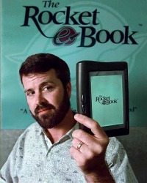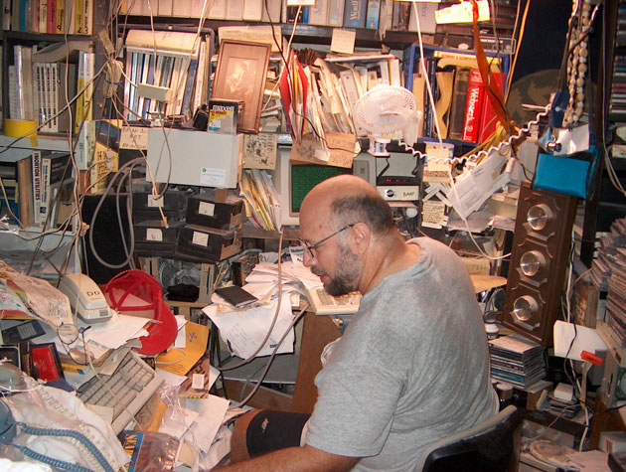

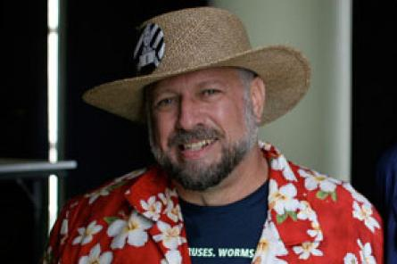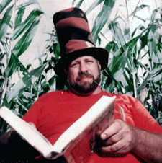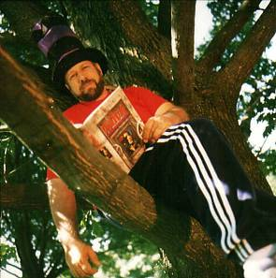

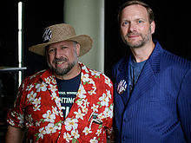

Hart (left) and Gregory Newby of Project Gutenberg at H.O.P.E Conference, 2006

Michael Stern Hart was born in Tacoma, Washington on March 8, 1947. He died on September 6, 2011 in his home in Urbana, Illinois, at the age of 64. His is survived by his mother, Alice, and brother, Bennett. Michael was an Eagle Scout (Urbana Troop 6 and Explorer Post 12), and served in the Army in Korea during the Vietnam era.
Hart was best known for his 1971 invention of electronic books, or eBooks. He founded Project Gutenberg, which is recognized as one of the earliest and longest-lasting online literary projects. He often told this story of how he had the idea for eBooks. He had been granted access to significant computing power at the University of Illinois at Urbana-Champaign. On July 4 1971, after being inspired by a free printed copy of the U.S. Declaration of Independence, he decided to type the text into a computer, and to transmit it to other users on the computer network. From this beginning, the digitization and distribution of literature was to be Hart's life's work, spanning over 40 years.
Hart was an ardent technologist and futurist. A lifetime tinkerer, he acquired hands-on expertise with the technologies of the day: radio, hi-fi stereo, video equipment, and of course computers. He constantly looked into the future, to anticipate technological advances. One of his favorite speculations was that someday, everyone would be able to have their own copy of the Project Gutenberg collection or whatever subset desired. This vision came true, thanks to the advent of large inexpensive computer disk drives, and to the ubiquity of portable mobile devices, such as cell phones.
Hart also predicted the enhancement of automatic translation, which would provide all of the world's literature in over a hundred languages. While this goal has not yet been reached, by the time of his death Project Gutenberg hosted eBooks in 60 different languages, and was frequently highlighted as one of the best Internet-based resources.
A lifetime intellectual, Hart was inspired by his parents, both professors at the University of Illinois, to seek truth and to question authority. One of his favorite recent quotes, credited to George Bernard Shaw, is characteristic of his approach to life:
"Reasonable people adapt themselves to the world. Unreasonable
people attempt to adapt the world to themselves. All progress,
therefore, depends on unreasonable people."
Michael prided himself on being unreasonable, and only in the later years of life did he mellow sufficiently to occasionally refrain from debate. Yet, his passion for life, and all the things in it, never abated.
Frugal to a fault, Michael glided through life with many possessions and friends, but very few expenses. He used home remedies rather than seeing doctors. He fixed his own house and car. He built many computers, stereos, and other gear, often from discarded components.
Michael S. Hart left a major mark on the world. The invention of eBooks was not simply a technological innovation or precursor to the modern information environment. A more correct understanding is that eBooks are an efficient and effective way of unlimited free distribution of literature. Access to eBooks can thus provide opportunity for increased literacy. Literacy, and the ideas contained in literature, creates opportunity.
In July 2011, Michael wrote these words, which summarize his goals and his lasting legacy: “One thing about eBooks that most people haven't thought much is that eBooks are the very first thing that we're all able to have as much as we want other than air. Think about that for a moment and you realize we are in the right job." He had this advice for those seeking to make literature available to all people, especially children:
"Learning is its own reward. Nothing I can
say is better than that."
Michael is remembered as a dear friend, who sacrificed personal luxury to fight for literacy, and for preservation of public domain rights and resources, towards the greater good.
This obituary is granted to the public domain by its author, Dr. Gregory B. Newby.

Eulogy for Michael S. Hart
As spoken by Newby at Michael's funeral, September 12 2011 (this sequence of words is granted to the public domain): "Rather than speak in whole sentences, which can be difficult at times like these, I will speak a series of words that characterize Michael. These words might help you to form your own memories of him. Friend. Visionary. Leader. Intellectual. Anti-Elitist. Digital Literati. Rebel. Frisbee Player. Hippie. Musician. Technician. Enthusiast. lover of Much and Many. Full of Passion. Scout. Veteran. Patriot. Pacifist. Humanist. Egalitarian. Educator. Man of the People. Builder. Maker. Speaker. Listener. Systems Analyst. Friend."

Message from Michael's Family
The family prepared a document with an image of Michael, "breaking down the bars of ignorance and illiteracy." The message is part of this PDF file and contains this text:
Thank you for your
kind thoughts at this time.
Michael will be truly missed
by his family – by his friends –
and by the world !!

Please keep breaking down the bars !!

Alice, Maggie, Liz and Bennett

======================================================================================================
http://www.engadget.com/2011/09/08/michael-s-hart-e-book-inventor-and-project-gutenberg-founder/

There's some sad news coming out of Illinois today, where Michael S. Hart, the e-book inventor who founded Project Gutenberg, has died at the age of 64. Hart's literary journey began in 1971, when he digitized and distributed his first text, after being inspired by a free printed copy of the Declaration of Independence he found at the University of Illinois at Urbana-Champaign. That same year, the Tacoma, Washington native founded Project Gutenberg -- an online library that aims to "encourage the creation and distribution of eBooks" and to "break down the bars of ignorance and illiteracy." By 1987, he'd already digitized a total of 313 books, including works from Homer, Shakespeare and the Bible, before recruiting more volunteers to help out. As of this June, Hart's pioneering library housed about 36,000 works in its collection (most of which are in the public domain), with an average of 50 new books added each week. Described by Project Gutenberg as an "ardent technologist and futurist," Hart leaves a literary legacy perhaps best summed up in his own words. "One thing about eBooks that most people haven't thought much is that eBooks are the very first thing that we're all able to have as much as we want other than air," he wrote in July. "Think about that for a moment and you realize we are in the right job." Michael S. Hart is survived by his mother and brother.
=======================================================================================================
http://articles.washingtonpost.com/2011-09-08/local/35274402_1_online-library-project-gutenberg-michael-s-hart

Some people called Michael S. Hart a Don Quixote, always tilting at windmills.
As it happens, Cervantes’s classic tale of the man of La Mancha is one of the more than 36,000 books in Project Gutenberg, a monumental free online library that Mr. Hart conceived of four decades ago, when the Internet was in its infancy and generations before the birth of iTunes and Wikipedia.
Mr. Hart, 64, was found dead Sept. 6 at his home in Urbana, Ill. He had a heart attack, said his brother, Bennett Hart.
A self-described “truck driver who got loose in academia,” Mr. Hart was a “legend” in the world of digital libraries, said Brewster Kahle, the founder of the online library Internet Archive.
Mr. Hart was credited with inventing the “eBook” in 1971. He often said he was just at the right place at the right time.
As a student at the University of Illinois, Mr. Hart was given access to a network-connected mainframe computer. He told USA Today that, by his estimation, the university had allowed him $100,000 worth of time on the machine, with the goal of improving his skills.
He was thinking about a way to repay the university. Then one evening, after Independence Day fireworks, he got hungry.
“I stopped at the grocery store to pick up a snack to take to the computer room, and they’d stuffed a copy of the Declaration of Independence on fake parchment in my bag,” he told USA Today in 1999. “I was pawing around to look for something, found it and decided, ‘If I put this up online, it will last a long time.’ ”
Mr. Hart manually typed in a copy of the Declaration of Independence and posted the document so that anyone on the network — about 100 people — could access it.
That single volume gradually turned into a massive library known as Project Gutenberg, named after the 15th-century inventor of the printing press. Over the following decades, Mr. Hart recruited hundreds of volunteers to help him manually type or scan in thousands of classics in the public domain, plus copyrighted works they had permission to reproduce, for the online library.
At times, Project Gutenberg drew criticism that it offered unreliable editions that were not always entirely accurate. For Mr. Hart, the project was simply about delivering as many books to as many people as he could.
“There are two things in the world that are truly, totally free with an endless supply,” he told the Chicago Tribune in 1999. “The air we breathe and the texts on Project Gutenberg.”
Michael Stern Hart was born March 8, 1947, in Tacoma, Wash., and grew up in Urbana. His parents worked as code-breakers during World War II; his father became a Shakespeare professor, and his mother a mathematician.
Ads by Google
- Immigration AdviceGet U.S. Permanent Resident Status. Talk to an Immigration Lawyer Today USImmigrationLawyers.com/Advice
Among the first books Mr. Hart added to Project Gutenberg were the works of Shakespeare and the first 100,000 prime numbers.
Mr. Hart studied chemical engineering at the University of Illinois before dropping out because he did not like his classes. He was drafted into the Army during the Vietnam War. He subsequently returned to the university and graduated — in two years, with straights A’s — with a liberal arts degree, his brother said.
Survivors include his mother, Alice Woodby, and his brother, both of the Washington area.
Mr. Hart cobbled together a living with the money he earned as an adjunct professor and with grants and donations to Project Gutenberg. But he led a life of near poverty, Kahle said, and “basically lived off of cans of beans.”
Kahle and other friends recalled that Mr. Hart’s house in Urbana was stacked, floor to eye-height, with pillars of books.
The man who spent a lifetime digitizing literature lived amidst the hard copies, which he often sent home with visitors. It was one more way for him to share his books.
========================================================================================

http://www.independent.co.uk/news/obituaries/michael-hart-ebook-pioneer-whose-project-gutenberg-has-been-disseminating-digital-literature-for-four-decades-2355497.html

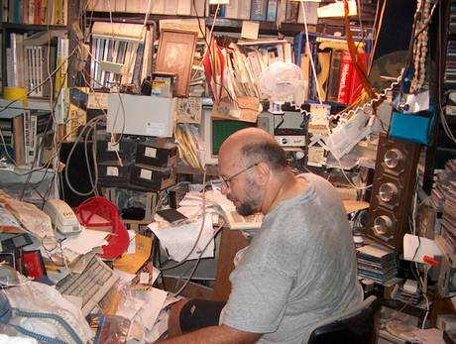

Michael Hart: E-book pioneer whose Project Gutenberg has been disseminating digital literature for four decades
Michael Hart, who has died of a heart attack at the age of 64, was widely seen as the pioneer of the first e-book, or electronic book, The Declaration of Independence, on 4 July 1971. This laid the foundation for his life's mission, Project Gutenberg, which he launched in 1971.
Hart's vision was to create a literate society by copying and making books freely available via computer decades before the spread of the internet, the World Wide Web and the use of email. A true visionary and self-described "cyber-hippie", the founder of the online library had always had a goal: "to encourage the creation and distribution of e-books", and, by making books available to computer users at no cost, "to help break down the bars of ignorance and illiteracy."
Project Gutenberg, named after the inventor of the Gutenberg printing press, Johannes Gutenberg, is recognised as the earliest, oldest and largest online literary project and, as of June 2011, offers access to over 36,500 e-books in 60 languages and a range of formats. Relying on volunteers who scan and proof-read without pay, it is estimated that more than 50 books are added each week. In 1998, Wired magazine added Hart to its "Wired 25," a list of people who were "actively, even hyperactively, inventing tomorrow". The project's chief executive, Gregory Newby, said Hart was "an ardent technologist and futurist". Long before the invention of personal computers and electronic readers, "he predicted that information contained in books and other media would surround us and be freely available."
Hart foresaw that anyone would be able to have their own copy of part or all of the Gutenberg collection. This vision came true, thanks to inexpensive computer hard drives and devices like the Kindle, iPhone and Android phone. He also predicted the enhancement of automatic translation.
Michael Stern Hart was born in Tacoma, Washington in 1947 into a well-educated family; his father was an accountant while his mother, a cryptanalyst during the Second World War, was the business manager for a high-end women's store. In 1958 the couple moved to Urbana and retrained, securing employment at the University of Illinois, lecturing on Shakespeare and mathematics respectively. Hart, intelligent and somewhat of a maverick, drifted in his late teens, working as a street musician then serving briefly in the US army before attending the University of Illinois, where he completed his BSc in two years, with his year's highest grades.
It was during this period that Project Gutenberg was spawned: Hart had been granted unlimited access and time to the university's huge main-frame computer but was unsure of how to use the valuable time. Then, inspiration struck. On 4 July 1971 he went to a grocery store, where he was a given a free printed copy, on faux parchment, of the US Declaration of Independence. He typed the text into a computer, and was intending to transmit it via email to other users on the network.
At this time there were only 100 users from élite institutions such as Harvard, the University of California and the Department of Defense. However, Hart was dissuaded as it might have crashed the system. Instead he notified users that it was available for download. Six members of this pre-internet network did so: the e-book was born and the digitisation of books became his mission.
Spurred on, for the first 18 years, Hart worked alone and the project moved slowly; by 1989 he had completed the Bill of Rights, the Constitution and the King James Bible. To support himself and the project he had a variety of jobs in which he was able to solicit donations. He was also extremely frugal, using home remedies rather than seeing doctors, repairing his own home and car and building computers and stereos, often from discarded components.
He encountered problems with copyright laws, and a big blow came in 1998 when the Copyright TermExtension Act was passed. It removed a million e-books from the publicdomain, extending copyright by 20 years. He also attacked the traditional publishing world, which he accused of profiting from the works of long-dead writers. "I am a revolutionary in this neo-industrial revolution," he said. "That's why they have trouble with me. How can anyone be troubled by free information?"
In 1994, the project's 100th text, The Complete Works of Shakespeare, appeared online. By now, the internet and the web had made their appearance, and Hart utilised them enthusiastically. In 1997 the 1,000th e-book was uploaded, Dante's Divine Comedy in the original Italian. To date, the most popular book is The Kama Sutra of Vatsyayana with over 25,500 downloads, followed by The Adventures of Sherlock Holmes and Pride and Prejudice. Project Gutenberg also releases collections on free CDs and DVDs.
Martin Childs
Michael Stern Hart, author and online activist: born Tacoma, Washington 8 March 1947; died Urbana, Illinois 6 September 2011.
=========================================================================================================================

http://en.wikipedia.org/wiki/Michael_S._Hart

Michael S. Hart
From Wikipedia, the free encyclopedia
Jump to: navigation, search
Michael Hart
Hart (left) and Gregory Newby of Project Gutenberg at H.O.P.E Conference, 2006
Born | Michael Stern Hart  March 8, 1947  Tacoma, Washington, U.S.
Died | September 6, 2011 (aged 64)  Urbana, Illinois, U.S.
Occupation | Author
Known for | Project Gutenberg
Website
pglaf.org/hart
Michael Stern Hart (March 8, 1947 – September 6, 2011)^{[1]} was an American author, best known as the inventor of the electronic book (or ebook) and the founder of Project Gutenberg, a project to make ebooks freely available via the Internet.^{[1][2][3]} Most of the early postings were typed in by Hart himself.

Contents
- 1 Early life
- 2 Project Gutenberg
- 3 Other activities
- 4 Personal life
- 5 Death
- 6 Writing Style
- 7 See also
- 8 References
- 9 External links

Early life
Michael Hart's father was an accountant and his mother, a former cryptanalyst during World War II, was a business manager at a retail store. In 1958 his family relocated to Urbana, Illinois, and his father and mother became college professors in Shakespearean studies and mathematics education, respectively. Hart attended the University of Illinois, graduating in just two years.^{[4]} He then attended but did not complete graduate school. He was also, briefly, a street musician.^{[5]}

Project Gutenberg
During Hart's time there, the University of Illinois computer center gave Hart a user's account on its computer system: Hart's brother's best friend was the mainframe operator.^{[6]} Although the focus of computer use there tended to be data processing, Hart was aware that it was connected to a network (part of what would become the Internet) and chose to use his computer time for information distribution. Hart related that after his account was created on July 4, 1971, he had been trying to think of what to do with it and had seized upon a copy of the United States Declaration of Independence, which he had been given at a grocery store on his way home from watching fireworks that evening. He typed the text into the computer but was told that it would be unacceptable to transmit it to numerous people at once via e-mail.^{[6]} Thus, to avoid crashing the system, he made the text available for people to download instead.
This was the beginning of Project Gutenberg. Hart began posting text copies of such classics as the Bible and the works of Homer, Shakespeare, and Mark Twain. As of 1987 he had typed in a total of 313 books in this fashion. Then, through being involved in the University of Illinois PC User Group and with assistance from Mark Zinzow, a programmer at the school, Hart was able to recruit volunteers and set up an infrastructure of mirror sites and mailing lists for the project. With this the project was able to grow much more rapidly.
The mission statements for the project were:
"Encourage the Creation and Distribution of eBooks"
"Help Break Down the Bars of Ignorance and Illiteracy"
"Give As Many eBooks to As Many People As Possible"^{[6]}
His overall outlook in the project was to develop in the least demanding format possible: as worded in The Chronicle of Higher Education, to him, open access meant " open access without proprietary displays, without the need for special software, without the requirement for anything but the simplest of connections. "^{[7]}

Other activities
Hart was an author and his works are available free of charge on the Project Gutenberg server. He was also a member of the RepRap Project, which aims at creating a self-replicating machine.^{[8]}

Personal life
He supported himself by doing odd jobs and used an unpaid appointment at Illinois Benedictine College to solicit donations for the project. "I know that sounds odd to most people, but I just never bought into the money system all that much. I never spent it when I got it. It's all a matter of perspective".^{[9]}
Hart glided through life with many possessions and friends, but very few expenses. He used home remedies rather than seeing doctors, fixed his own house and car, and built many computers, stereos, and other gear, often from discarded components.^{[1]}
The man who spent a lifetime digitizing literature lived amidst the hard copies in his house in Urbana stacked, floor to eye-height, with pillars of books. Mr. Hart led a life of near poverty, and “basically lived off of cans of beans.” Mr. Hart cobbled together a living with the money he earned as an adjunct professor and with grants and donations to Project Gutenberg.^{[10]}

Death
Hart died on September 6, 2011 of a heart attack at his home in Urbana, Illinois. He was 64.^{[2][10]}

Writing Style
Michael Hart's email messages had equal line length paragraphs in monospaced font: he chose the wording in such a way that each line had the same number of characters.
Sample (from his last Newsletter, 21 June 2011):^{[11]}
As many of you know, just 5 years ago or so Australia's
Parliament voted a resolution to resist those copyright
extensions that had recently taken place in the US, EU,
and other locations, but only a few years later tumbled
into line after a few rounds of economic warfare levied
upon them by The Mouse or other long copyright holders.

See also
- History of the Internet
- Project Gutenberg

References
  - ^ ª ^{b} ^{c} Michael S. Hart, Project Gutenberg
  - ^ ª ^{b} Flood, Alison (08 September 2011). "Michael Hart, inventor of the ebook, dies aged 64". The Guardian.
  - ^ Grimes, William (08 September 2011). "Michael Hart, a Pioneer of E-Books, Dies at 64". The New York Times.
  - ^ Poynder, Richard (09 March 2006). "Interview with Michael Hart". Open and Shut? (blog).
  - ^ "Michael Hart". The Economist. 24 September 2011.
  - ^ ª ^{b} ^{c} Hart, Michael S., The History and Philosophy of Project Gutenberg, Project Gutenberg
  - ^ Jensen, Michael Jon (12 September 2011). "Michael Hart, 1947–2011, Defined the Landscape of Digital Publishing". Chronicle of Higher Education.
  - ^ Moody, Glyn (08 September 2011), "Michael Hart (1947–2011): Prophet of Abundance", Open Enterprise (blog) (Computer World UK)
  - ^ Schofield, Jack (13 September 2011). "Michael Hart obituary". The Guardian.
  - ^ ª ^{b} Langer, Emily (08 September 2011). "Project Gutenberg creator Michael S. Hart dies at 64". The Washington Post.
  - ^ Hart, Michael S. (20 July 2011). "[gmonthly] Project Gutenberg Monthly Newsletter".
==========================================================================================================================

