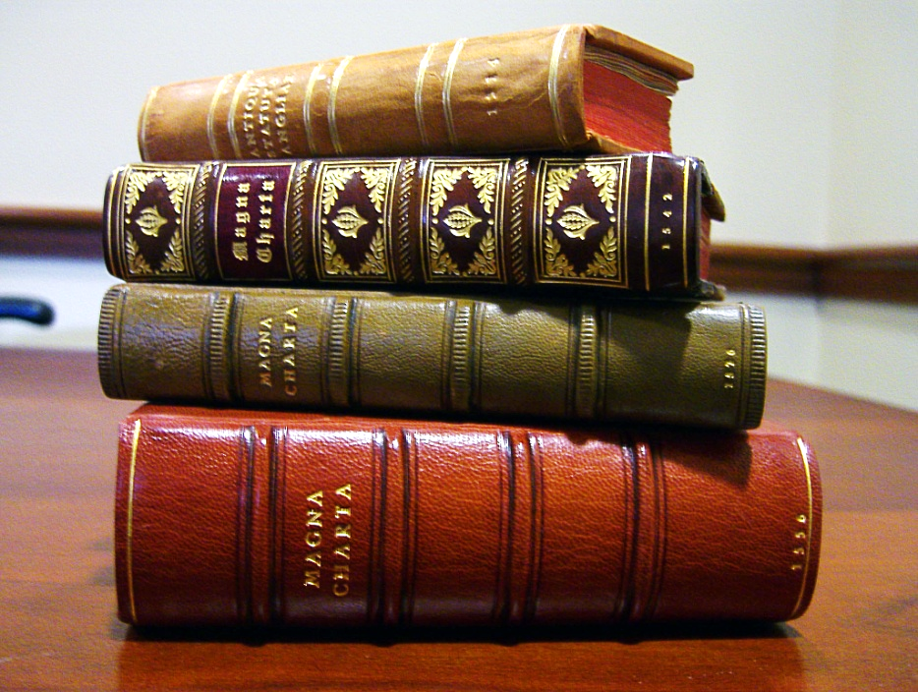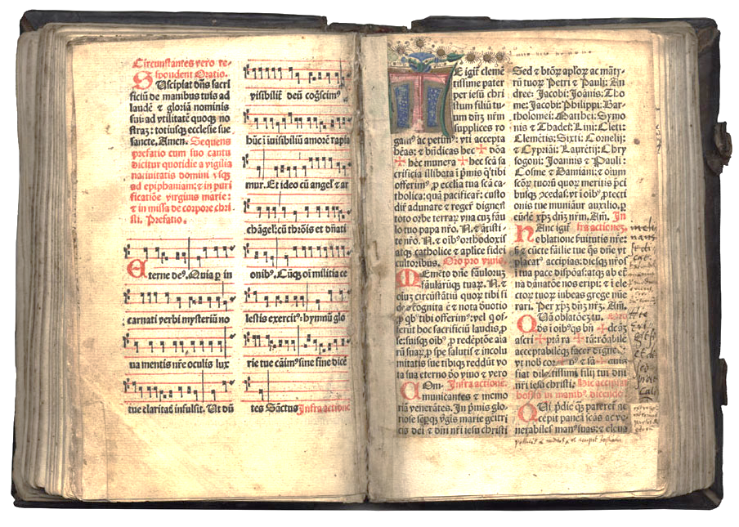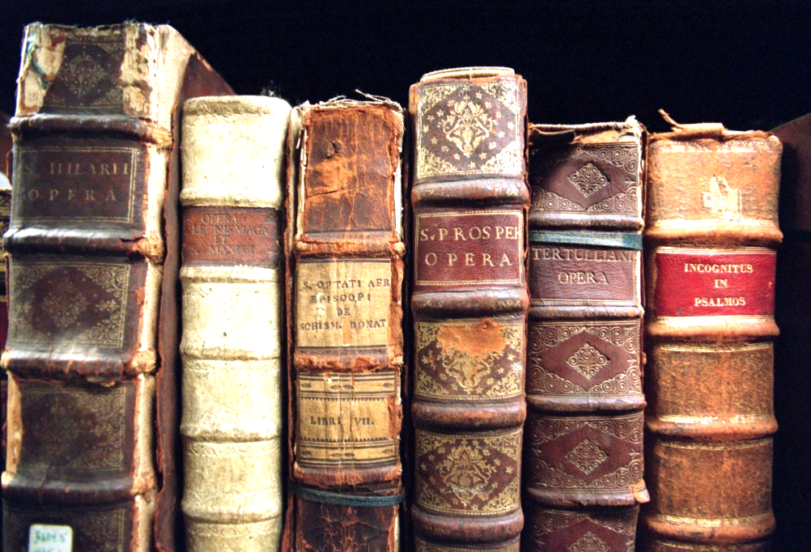

**“What are e-texts (electronic texts) & how does it help me?”**

**Make yourself laugh**

**We live in a world that is changing fast and the information age is here.**

You ask the old librarian:   "Do you have that book in your library?  No, it is checked out now for two weeks and there are three people waiting for it before you, shall I add you to the list?"  
  
**You ask the modern e-texts librarian:  "Do you have that book in your library?  Yes of course, shall I put a copy on your flash drive?"**

You ask the old librarian:   "Do you have that book in your library?  No, but I can get it from another library in a few weeks, if it is available and not checked out at that library."

**You ask the modern e-texts librarian:  "Do you have that book in your library?  Yes of course, shall I put a copy on your flash drive?"**

You ask the old librarian:   "Where will I find that book, in the section under American History or Religion or Philosophy or Psychology?   That book is rare and we only have one copy so I can check where it is now and get back to you and will tell you if it is available and not checked out."

**You ask the modern e-texts librarian:  "Where will I find that book, in the section under American History or Religion or Philosophy or Psychology?   Yes of course we put a copy in each section and you can search for it in a fraction of a second.  Shall I put a copy on your flash drive?"**

You ask the old librarian:   "Do you have that book in your library?  No, we have to consider our shelf space and that book was discarded because we had only a few people ask for it.  We also are given books that we find offensive and politically incorrect, or not acceptable to today's scientific beliefs so we decide to discard that publication."

**You ask the modern e-texts librarian:  "Do you have that book in your library?  Yes of course expensive shelf space is not an issue in this library and we do not have to review the importance of any book for the people visiting this library.  My favorite quote of Schopenhauer is: "All truth goes through three steps: First, it is ridiculed. Second, it is violently opposed. Third, it is accepted as self-evident."  Now shall I put a copy on your flash drive?"**

You call the old librarian on the phone and ask:  "Do you have that book in your library?  Yes and because of budget cuts we are only open at, such in such, limited hours and we are located across town, be on time."

**You call the modern e-texts librarian:  "Do you have that book in your library?  Yes of course as we do not have to build thousands of shelves and have acres of space we have a lot of money for all the e-texts we get.  What is your email and I will send you a copy in a couple minutes?  If you want I can also send you all the other books by that author or on your subject in the same email."**

You ask the old librarian:   "Where can I find, in this 500 page book, the information about "Atlantis" I need?  Sorry, most books have limited indexes or no indexes at all so spend a few hours and look for it".

**You ask the modern e-texts librarian:   "Where can I find in this 500 page book the information about "Atlantis" I need.  You can click CTRL + F and type in "Atlantis" and find any information instantly and can copy it instantly onto your own notes, so enjoy."**

You ask the old librarian:   "How many copies are there of that rare book and can I borrow it?  No there is only one copy and you must use it after getting permission, in our library, only.

**You ask the modern e-texts librarian:   How many copies are there of that rare book and can I borrow it?  Of course, we can make millions of copies of that rare book.  Now, shall I put a copy on your flash drive?"**

You ask the old librarian:  "I am a slow reader, my English isn't so good and I have trouble reading or my eyes are not as good as they used to be, can someone read to me?  We have a few audio books and that is all we can do for you."

**You ask the modern e-texts librarian:   "I am a slow reader, my English isn't so good and I have trouble reading or my eyes are not as good as they used to be, can someone read to me?  You can go on the net and download Natural Reader.  This will read any books or papers instantly, and even your email, anything on your computers clipboard.  This program can make the font size any size, the speed can be slow or fast so you can follow along or you can listen to some beautiful piano music at the same time while being read to.  We also have a wonderful slide show you can view with the music of your choice while you are being read to. You can even have the paper you just wrote read to you to hear how it sounds out loud."**

You ask the old librarian:  "I enjoyed that book by that author.  Do you have any speeches or talks or documentaries by him or on that subject?  Yes, but they are in another section of the library and I am not sure where they are or if we have them.  Let me check and get back in a while.  Yes, we have only a couple but they are checked out now for two weeks and there are three people waiting for it before you, shall I add you to the list?"

**You ask the modern e-texts librarian:   "I enjoyed that book by that author.  Do you have any speeches or talks or documentaries by him or on that subject?  Yes of course they are all together in our "" E-texts Library of the Future" which is here NOW.  So, shall I put a copy of all you are requesting on your flash drive?"**

You ask the old librarian:   "Do you have that book in your library?  What is the ISBN (International Standard Book Number) number?"

**You ask the modern e-texts librarian:   "Do you have that book in your library and do I need the ISBN (International Standard Book Number) number?  No, I can search for your book by authors name or any keyword or even the date in a couple seconds.  You only need ISBN numbers for hard texts for locating them or ordering them from a bookstore.  They have no need for ISBN numbers with the instant search we have on any computer today. Now, shall I put a copy on your flash drive?"**

**Do not print books: save paper and ink, get ecological, get modern, use searchable & easy to copy e texts, be a good example for others………..**

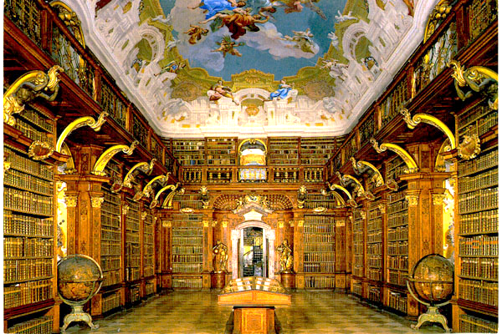

[Melk Monastery Library, Melk, Austria](http://www.thegentlemanscholar.com/Famous_Libraries.html)

**END**